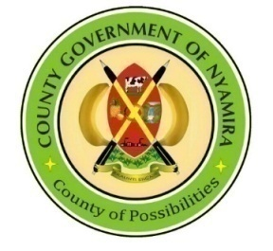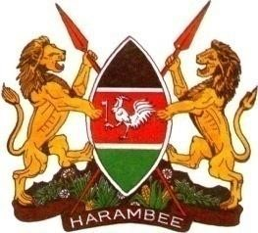

**REPUBLIC OF KENYA**

**COUNTY GOVERNMENT OF NYAMIRA**

**SECTOR PLAN FOR SOCIAL SERVICES, CULTURE AND RECREATION**

**2023-2033**



**SECTOR VISION AND MISSION**

**Vision**

To be the leading county in social development, having high levels of gender parity in all spheres

**Mission**

To empower the youth and vulnerable groups, promote culture and sports, and protect children while mainstreaming gender parity for sustainable socio-economic development

Foreword

I am pleased to present the sector plan year 2023-2033.This sector Plan outlines the objectives and strategies of the sector of social services, culture and recreation Nyamira County. In developing this plan, the Department reflected on challenges of the past affecting the county and looked ahead to identify its strengths that it must leverage on, the potential threats and key opportunities.

We have reviewed our Mission statement and developed a Vision based on that mission. Our Mission statement encapsulates the primary objective of the County, which is to empower all persons in the county, so that they can make the best of the available opportunities. The social development sector, encompassing gender, youth, culture and social protection dimensions covers virtually all aspects of life. The sector has strong linkages with other sectors of the economy and contributes towards the employment and wealth creation objectives of the country. In a rapidly changing global environment the social sector, especially the youth, is an integral part in the development process. This sector Plan outlines the issues, concerns and challenges affecting the people of Nyamira County.

We have looked closely at our core values and the unique abilities of our stakeholders that can contribute to our mission. Inspired by the insight, and with the information gathered from both internal and external stakeholders in the sector, we have worked on creating and clarifying our strategic priorities that are aligned to Kenyan Vision 2030. This Plan is comprehensive with crucial linkages between most of its components of Gender, youth skills development, promotion of sport and arts, enhancement of cultural integration, financial prudence, infrastructure development and mitigation of social challenges like HIV/AIDS, drug and substance abuse among the youth and the workforce of the Department in general.

With this clarity of focus, this Department will now turn its attention to implementation of the sector Plan to realize the intended outcomes. During the implementation process, the Department will continue to be alert to emerging issues and where appropriate, revise the strategic priorities in line with the evolving conditions.

We at the Department have the will, human resources, courage and commitment to implement this sector Plan and we believe we can make a significant contribution in the transformation of Nyamira County. We are confident that with the commitment, dedication and zeal of the staff members of the Department, communities, stakeholders and the unwavering support of the entire private sector and the development partners, we will succeed in our endeavors. Against this background, we therefore wish to urge all the stakeholders to take ownership of the Plan and ensure its successful implementation.

**CECM SOCIAL SERVICES, CULTURE AND RECREATION**

**DR. GRACE NYAMONGO**

# ACKNOWLEDGEMENT

The 2023-2033 edition of the social services, Culture and Recreation Sector Plan was prepared in accordance with section 109 of the County Government Act, 2012 and is the Second version since the inception of the County Government of Nyamira. I would like to acknowledge the directorates in the Sector for their various contribution without which this document would not be a success. All the county directorates in the Sector were invited to contribute in the preparation of the Sector plan. This information was analyzed by the team lead by the CECMs in charge of the departments that form the sub sectors in the sector; CECM Dr. Grace Nyamongo. Acknowledgement is made to the Sector Working Group members who spent significant time and effort putting together the document; CCO Zipporah Orina, sports director Jared Nambaka, culture director Kennedy Nyachoti, Gender director Rachel Okong’o and directors from national government including Elijah Langat, Sammy Korir, Lydia Matende, Beatrice Mogendi and Ronald Mangaa . Special Acknowledgement is made to the Economic Planning team led by CCO Azenath Maobe, Director economic planning and budgeting Paul Onyango and Secretariat of the Sector Working Group Hesborn Orero Oichoe for coordinating the process of preparing this Sectoral Plan,as well as Martin Ogoti from KNBS ,Rose Wakhuloba from National Population Council and the team from the National Treasury; for provision of technical backstopping in the preparation of this document. Finally, I am indebted to express my sincere gratitude to the entire staff of the Sub sectors for their dedication and commitment during the entire exercise.

**CCO SOCIAL SERVICES, CULTURE AND RECREATION**

**ZIPPORAH ORINA**

Table of Contents

Foreword 3

ACKNOWLEDGEMENT 4

List of Abbreviation 8

LIST OF TABLES 9

LIST OF MAPS AND FIGURES 10

**EXECUTIVE SUMMARY** 11

CHAPTER ONE 12

OVERVIEW AND BACKGROUND OF THE COUNTY 12

1.0 INTRODUCTION 13

1.1 OVERVIEW OF THE COUNTY 13

1.2 BACKGROUND INFORMATION 15

Sub-Sectors and their Mandates 15

Sub sector of Culture 15

Sub sector of Sports 15

Sub Sector of Youth Empowerment 16

1.3 RATIONALE FOR THE COUNTY SECTORAL PLAN 16

**Legal Framework For Sector Plans** 16

1.4APPROACH/METHODOLOGY IN THE PREPARATION OF THE SECTOR PLAN 17

CHAPTER TWO 18

PERFORMANCE REVIEW OF THE PREVIOUS CIDP PERIOD 18

2.0 Introduction 19

2.1 Analysis of the sector Revenue Sources 19

2.2 County Budget Expenditure Analysis 20

2.3 Sector Programmes’ Performance Review 21

2.4 Challenges 21

2.5 Emerging issues 22

2.6 Lessons Learnt 22

2.7 Development Issues 22

CHAPTER 3 39

SPARTIAL PLAN FRAMEWORK 39

3.0 INTRODUCTION 40

3.1 SPATIAL DEVELOPMENT FRAMEWORK 40

3.2 STATUS OF COUNTY PHYSICAL AND LAND USE PLANNING STATUS 40

3.3 COUNTY RESOURCE POTENTIAL GROWTH AREAS. 41

3.3.1 Physiographic Characteristics 41

3.3 Land and Land Use 55

3.3.1 Opportunities 55

3.3.2: Challenges 58

3.4 Environment and Natural Resources: 58

3.4.1 Opportunities: 59

3.4.1 Opportunities 61

3.4.2 Challenges 62

3.6 ICT 67

3.6.1 Opportunities 67

3.6.2 Challenges 67

3.7 Energy 67

3.7.1 Opportunities 67

3.8 Water and Sanitation 70

3.8.1 Opportunities 70

3.8.2 Challenges 72

3.9 Education 73

3.10 Health 76

3.10.1 Opportunities 77

3.10.2 Challenges 77

CHAPTER 4 79

DEVELOPMENT PRIORITIES, STRATEGIES AND PROGRAMMES 79

4.0 Introduction 80

**4.1** Development Priorities and Strategies 80

4.1.1 SECTOR NAME: SOCIAL PROTECTION, CULTURE AND RECREATION 80

4.2 Sector Programmes and Flagship Projects 89

4.2.1 Sector Programmes 89

4.2.2 Flagship Projects 97

4.3 CIDP Linkages with National Development Agenda, Regional and International 98

4.4 Cross-Sectoral Linkages 108

Environment Protection, Water and Natural Resources 109

CHAPTER FIVE 110

SECTOR IMPLEMENTATION FRAMEWORK 110

5.0. Introduction 111

5.1. Institutional Framework 111

Roles of the Structures 113

5.2 Resource Mobilization and Management Framework 115

5.2.1 Resource Requirements by Sector 115

Source: Sectors 116

**5.2.2: Revenue Projections** This section should indicate the various sources of revenue in the County as in Table 23. 116

5.2.3 Estimated Resource Gap 116

5.2.4 Resource Mobilization and Management Strategies 117

5.3 Asset Management 117

5.4 Risk Management 117

CHAPTER SIX 119

MONITORING, EVALUATION AND LEARNING 119

6.1 Overview 120

6.2 County Monitoring and Evaluation Structure 120

6.3 M&E Capacity 120

6.4 M&E Outcome Indicators 120

6.5 Data Collection, Analysis and Reporting 121

6.6 Dissemination, Feedback Mechanism, Citizen Engagement and Learning 121

6.7 Evaluation Plan 121

# List of Abbreviation

SDGS Sustainable Development Goals

FGM Female Genital Mutilation

FKF Kenya Football Federation

MTP Medium Term Plans

NEMA National Environment Management Authority

GDIMS Gender Protection Information Authority

GTWG Gender Technical Working Groups

PLWD People Living with Disabilities

GBV Gender Based Violence

AIDS Acquired Immune Deficiency Syndrome

# LIST OF TABLES

Table 1: Analysis of County Revenue Sources 14

Table 2 County Expenditure Analysis 15

Table 3: Sector Development issues 17

Table 4: Sector Priorities and Strategies 78

Table 5: Sector Programmes 85

Table 6: Flagship Projects 93

Table 7**: Linkage with Kenya Vision 2030, other plans and international obligations** 95

Table 8: Cross-sectoral impacts 104

Table 9: Institutional Arrangement 109

Table 10: Summary of Sector Financial Resource Requirements 111

Table 11: Revenue Projections 112

Table 12: Resource Gaps 112

Table 13: Risk, Implication, Level and Mitigation Measures 113

Table 14: Outcome Indicator Reporting 115

Table 15 : Evaluation Plan 117

# LIST OF MAPS AND FIGURES

Figure 1: County map 9

Figure 2**. Natural Features** 37

Figure 3**. Agro-Ecological Zones** 39

Figure 4**. Rainfall Distribution Map** 41

Figure 5**. Solar Potential Map** 43

Figure 6**. Temperature Distribution Map** 43

Figure 7**. Topography Map** 46

Figure 8**. Population Density Map** 48

Figure 9**. Land Use Classification Map** 52

Figure 10**. Urban Extents** 57

Figure 11**: Road Network and Classification** 60

Figure 12**: Electricity Reticulation Map** 64

Figure 13**: Water Sources** 66

Figure 14**: Distribution of Primary Schools** 69

Figure 15**: Distribution of Secondary Schools** 69

Figure 16**: Distribution of Tertiary Institutions** 70

Figure 17**: Distribution of Health Facilities** 72

***Graph 1:*** Analysis of County Revenue Sources

**EXECUTIVE SUMMARY**

Sector planning process keeps an organization on track all the time, and allows it to respond adaptively to change. In recognizing this sector of social services, culture and recreation of Nyamira County have developed a sector plan which covers the next ten years (*2023-2033).*

In delivering services to citizens the sector of social services, culture and recreation of Nyamira County will be guided by creativity and innovativeness, professionalism and timeliness, partnership, transparency and accountability, team spirit and integrity as its core values. Overly, this will require working strategies, leadership commitment, a committed staffing and support from stakeholders.

Under the leadership of Executive Committee Member and Departmental Chief Officer, the Department of gender, youths, sports culture and social services has five sub sectors each with distinguishable constitutional functions. culture for approvals of persons for awards & honors as heroes &, heroines, coordination of cultural activities (Heritage, exhibition, museums/cultural centers, concerts, art and related food competitions /festivals, development of creative cultural industries). Liquor licensing and control, establishment of treatment and rehabilitation facilities and programs, carrying out public education on alcoholic drinks and drug abuse in the county in collaboration with other stakeholders. Provision of library and archiving services, consultancy, advisory and information dissemination and development of film industry, sports which ensures promotion and development of sports facilities and activities. In particular the sub sector develops sports stadia and play grounds. It also does talent search, research in sports and supports sports activities by providing sports equipment. The sub sector coordinates inter sectorial collaboration of programmes among stakeholder such as sports, art development and market sports as an industry in the County, youth empowerment which includes coordinating the youth empowerment issues across the county. In specific capacity building of youth countywide in collaboration with other stakeholders and establish youth desk in each sector, gender empowerment involves Gender mainstreaming and empowerment of Women, Girls and Boys, establishment of gender desk in every sector to handle gender-based violence, child rescue Centre, rehabilitation centers, home for the Aged and related issues, and social services which involves empowerment of persons with disability, social protection to children, widows/widowers, women and older persons, interventions on various reliefs on vulnerable groups in the county.

# CHAPTER ONE

# OVERVIEW AND BACKGROUND OF THE COUNTY

## 1.0 INTRODUCTION

This chapter gives the details of the sector in terms of overview of the county, background of the county, mandates of the sector, rationale for the sector plan and approach / methodology of the sector plan

## 1.1 OVERVIEW OF THE COUNTY

Nyamira is situated in the Western part of Kenya. The County covers an area of 899.4km2. It lies between latitude 00 30’and 00 45’south and between longitude 340 45’ and 350 00’ east. It is indeed formed part of one of the divisions of the larger Kisii district way back in 1970s. In 1987, the Nyamira as a divisional boundary was created a district which has since existed with four constituencies. The coming of the devolution in 2013, Nyamira forms part of the 47 County Governments with one extra Constituency created and 20 electoral wards. The County Headquarter is located in Nyamira South Sub County, Township ward formerly the head-quarter for Nyamira District. It is located along Konate Junction Miruka Centre Road approximately six (6) kilometres from the Konate Junction, off the Kisii Chemosit Road

The County’s topography is mostly hilly *“Gusii highlands”*. The Kiabonyoru, Nyabisimba, Nkoora, Kemasare hills and the Manga ridge are the most predominant features in the county. The two topographic zones in the county lie between 1,250 m and 2,100 m above the sea level. The low zones comprise of swampy, wetlands and valley bottoms while the upper zones are dominated by the hills. The permanent rivers and streams found in the County include Sondu, Eaka, Kijauri, Kemera, Charachani, Gucha (Kuja), Bisembe, Mogonga, Chirichiro, Ramacha and Egesagane. All these rivers and several streams found in the County drain their water into Lake Victoria. The major types of soil found in the County are red volcanic (Nitosols) which are deep, fertile and well-drained accounting for 85 per cent while the remaining 15 per cent are those found in the valley bottoms and swampy areas suitable for brick making.

The County is divided into two major agro-ecological zones. The highland (LH1 and LH2) covers 82 per cent of the County while the upper midland zone (UM1, UM2 and UM3) covers the remaining 18 per cent. Although the vegetation in the County is evergreen, there is no gazetted forest. The county has a bimodal pattern of annual rainfall that is well distributed, reliable and adequate for a wide range of crops. Annual rainfall ranges between 1200 mm-2100 mm per annum. The long and short rain seasons start from December to June and July to November respectively, with no distinct dry spell separating them. The maximum day and minimum night temperatures are normally between 28.7C and 10.1C respectively, resulting to an average normal temperature of 19.4C which is favourable for both agricultural and livestock production.



The county has an estimated population of 653,515 as at 2022, with 336,407 being female and 317,108 males

Agriculture is the County’s economic backbone where 90% of its population is dependent on agricultural production and marketing directly and indirectly. It supports 80% of total employment opportunities in the county. Nyamira County lies in the Lake Victoria region, a region whose thirteen (14) counties have come together and formed the Lake Region Economic Bloc with the common understanding that strategic connections between Counties with shared interests seated in a desire for mutual benefit can be an effective and intelligent means of increasing the possibility of creating notable development impact across several counties. The Lake Region Economic Bloc is made up of Bungoma, Busia, Homa Bay, Kakamega, Kisii, Kisumu, Migori, Nyamira, Siaya, Vihiga, Bomet, Trans Nzoia and Kericho Counties.

The County has inter county relations; along the Homabay County (Rachuonyo) border there is ethnic intermarriages, this is evident in Miruka and Nyamusi areas that has promoted peace coexistence. Miruka and Keroka markets along the borders of Homabay and Kisii counties respectively have promoted exchange of goods and services for the people living along these borders. The existence of the tea zones in Kericho and Nyamira counties has promoted employment among the tea factories and the dwellings.

Figure : County map

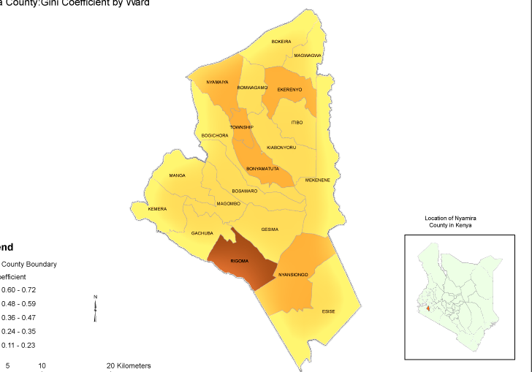

## 1.2 BACKGROUND INFORMATION

The department has two devolved functions: Sports and Culture and other concurrent functions; Gender, Youth and Social services [disabilities, women, children and etc.] with the core mandate of promoting social welfare among the people. In pursuit of this goal the department is guided by among other policy instruments, NYS Act No.6 of 2007, the Sports Act 2013, the Nyamira Alcohol Control Act 2014, disability act no 14 of 2003, children act 2022 and the Constitution of Kenya 2010.

**Mandate**

The Department of Gender, Youth, Sports, Culture & Social Services has been mandated to develop and empower the youth, promote sports, culture and also improve the provision of social welfare to venerable groups and mainstream gender and youth in all of its programmes.

# Sub-Sectors and their Mandates

# Sub sector of Culture

The mandate of the sub sector includes, approvals of persons for awards & honors as heroes & heroines, coordination of cultural activities (Heritage, exhibition, museums/cultural centers, concerts, art and related food competitions /festivals, development of creative cultural industries). Liquor licensing and control, establishment of treatment and rehabilitation facilities and programs, carrying out public education on alcoholic drinks and drug abuse in the county in collaboration with other stakeholders. Provision of library and archiving services, consultancy, advisory and information dissemination and development of film industry.

# Sub sector of Sports

The sports sub sector has the mandate of promotion and development of sports facilities and activities. In particular the sub sector develops sports stadia and play grounds. It also does talent search, research in sports and supports sports activities by providing sports equipment. The sub sector coordinates inter sectorial collaboration of programmes among stakeholder such as sports, art development and market sports as an industry in the County.

# Sub Sector of Youth Empowerment

The sub sector involves coordinating the youth empowerment issues across the county. In specific capacity building of youth countywide in collaboration with other stakeholders and establish youth desk in each sector.

**Sub sector of Gender Empowerment**

The sub sector involves Gender mainstreaming and empowerment of Women, Girls and Boys, establishment of gender desk in every sector to handle gender-based violence, child rescue Centre, rehabilitation centers, home for the Aged and related issues.

**Sub sector of Social Services**

The social services subsector involves empowerment of persons with disability, social protection to children, widows/widowers, women and older persons, interventions on various reliefs on vulnerable groups in the county.

To empower the youth and vulnerable groups, promote culture and sports, and protect children while mainstreaming gender parity for sustainable socio-economic development

## 1.3 RATIONALE FOR THE COUNTY SECTORAL PLAN

### **Legal Framework For Sector Plans**

The Constitution of Kenya, 2010 created a two-tier system of governance, the national and devolved governments that are distinct but interdependent, each with specific functions as set out in fourth schedule of the constitution. County governments are required to prepare the County sector plans to enable prioritization of socio-economic development issues at the local level.

Part XI of the County Governments Act, 2012 requires county governments to plan for the County. The Act requires that Counties prepare County plans including a ten-year County sector Plan. The Act prescribes that County plans should ensure harmony between National and County plans and that no government spending should be made outside the approved framework.

**Linkage Of Sector Plans With The Kenya Vision 2030**

Kenya’s Vision 2030 is an economic blueprint that seeks to create “a globally competitive and prosperous nation with a high quality of life by 2030”. The Vision aims to transform the country into a newly industrializing, middle-income country providing a high quality of life to all its citizens in a clean and secure environment. The Vision is anchored on three key pillars: economic; social; and political. Kenya Vision 2030 is implemented through successive five years Medium Term Plans (MTP) at the national level while the sector plans implement it at the county level

The sector plan has integrated and will implement the 17 Global Sustainable Development Goals (SDGs) as outlined in the UN 2030 Agenda for Sustainable Development. The Plan’s Implementation is also aligned towards achieving the Goals of the African Union Agenda 2063 which constitutes the strategic framework for socio-economic transformation of the continent in the next 50 years

## 1.4APPROACH/METHODOLOGY IN THE PREPARATION OF THE SECTOR PLAN

A concept note was issued regarding the preparation of the sector plans, then after a circular was circulated to departments by the budgeting and planning department to carry out public participation regarding the plan.

After that the county cabinet approved the concept note, the governor went ahead to launch the exercise.

As a constitutional requirement, and advert was gazetted to give the public information on the venue, dates and issues to be discussed during public participation.

Afterward, a five-day consultation exercise to operationalize the various sector working groups was held in Best Western hotel. This forum was meant to develop the sectoral plans. Several stakeholders allied to the sectors were invited for consultations. A template for the sectoral plans was the shared by the National Treasury Planning department invited to the meeting to provide technical backstopping. The technical working group for the sector alongside the stakeholder went working into group to develop the sectoral plan. Various stakeholders were represented including the technical teams from the county government comprising the CEC, CCO and County directors of the sector.

# CHAPTER TWO

# PERFORMANCE REVIEW OF THE PREVIOUS CIDP PERIOD

## 2.0 Introduction

This chapter provides a review on implementation of the previous CIDP 2018-22. It presents an analysis of county performance in terms of revenues, expenditures and key outcomes as well as the major challenges faced in the implementation of the plan, Emerging issues,Lessons Learn and development issues

## 2.1 Analysis of the sector Revenue Sources

This section should provide annual projected revenues versus actual receipts within the period under review. The information should be tabulated as in Table 11.

Table : Analysis of County Revenue Sources

|  |  |  |  |  |  |  |  |  |  |  |
| --- | --- | --- | --- | --- | --- | --- | --- | --- | --- | --- |
| **Revenue Sources** | **Revenue Projection (Ksh.)** | | | | | **Actual Revenue (Ksh.)** | | | | |
| **FY1 2018/2019** | **FY 2 2019/2020** | **FY3 2020/2021** | **FY 4 2021/2022** | **FY 5 2022/2023** | **FY1 2018/2019** | **FY2 2019/2020** | **FY3 2020/2021** | **FY4 2021/2022** | **FY5 2022/2023** |
| Equitable Share | 104,548,349 | 98,928,673 | 78,313,847 | 108,974,358 | 87,579,182 | 74,870,325 | 116,011,852 | 98,683,175 | 81,968,317 | 0 |
| Own Source Revenue | 29,985,700 | 20,985,405 | 20,985,405 | 2,035,020 | 10,036,711 | 3,485,120 | 1,369,000 | 1,421,000 | 659,600 | 0 |
| **Total** | **134,534,049** | **119,914,078** | **99,299,252** | **111,009,378** | **97,615,893** | **78,355,445** | **117,380,852** | **100,104,175** | **82,627,917** | **0** |

***Graph 1*** : Analysis of County Revenue Sources

## 2.2 County Budget Expenditure Analysis

This section should provide an analysis of total budget allocation and total actual expenditure by sector. The information should be summarized as in Table 12.

Table County Expenditure Analysis

|  |  |  |  |  |  |
| --- | --- | --- | --- | --- | --- |
| **F/Y** | **Total Budget** | **Total Actual** | **Variance** | **Absorption** | **Remarks** |
| **Allocation (Ksh in millions)** | **Expenditure (Ksh in millions)** | **rate (%)** |
| 2018/2019 | 134,534,049 | 78,355,445 | -56,178,604 | 58.2 | Delayed disbursement |
| 2019/2020 | 119,914,078 | 117,380,852 | -2,533,226 | 97.9 |  |
| 2020/2021 | 99,299,252 | 100,104,175 | 804,923 | 100.8 |  |
| 2021/2022 | 111,009,378 | 82,627,917 | -28,381,461 | 74.4 | Delayed disbursement |
| 2022/2023 | 97,615,893 |  |  |  |  |
| Total | **562,372,650** | **378,468,389** | **86,288,368** | **331.3** |  |

*Provide a brief discussion on budget implementation performance based on variance between actual allocations versus actual expenditures (absorption rates by each sector).*

## 2.3 Sector Programmes’ Performance Review

***Social protection, culture and recreation sector***

**General Administration and Policy Planning**

*In the plan period, the general administration and policy planning targeted to* enhance institutional efficiency and effectiveness in implementation and service delivery and adherence to set up legalframework *through 10* trainings and capacity building sessions for staffs and other Stakeholders, 15 bills, policies and plans preparation, Strategic Plans preparation, annual budgets preparation, holding 100 Meetings and Workshops for staff members and remunerating 52 staffs

**Cultural Development & Promotion**

In the plan period, the cultural development and promotion targeted to appreciate and promote cultural expression and heritage through establishment of County choir, band and troupes and purchase of 15 cultural equipment. To increase safety in alcohol consumption through licensing 800 outlets selling alcohol, empowering vulnerable groups across the county through mapping of 10 plwds in 10 wards, supporting 1000 plwds and holding of 5 plwds cerebrations. To Promote and develop a reading culture through construction of a library and to control Betting, lotteries and gaming by reducing 70,000 persons participating in betting, lottery and gaming

**Promotion And Management of Sports**

In the plan period, the promotion and management of sports targeted to to promote and develop sports talent through identifying, mentoring and nurturing of 171 talents, purchase of 36 sports equipment, 2 benchmarking visits, rewarding of 500 sports disciplines/men and women, holding of 50 sports activities/tournaments, participating of 10 sports activities outside the county, establishment of 10 county staff sports teams, mainstreaming of 2 PLWDs categories in sports activities, 2 gender mainstreamed in sports activities, construction of talent academy and development of Stadia

**Gender Equity And Empowerment Of Women**

In the plan period, the gender equity and empowerment of women targeted topromote gender equity and equality through holding of 56 gender mainstreaming sensitisations, reactivating of 3 County Gender Technical Working Group (GTWG), training of 5 Area Gender Technical Working Groups (GTWG), 90 women fora on existing funds and programmes targeting them e.g. NGAAF,AGPO,YEDF,UWEZO, forming of 2000 groups and holding of 100 sensitization fora on saving culture and entrepreneurship

**Children Development Protection And Participation**

In the plan period, the children development protection and participation targeted to strengthen child welfare, protection structures and system through establishment of child advisory committees previously known as AACs, recruitment of 42 VCOs, creation of child rights awareness and support of 295 children by presidential secondary school bursaries(pssb)

## 2.4 Challenges

1. Lack of policy framework
2. Inadequate staff and other resources
3. Poor monitoring and evaluation
4. The existing youth centres can’t be used
5. Weak coordination and linkage mechanism.
6. Only a handful of youth get to attend
7. Few groups making repayments

## 2.5 Emerging issues

1. Delayed / Inadequate funding
2. Covid-19 pandemic
3. Gender and PWD mainstreaming
4. Youth involvement.
5. Non operationalization of the youth empowerment centres
6. Non responsive youth in attending meetings not funded

## 2.6 Lessons Learnt

1. Monitoring and evaluation is key
2. Proper planning and engagement of key stakeholders at all stages
3. Proper utilization of human and non-human resources.
4. Provision of adequate equipment and facilities
5. Provision of financial facilitation for programs and activities
6. Establishments of a legal framework for defaulters follow up

## 2.7 Development Issues

This section should present key sector development issues and their causes as identified during data collection and analysis stage. The information should be provided as indicated in Table 14.

Table : Sector Development issues

|  |  |  |  |  |  |
| --- | --- | --- | --- | --- | --- |
| **Development issues** | **Root Causes** | **Development Objective** | **Immediate Objective** | **Existing opportunities/ strengths within the sector** | **Strategies** |
| **National council for persons with disabilities(ncpwd)** | | | | | |
| Low level of inclusion of persons with disabilities | -Low awareness on the rights of persons with disabilities  -Stigma and negative attitude towards persons with disabilities  -cultural beliefs and practises  -inadequate staff  -lack of county specific action plan for persons with disabilities for harmful practises such as isolation and hiding  -inaccessible building and environment  -Lack of sign language interpreters in most government ministries and MDAs  -inaccessible IEC materials | Disability mainstreaming and sensitization programs | -Increase awareness on the rights of persons with disabilities  Adequate staff  -Initiate county specific plan of action for pwds  Positive Cultural practices  -Modify buildings and environment to accommodate persons with disabilities  -employment of sign language interpreters within the county | -Existing laws, policies and regulations  -Existence of partners | -Sensitization campaigns on the rights of persons with disabilities  -Mainstreaming training and audit to government ministries and MDAs  -Enforcement of relevant laws, policies and regulations on pwds  -Recruit staff ie sign language interpretors  -develop county specific plan of action for pwds  -Sensitization campaigns against harmful practices |
| Inadequate data for persons with disabilities | -Stigma and negative attitude  -Cultural beliefs and practises  - -Unacceptance  -Mobility challenges  -assessment only done at NCRH  Inadequate assessment team | Registration of persons with disabilities with NCPWD | Increased awareness on importance of registration and data of PWDs  Increase awareness on disability for the community to appreciate disability | some data at NCPWD | Devolve Assessment facility to sub county hospital  -free assessment and any other health services to PWDs  -sensitization campaign on disability  Employ assessment team  Conduct mass registration at the locational level |
| Inadequate support to persons with albinism | Stigma and negative attitude  Cultural beliefs and practises | Awareness creation on PWAs  Enhance PWA programs | Increased awareness level  Increased number of PWAs collecting sunscreen lotions | Some programs at NCPWD | Sensitization campaign |
| ,Inadequate provision of economic empowerment and scholarship to persons with disabilities | lack of county PWDs act, policy and regulation  -poor coordination and linkage networks | Provision of safety net programs for persons with disabilities | Development of persons with disability act, policy and regulation  -strengthen coordination and linkage mechanisms and multisectoral collaboration | Cash transfer for persons with severe disabilities  Existence of NCPWD bursaries and social protection services | -establishment of complimentary programmes for PWSD , -scholarship  and bursaries  -implimentation of relevant laws, policies and regulations  -operationalize county PWDs act and policies |
| Inadequate provision of assistive devices | -lack of county PWDs act, policy and regulation  -poor coordination and linkage networks | Adequate provision of assistive devices | -Development of persons with disability act, policy and regulation  -strengthen coordination and linkage mechanisms | -provision of assistive device by the NCPWD  Existence of partners | -procure various assistive devices and issuance to beneficiaries  -Enforcement of relevant laws, policies and regulations  -operationalize PWDs act and policies |
| **Sports Development** | | | | | |
| Poor performance /standards in sports | Inadequate sports facilities.  Inadequate sports equipment.  Low awareness on the socio-economic importance of sports.  Inadequate talent identification and nurturing  Inadequate number of trained sports personnel  Weak sports management skills.  Lack of diversification in sports disciplines.  Inadequate sport clubs. | Improve  performance /standards in sports | To increase sports facilities.  To provide adequate sports equipment.  Increased awareness on the economic importance of sports.  Enhanced talent identification and nurturing activities.  To increase number of trained sports personnel.  Strengthen sports management skills.  Diversified sports disciplines  To encourage formation of Sports Clubs. | Existing laws, policies and regulations at national level.  Existence of a pool talents and role models.  Existence of some sports facilities.  Existence of some sports equipment.  Existence of partners such as sports federations/associations and sponsors. | Establish and equip talent centres /academies.  Establish and equip sports facilities (Build stadia and playing grounds) at grass root levels.  Develop laws, policies and regulations at county level.  Train sports personnel by building capacity for coaches, referees and federation officials within the county  Mentor and nurture talents.  Benchmarking by sports personnel.  Capacity building of sports personnel.  Develop a reward and motivation system.  Create awareness on the existence and importance of other or emerging sports disciplines ( tennis, basketball, rugby sports for PWDs etc)  Organize annual sports and events week.  Organize county leagues for various disciplines in conjunction with various sports federations in the county level  Support and nurture young talents through funding of various leagues  Equip and support various sport clubs.  Establishment of a high altitude training centres  Adapt an international standard approach in developing talents i.e by adapting statutes of international sports policies  Restructure and support the existing talent centres to meet the needs of the existing sports federations  Federations to prepare a consolidated sports calender for adoption by the county government  Federations to be involved in equipping and developing talent centres  Support and facilitate the annual budget for federations in the running of structured leagues[sub county, county and regional leagues] |
| **Gender Development** | | | | | |
| Low levels of Gender mainstreaming | Low awareness on gender mainstreaming  Weak coordination and linkages among partners  Area Gender Technical Working Groups (GTWG) not fully functional  Inadequate training Gender Technical Working Groups (GTWG )  Weak Monitoring and evaluation of programmes  Inadequate of office Space  Low uptake of affirmative services  Inadequate staff  Low income among women and women with disabilities | High levels of Gender mainstreaming | increased awareness on gender mainstreaming  strengthen coordination and linkages among partners  fully devolve Area Gender Technical Working Groups (GTWG) in the county  Adequate training Gender Technical Working Groups (GTWG )  Strengthen Monitoring and evaluation of programmes  adequate of office Space  High uptake of affirmative services  Adequate staff  Increase opportunities for income generation | Existing laws, policies and regulations  Area Gender Technical Working Groups (GTWG) at county level  Existence of partners  Gender Desks at Nyamira Huduma Centre and Nyamira Police Stations | Sensitization campaigns on Gender mainstreaming  Launch Area Gender Technical Working Groups (GTWG) at county level and ward level  Construct offices at sub county levels  Train Area Gender Technical Working Groups (GTWG) at all levels  Initiate Gender Protection Information Management System (GDIMS)  Enforcement of relevant laws, policies and regulations  Establishment of gender recovery centre/protection/ rescue centre Nyamira County  Increase Women empowerment- through provision of soft loans/grants to women groups. County wide  Recruit staff  Utilization of other micro finance organizations and development partners  Train of income generating strategies |
| Negative cultural practices | Increased female Genital Mutilation  Medicalization of FGM  Low reporting and witnessing of FGM cases | Positive cultural practices | Decreased female Genital Mutilation  DE medicalization of FGM  High reporting and witnessing of FGM cases | Existing laws, policies and regulations  Area Gender Technical Working Groups (GTWG) at county level  Existence of partners  Gender Desks at Nyamira Huduma Centre and Nyamira Police Stations  Anti FGM Board at national level | Sensitization campaigns on Gender mainstreaming  Launch Area Gender Technical Working Groups (GTWG) at county level and ward level  Initiate Gender Protection Information Management System (GDIMS)  Establishment of gender recovery centre/protection Nyamira County HQs  Anti FGM Board be devolved to county level |
| High rate of defaulters on affirmative loans/fund eg UWEZO, WEF, YEDF | Weak monitoring, reporting evaluation framework.  Political interference.  Inadequate sensitization/awareness on the need to repay.  Low financial literacy on most groups, youth and women | To reduce the rate of defaulters on affirmative loans/funds. | Increase the awareness on the importance of loan uptake.  Increase awareness on financial literacy.  Establish a legal framework policy on loan repayment. | Availability of various government affirmative funds eg UWEZO, NGAAF, AGPO, BDYD and grants/donors. | Increasing funding from government and other multi- national partners.  The county government to establish gender affirmative funds. |
| Lack of county policies on gender, PWD, affirmative funds | Some functions are not fully devolved to the counties eg gender, children, PWD, women, youth.  Duplication of functions. | Formulate/customize county gender policies | Sensitization of various stakeholders on the importance of formulating gender policies | Existing national gender policies  Availability of multi-sectoral public private partnership (PPP), NGOs and international supporters | Customize national policies to county  Identification of partners to support development of various gender policies. |
| Lack of Gender Based Violence Recovery Centres | No policy frameworks  Low budgetary allocation | Establish GBV recovery centres | Sensitization of the stake holders on the need to establish GBVRC.  Allocation of funds | The stake holders and current Governor’s manifesto | Identification of partners, state and non-state partners( NGAAF, county government and NGAO |
| Lack of GBV safe space/homes | No policy frameworks  Low budgetary allocation | Establish GBV spaces/ homes | Sensitization of the stake holders on the need to establish GBVRC.  Allocation of funds | The stake holders and current Governor’s manifesto | Identification of partners, state and non-state partners( NGAAF, county government and NGAO |
| Triple threat (HIV/AIDS, teenage pregnancy and GBV) | Increased drug use  Lack of advocacy  Harmful cultural, religious brliefs and practices | To end the causes of triple threats | Sensitization and mobilization of resources  Increase collaborationand multi-sectoral approach | Existing government bodies eg NACC, NGAO, ministry of health and partners( NGOs , CBOs) | Increase collaboration and multi-sectoral approach, GTWG and policies such as children/;’[-n’s act |
| Inadequate gender statistics | Inadequate mapping, coordination and planning on gender statistics | Increase accessibility of gender statistics of the county | Increase advocacy and awareness on the need for gender ststistics | Availability of gender desk officers, NCPD, Gender data Kenya | Advocacy and collaboration with stake holders  Awareness creation |
| **Cultural Development** | | | | | |
| Low appreciation of cultural heritage | Negative globalization  Negative urbanization  Negative modernization  Negative imitation of foreign cultures  Low regard of culture as a source of economic livelihood.  Local cultures are seen as no longer fashionable  Low information about the value of our cultures.  Loss of our tangible and intangible cultural expressions.  Lack of active cultural groups such as county choir and band and council of elders | High appreciation of cultural heritage | Positive globalization  Positive urbanization  Positive modernization  Positive imitation of foreign cultures  High regard of culture as a source of economic livelihood.  Local cultures are seen fashionable.  High information about the value of our cultures.  Gain of our tangible and intangible cultural expressions.  Enough active cultural groups such as county choir and band and elders | Existence of various cultural groups  Museum structure at manga  Existence of artifacts  Existence of oral traditions | Construction of a social hall in every sub county.  Establishment of cultural centres Keroka, Nyamaiya & Nyamira  Establishment of botanical garden at county headquarters  Restoration of traditional caves at manga sub county  Celebration of annual cultural and sports festivals  Collection and preservation of artefacts  Equip the museum structure at manga  Refurbish the museum structure at manga  Documentation of oral traditions  Initiate a county choir and band and elders  Development of Nyamira film industries/studios {to document and showcase culture as an industry for employment for the youth} |
| Poor reading culture | Inadequate reading facilities.  Inadequate awareness on the importance of continuous reading.  Inadequate institutions to influence reading culture e.g. universities and collages | Enhanced reading culture | Adequate reading facilities.  Adequate awareness on the importance of continuous reading.  Adequate institutions to influence reading culture e.g. Universities and collages | Existence of functioning library on a rented premises in Nyamira county HQs  Willing and ready clients to use the facilities | Construction of one library per sub county  Create awareness on the importance of continuous reading county wide  Lobby for institutions to donate books to libraries in Nyamira county  Make the existing library to be user friendly. |
| Uncontrolled Betting , lotteries and gaming | Inadequate relevant laws, policies and regulations  Inadequate enforcement of relevant laws, policies and regulations  Inadequate staff | Controlled Betting , lotteries and gaming | Adequate of relevant laws, policies and regulations  Adequate enforcement of relevant laws, policies and regulations  Adequate staff | Existence of relevant laws, policies and regulations at national level  Proper enforcement of relevant laws, policies and regulations  Staff  Unregulated Betting, lotteries and gaming at county level. | Develop county specific laws, policies and regulations  Conduct campaigns to sensitize the public on the negatives of addition to betting and gaming |
| Uncontrolled alcohol consumption, drugs and substance abuse | Inadequate relevant laws, policies and regulations  Inadequate enforcement of relevant laws, policies and regulations  Inadequate staff | Controlled alcohol consumption, drugs and substance abuse |  | Existence of relevant laws, policies and regulations at national level  Existence of Nyamira County Alcohol consumption and control, and substance abuse act 2014  Proper enforcement of relevant laws, policies and regulations  Staff | Enforcement of relevant laws, policies and regulations at national level  Review of Nyamira County Alcohol consumption and control, and substance abuse act 2014  Proper enforcement of relevant laws, policies and regulations  Recruit staff  Establish at least one rehabilitation centre.  Conduct campaigns to sensitize the public on the dangers of addition and abuse of alcohol, and substance abuse. |
| **Social Development and Services** | | | | | |
| Inadequate community participation in socio-economic activities | Inactive/disintegrated community groups e.g. Women groups, Youth groups, Self Help Groups, Men groups and CBOs | Enhanced community participation in socio-economic activities | Vibrant and operational community groups actively participating in socio-economic activities such as Village Savings and Loan Associations (VSLAs) | Existing registered community groups  Existence of Affirmative Actions Funds such as YEDF, WEF, Uwezo Funds  Existence of Micro-Finance Institutions  Established and operational Sub-County Offices  Existence of Community Group Registration Act 2022 | Mobilize and sensitize community members on the importance of group formation  Registration of community groups in accordance with Community Group Registration Act 2022  Establish and capacity build County and Sub-County Social Development Committees (SDCs) as guided by the Act  Capacity building of community groups on resource mobilization  Link community groups to MFIs, State and other Non-State actors |
| Community exposure to unintended negative adverse effects of social risks in development projects | Inadequate knowledge on the negative effects of social risks in development projects | Local communities protected from unintended negative adverse effects of social risks on development projects | Sensitize County Government officials and Multisectoral Committees on SRM  Establish County Social Risk and Management Committee | Existence of SRM principles  Existence of Financing Locally Led Climate Action (FFLoCA) Programme | Engage National Government and other non-state actors on the formation and training of County Social Risk and Management Committee  Address complaints and grievances from community members affected by development projects in the County |
| Violation of the rights of older persons | Weak kinship and inadequate/limited natural resources e.g. land | Rights of older persons protected  Strengthened partnership on the implementation of older persons and ageing programmes | Establish one Older Persons Rescue Centre in the County (Home for the Aged) | Existence of the National Standards and Guidelines on the Establishment and Management of Institutions of the Older Persons | Develop County Policy Brief on issues affecting older persons and Ageing  Hold consultative engagement forums on intergenerational solidarity  Engage State and Non-State actors on addressing issuing affecting older persons and ageing  Organize and participate in observance of the UN day on Older Persons (UN IDOP) |
| Disintegrated families | Weak family care support systems | Strengthened family care and support systems | Training of Trainer of Trainers (ToTs) on National Parenting and Training Programme  Formation of County Multi-Sectoral Technical Working Group on the Implementation of National Parenting Programme | Existence of pilot National Parenting Training Manual (NPTP)  Existence of non-state actors (stakeholders) | Identify and train County Trainer of Trainers (ToTs) on National Parenting Programme (NPP)  Train Lay Volunteer Counsellors (LVCs) as facilitators on the National Parenting Training Manual (NPTP)  Train parents/caregivers (including parents and caregivers of persons with disabilities) on NPP |
| Social Protection | | | | | |
| Improper utilization of stipends received by the vulnerable members of the community (cash transfer beneficiaries and caregivers) | High level of poverty among the vulnerable members of the community (older persons, persons with disabilities and Orphans & vulnerable children) | Improved economic livelihood standards amongst the vulnerable members in the community | Financial literacy among cash transfer program beneficiaries | Existence of National Safety Net Program (OPCT, PWSDCT and CT-OVC) | Capacity building of all cash transfer beneficiaries and caregivers on financial literacy  Mobilization of beneficiaries and caregivers in cash transfer program to ensure 100% utilization of the stipend  Link and work with nyumba kumi, village elders and beneficially welfare committee |
| **Children Development** | | | | | |
| Weak child protection systems | Low awareness on child rights.  Weak coordination and linkages among partners  Inadequate training of Children Advisory Committees  Weak Monitoring and evaluation of programmes  Weak Child Protection Volunteer System  Inadequate data for child protection  Inadequate staff  Lack of child rescue centre  Harmful Cultural practices e.g. Rampant FGM  Lack of County Policy on Child Welfare | strengthen child protection system in the county | Increased awareness on child rights.  Strengthen coordination and linkages among partners  Adequate training of Children Advisory Committees  Strong Monitoring and evaluation system developed  strengthen Child Protection Volunteers System  adequate data for child protection  Adequate staff  Establish child rescue centre  Develop and launch County Child Policy  Positive Cultural practices e.g. reduced FGM | Existing laws, policies and regulations  Children Advisory Committee (CAC) already existing at county and sub county level  Existence of partners  Children Desks at Nyamira Police Stations | Sensitization campaigns on child rights  Establishment of children assembly from ward level  Train CACs at all levels  Improve Child Protection Information Management System (CPIMS) usage and data sharing  Enforcement of relevant laws, policies and regulations  Recruit staff  Build county child rescue centre  Develop, launch and implement a County Child Policy  Sensitization campaigns against harmful cultural practices  Coordinate County stakeholder meetings |
| Inadequate care of orphans and vulnerable children | Increase in HIV/AIDs  Breakdown in family care system  Illiteracy levels  Increase in orphan hood  High levels of poverty  Disinheritance of OVCs (Orphans and Vulnerable Children) and widows  Few resources to support child welfare programs  Poor coordination of partnerships to support the most vulnerable OVC | Adequate care of orphans and vulnerable children | Decrease in HIV/AIDs  Strengthen in family care system  Increase levels literacy levels  Decrease in orphan hood  Low levels of poverty  Discourage disinheritance of OVCs and widows  Increased funding for children welfare programs  Improved coordination of partnerships for supporting OVC | Cash Transfer for Orphans and Vulnerable Child Programme(CT OVC)  Existence of bursaries e.g. Presidential Secondary Schools Bursary  Existence of partners | Promote family based care for all children  Establishment of complimentary programme of CT OVC  Scale up and bursaries  Enforcement of relevant laws, policies and regulations  Provide parenting training to caregivers  Community awareness programs to promote care for children  Advocacy and lobbying of partnerships to support vulnerable households  Advocacy to improve county funding for children welfare programs  Conduct parenting training sessions |
| **Youth Development** | | | | | |
| High levels of Youth Unemployment | Lack of awareness on Affirmative Action  Programmes.  Low uptake of Affirmative Action Funds.  Low rates of loan repayment on Affirmative Action Funds.  Non-existent Youth Fund at the county level.  Inadequate Youth Sector Working Group on Youth Unemployment.  Non operational  Community Youth SACCOs.  Inadequate talent identification and innovation harnessing.  Poor Linkages between talented youth and innovators to relevant stakeholders for mentorship/ skills transfer/Incubation/Technical support /Financial support/ markets networks.  Inadequate youth talent and innovation documentary.  Limited involvement of youth in Brand Kenya Active campaign.  Non existent a Youth Development Policy.  Limited awareness on Youth Development Policy.  Non existent Youth Sector Working Group.  Non existent Youth Development Index.  Lack of internship.  Emphasis on white collar jobs in relation to technical jobs.  A slow growing economy.  An economy not responding to the needs of the population.  A Subsistence economy.  High levels of corruption.  Unguided career choices.  Unpredictable climatic changes.  Adaption of new technology without retraining and retooling.  Inadequate office Space.  Non existent county specific plan of action for youth.  Inadequate data of youth engaged in agriculture towards the realization of the Big 4 Angenda. | To promote youth talent, innovation and entrepreneurship development through Promotion of skills development and job creation for the youth. | To increase awareness on Affirmative Action  Programmes.  To improve uptake of Affirmative Action Funds.  To enhance loan repayment on Affirmative Action Funds.  To enhance youth access to capital for business creation.  Create Youth Sector Working Group on Youth Unemployment.  To enhance operationalization of  Community Youth SACCOs.  Enhanced talent identification and nurturing activities.  To enhance the creation of a youth talent and innovation documentary.  Enhanced Youth involvement in Brand Kenya Active campaign to enhance employability.  To establish a youth development policy.  Enhanced awareness on Youth Development Policy.  To activate creation of a Youth Sector Working Group.  To provide a Youth Development Index.  To enhance work experience.  To encourage youth to acquire technical skills.  To promote economic growth.  To enhance a responsive economy.  Promote career guidance.  Encourage youth training in technology.  To provide Inadequate office Space.  Initiate county specific plan of action for youth.  Enhance adequate data on youth engaged in agriculture towards the realization of the Big 4 Angenda. | Existence of relevant laws, policies and regulations at national level  Existence of the national government affirmative programmes.  Existence of a pool talents, innovators and role models.  Existence of partners and other stakeholders. | Hold sensitization Fora/clinics on Affirmative Action Funds. (AGPO, UWEZO, YEDF, WEF, NGAAF).  Fund more youth groups.  Create a legal framework for follow-up of loan defaulters.  To create a youth development fund at the county level.  Constitute a Youth Sector Working Group on Youth Unemployment.  Operationalization of  Community Youth SACCOs.  Hold talent Auditions and innovation contests to harness youth talent and innovation.  Link the harnessed (identified) youth talent and innovations to relevant stakeholders for mentorship/ skills transfer/Incubation/Technical support /Financial support/ markets networks.  Develop a youth talent and innovation documentary.  Mobilize and engage youth in Brand Kenya Active campaign.  Enactment of a Youth Policy, Bill and Act.  Awareness creation on the Youth Policy.  Establish youth sector working groups.  Hold implementation forums on Youth development Policy.  Establish a Youth Development Index technical working group.  Hold a retreat to develop a county Youth Development Index framework.  Analysis of data, report writing and printing.  Benchmarking by Youth Development Officers.  Provide internship opportunities.  Sensitization on the importance of technical skills.  Mobilize youth to join TVETs.  Multi sectoral collaborations towards an Industrialized economy.  Sensitization programmes and activities on corruption.  Hold Career guidance fora..  Train youth in new technologies.  Construct and renovate offices.  Develop county specific plan of action for youth.  Identification of youth engaged in agriculture. |
| High levels of Drugs and Substance abuse and Radicalization. | Cheap and readily available drugs and substances.  Idleness.  Peer Pressure.  Depression. | To promote a sober youthful population for community development | To enhance reduction of the level of Drugs and Substance abuse and Radicalization. | Existence of relevant laws, policies and regulations at national level  Existence of the national government affirmative programmes.  Existence of partners and other stakeholders. | Sensitization on drugs and substance abuse and negative cultural practices (FGM) and Radicalization. |
| Non- Interested Youth in Social and Sustainable Community Development | Inadequate youth leadership and life skills.  Limited involvement of youth in decision making.  Few mentored youth on National values.  Limited involvement of youth in peace building and conflict resolution.  Lack of a training manual on youth mentorship & Coaching. | To promote, support & mobilize youth in Youth social development | To enhance youth leadership skills.  To improve youth involvement in decision making.  To Enhance youth mentorship on National values.  Enhance the development of a training manual on youth mentorship & Coaching.  Enhanced awareness on environmental conservation. | Existence of relevant laws, policies and regulations at national level  Existence of the national government affirmative programmes.  Existence of partners and other stakeholders. | Training Youth in Leadership and life skills.  Map and Engage youth partners in Decision making.  Train Youth on mentorship and Sensitize on National values.  Engage Youth in peace building through youth exchange programmes and activities.  Carry out a baseline survey to collect data on youth mentorship programs from the youth on the ground.  Design and Develop a training manual on youth mentorship & Coaching.  Sensitization on environmental conservation.  Tree planting exercises. |
| Un Operational and Stalled  And Lack of Youth Empowerment Centres | Inadequate facilities.  Inadequate equipment.  Untrained Youth empowerment centres management committees. | To enhance youth access to youth friendly services | To enhance existence and operationalization of Youth Empowerment Centres.  To enhance Youth empowerment centres management. | Existence of relevant laws, policies and regulations at national level  Existence of the national government affirmative programmes.  Existence of a pool talents, innovators and role models.  Existence of partners and other stakeholders.  Existence of some YECs. | Refurbishment and Equipping of Youth Empowerment Centres.  Provision of adequate facilities and equipment.  Operationalization of YECs.  Construction of new YECs.  Train Youth empowerment centres management committees. |
| Teenage pregnancies and high levels of HIV/AIDs infection among the youth | Tripple threads | To enhance youth access to youth friendly services. | To counter the triple threads. | Existence of relevant laws, policies and regulations at national level.  Existence of the national government affirmative programmes.  Existence of partners and other stakeholders. | Sensitization of youth on Sexual and Reproductive Health issues. |

### 

# CHAPTER 3

# SPARTIAL PLAN FRAMEWORK

## 3.0 INTRODUCTION

This section, describes the spatial framework within which development projects and programs will be implemented, establishing a broad physical and Land Use Planning framework that provides spatial planning policies to support economic and sectoral planning.

## 3.1 SPATIAL DEVELOPMENT FRAMEWORK

The County Government of Nyamira‘s transformative agenda is anchored on socio-economic transformation aimed at ensuring that the quality of life is improved throughout the County. This transformative agenda sets outs the blue print for economic growth that covers all strategic development areas within the County. This vision can only be achieved if the development is anchored in sound GIS based Physical and Land Use Planning. As such, the Vision lays emphasis on spatial reforms, with the preparation of the County Spatial Plan and various areas Local Physical Development Plans.

The role of Land use planning and indeed the CSPs is explicitly outlined in the Constitution of Kenya Article 61 and 66, further County Government Act of 2012 which under section 110 (1)(a) stipulates that the County Spatial plans shall give effect to the principles and objects of planning and development contained in section 102 and 103 of the same Act. It also outlines that the CSPs should set out the guidelines for a land use management system in the County.

As espoused in the Physical and Land Use Planning Act of 2019, the preparation and implementation of the CSP will set the momentum for prudent utilization of County space, resources and inter-ministerial coordination. Further, the plan will facilitate the achievement of the land policy principles of efficiency, equity, sustainability and productivity, and promote the attainment of social, economic and environmental goals and objectives. Further, the Plan provides strategies and policies to deal with challenges including urbanization, regional imbalances/inequalities, rural under-development, environmental degradation, and underutilization of the massive resources available in the country.

The policy framework that the preparation of the CSP alludes to include; Sustainable Development Goals, New Urban Agenda, The Kenya Vision 2030, Medium Term Plans, Urban Land Use Planning and Oversight guidelines, national land use policy, national urban development policy, national spatial plan among others.

## 3.2 STATUS OF COUNTY PHYSICAL AND LAND USE PLANNING STATUS

Since the enactment of the Physical and Land Use Planning Act and establishment of the Nyamira Municipality, through the Planning authority, the Physical and Land Use Directorate, the County has prepared Nyamira Municipality Spatial plan to preparation of the final report, subject to the County Executive Committee Members ratification, County assembly approval to the eventual ascent by H.E the County Governor of Nyamira. Alongsie the MSP, the Planning Authority have prepared 9 Local and Physical Development Plans for major urban centers within Nyamira Municipality. The towns include, Nyamaiya, Miruka, Kioge, Nyamira Township, Sironga, Konate, Kebirigo, Ting’a and Nyaramba.

It shall be noted that the county has more than 70 upcoming urban centers with either have outdated plans or no plans and notably require urgent planning intervention to ensure coordinated development and appropriate sustainable investment for the prosperity of the people of Nyamira. This shall be given priority at the completion of the CSP strategic urban areas spatial and institutional development for wealth creation. The County Spatial Plan 2022-2032, after completion of the Inception Report, The situational Analysis Report, is at its third stage of Draft Plan Formulation before preparation of the Final Plan report for approval consideration stage.

## 3.3 COUNTY RESOURCE POTENTIAL GROWTH AREAS.

The CSP of the Situational Analysis of the economic systems is prudent for the understanding of human interactions, growth and development of an area. Kenya’s Vision 2030 is founded on the economic, social and political pillars. Being one of the pillars identified to guide the national agenda, the economy is therefore integral to any region’s growth and development. Accordingly, Nyamira County has a rich economic base founded on agriculture, mining, tourism and hospitality, agro-based industries as well as trade and commerce. The forgoing shall transform the County wealth and economy through focus on specific thematic identified and highlighted hereunder for modelling.

### 3.3.1 Physiographic Characteristics

Physical features play a critical role in the county development. Some of the features like rivers, wetlands, forests/hills and water falls are sources of livelihoods to the county residents. The county physiographic characteristics present both opportunities and challenges as outlined below:

Figure **. Natural Features**

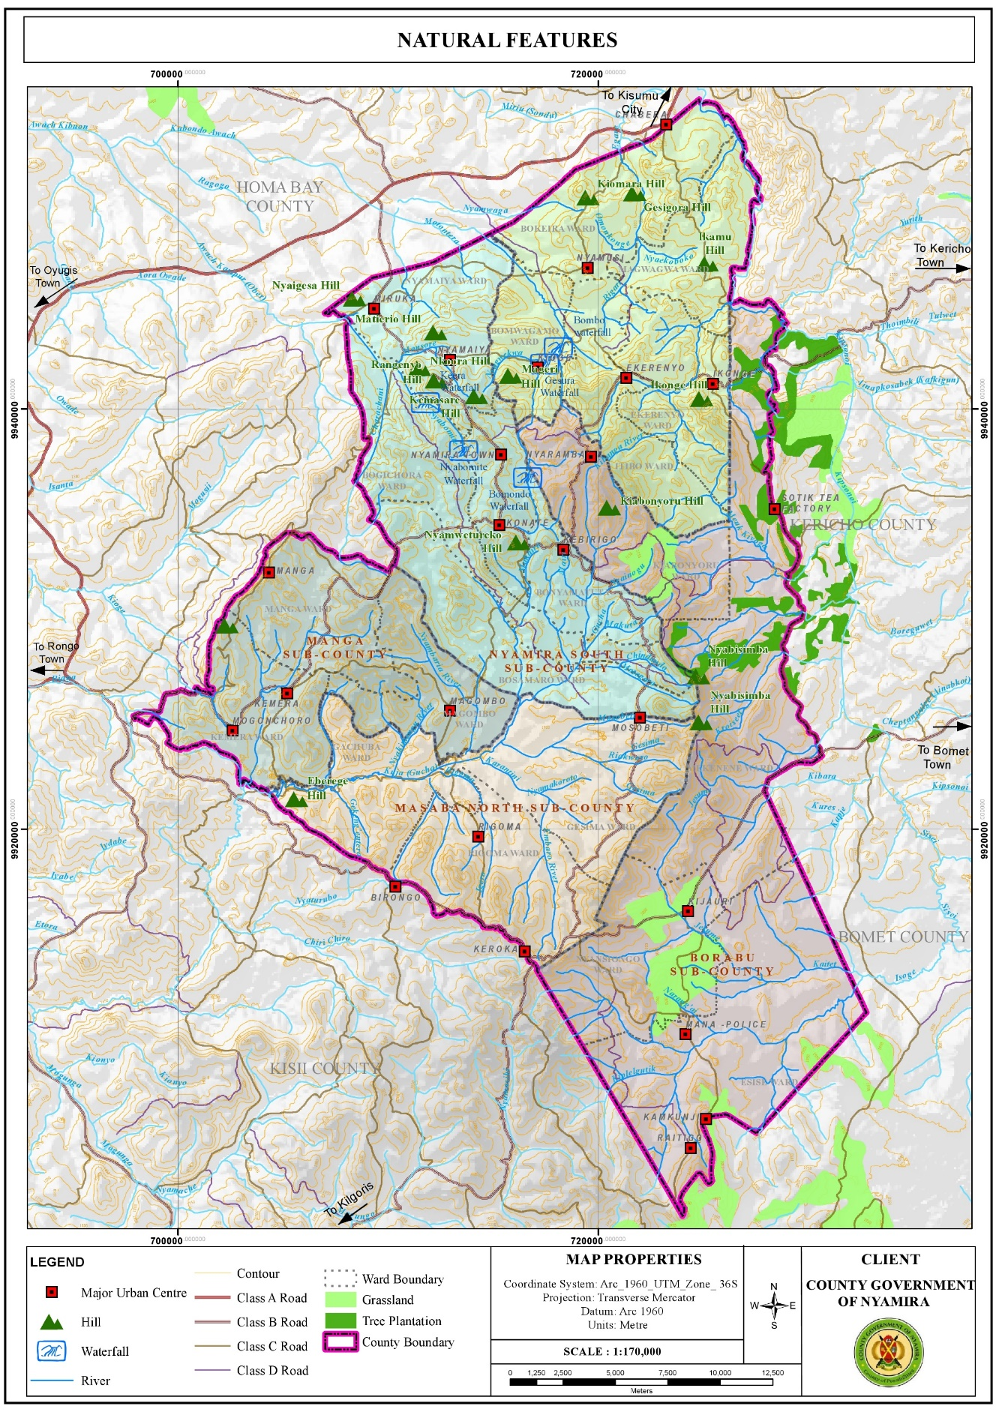

#### 3.3.1.1 Opportunities

1. Hydrology: The County is adequately drained by the four main rivers and their tributaries. There are also several springs, wetlands and few water falls which sustain the county’s hydrological cycle. In addition, the high-water tables in the county have enabled the digging of shallow wells and boreholes. These water resources are the main water sources in the county, for instance, the intake for Nyamira water supply is located at River Eaka. River Sondu on the other hand has a lot of potential for hydro-electricity power generation which if tapped could contribute greatly towards the economic development of the county. The presence of numerous rivers presents opportunities for water harnessing through river obstruction.
2. Favorable Climatic Conditions for Agricultural Activities: The county has a bimodal pattern of annual rainfall that is well distributed, reliable and adequate for a wide range of crops with annual rainfall ranging between 1200 mm – 2100 mm per annum. The cold temperatures in the county are ideal for the growth of certain crops like tea and coffee which grow better in relatively cold regions.
3. Suitable Ecological Zones and Fertile Volcanic Soils for Agricultural Activities: The county is divided into two major agro-ecological zones. The highland zone (LH1 and LH2) covers 82 per cent of the County while the upper midland zone (UM1, UM2 and UM3) covers the remaining 18 per cent. These zones are suitable for growing various crops among them; tea, coffee, bananas, maize, avocado, sugarcane, pineapple, sweet potato, pyrethrum etc. These suitable ecological zones coupled by the rich volcanic soils make the county one of the main food producers in the country exporting food commodities to the regional hinterland and the country’s capital. However, the economic viability of the agricultural sector is threatened by the diminishing land sizes resulting from unregulated subdivision mainly for inheritance purposes.

Figure **. Agro-Ecological Zones**

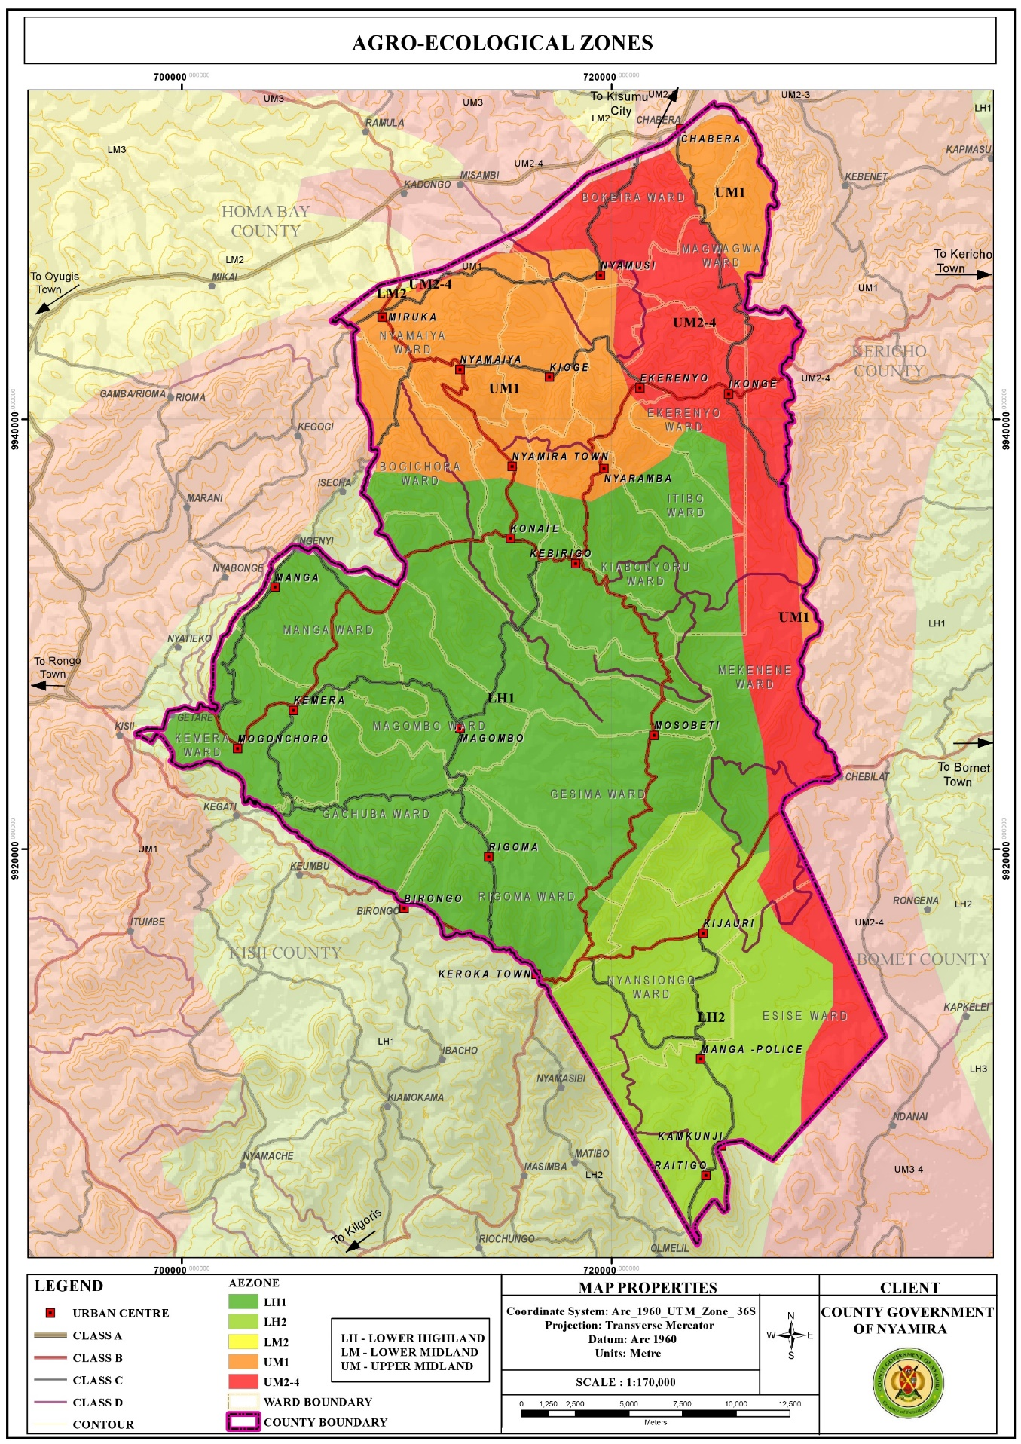

1. High Rainfall Amounts: The high rainfall patterns of between 1200 mm – 2100 mm per annum present opportunities for rain water harvesting through creation of large-scale runoff collection reservoirs and household rainwater harvesting. The harnessed water would be used during the relatively dry seasons of the year. If the harnessing is optimally undertaken, it would augment the terrain problems associated with piped water provision. Moreover, the rain water would reduce pressure on the natural water resources like springs, streams, rivers and wells which together supply water to about 80% of the population.

Figure **. Rainfall Distribution Map**

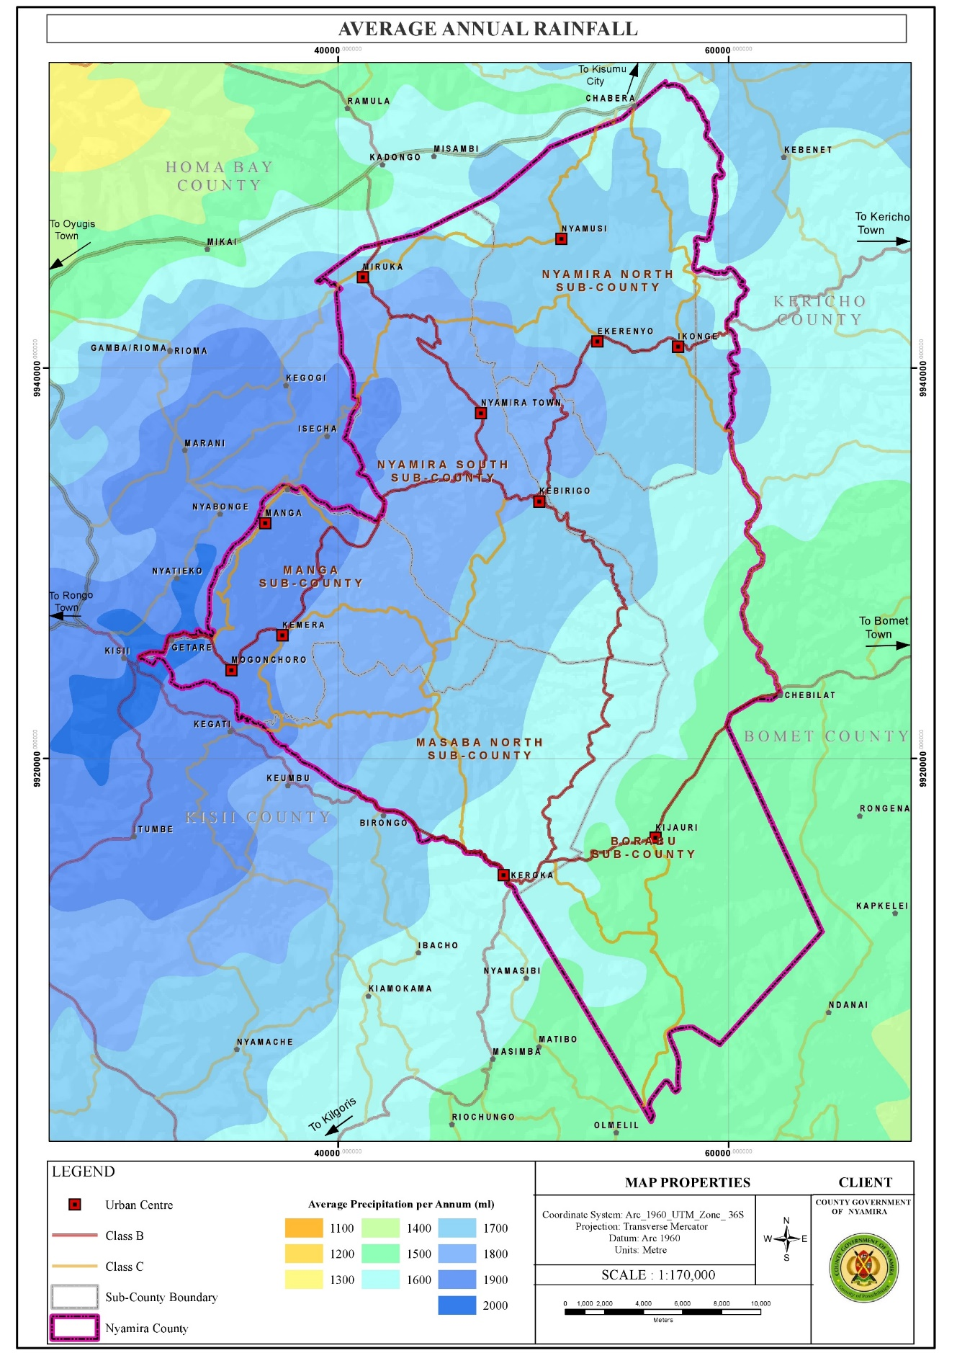

1. Renewable Energy: Harnessing like solar and wind though in small scale Nyamira County is relatively cold. However, the northern part of the county comprising of areas around Miruka, Nyamusi and Chabera have high solar potential with an annual solar photovoltaic power potential of between 1691 -1710 kWh/kWp. These areas also are the hottest with temperatures of 21.10C – 21.50C. The high temperatures in the northern part of the county coupled with high solar potential present an opportunity for solar power generation even at the household level. The county has an average wind speed of 2.46m/s which is beyond the cut-in-speed for small turbine to start generating energy which is set at 2m/s. However, the wind potential in the larger county is not at the required maximum of 10-15m/s with the exemption of the area around Manga ridge, an area near Birongo Market Centre in Masaba North Sub-County and an area near Ekerenyo Market Centre in Nyamira South Sub-County with relatively high wind power density of between 301 - 400 Watts per Square Metre. This wind power could be tapped to produce electricity.

Figure **. Solar Potential Map**

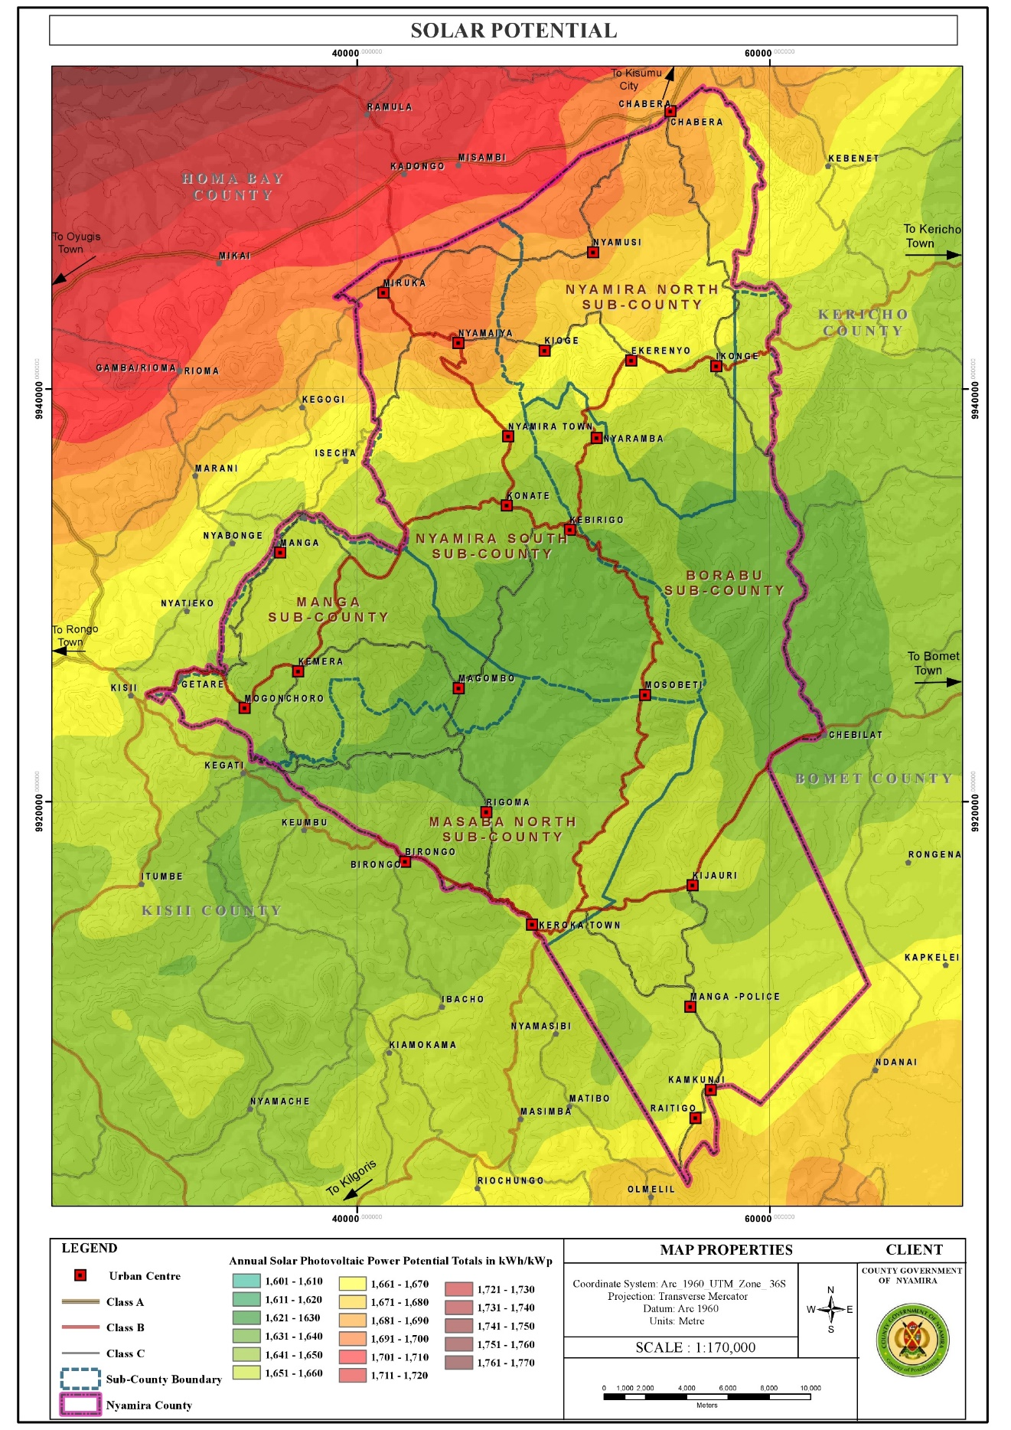

Figure **. Temperature Distribution Map**

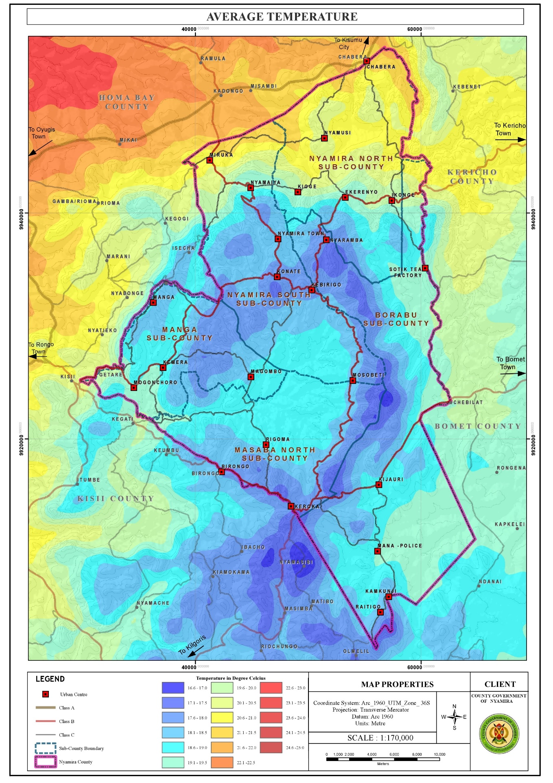

#### 3.3.1.2 Challenges

1. Depression of Water Levels: The water levels in the rivers, springs, streams and waterfalls have been depressing over time a phenomenon attributable to several factors among them, planting of inappropriate tree species along the riparian reserves and water catchment areas, improper farming methods, unregulated water obstruction upstream and the negative effects of climate change. These factors have resulted to reduction of water levels in the main rivers and drying up of the streams.
2. Unfavorable topography for construction: The rugged terrain in the county makes some areas inaccessible as construction of roads to certain places especially those on the hilly areas or low lands is an expensive undertaking. In addition, piping of the water from the various water sources in the low lands to the majority of the homesteads in the hilly areas is very costly, rendering it unfeasible. This forces the residents to access the water from their natural sources (springs and rivers).

Figure **. Topography Map**

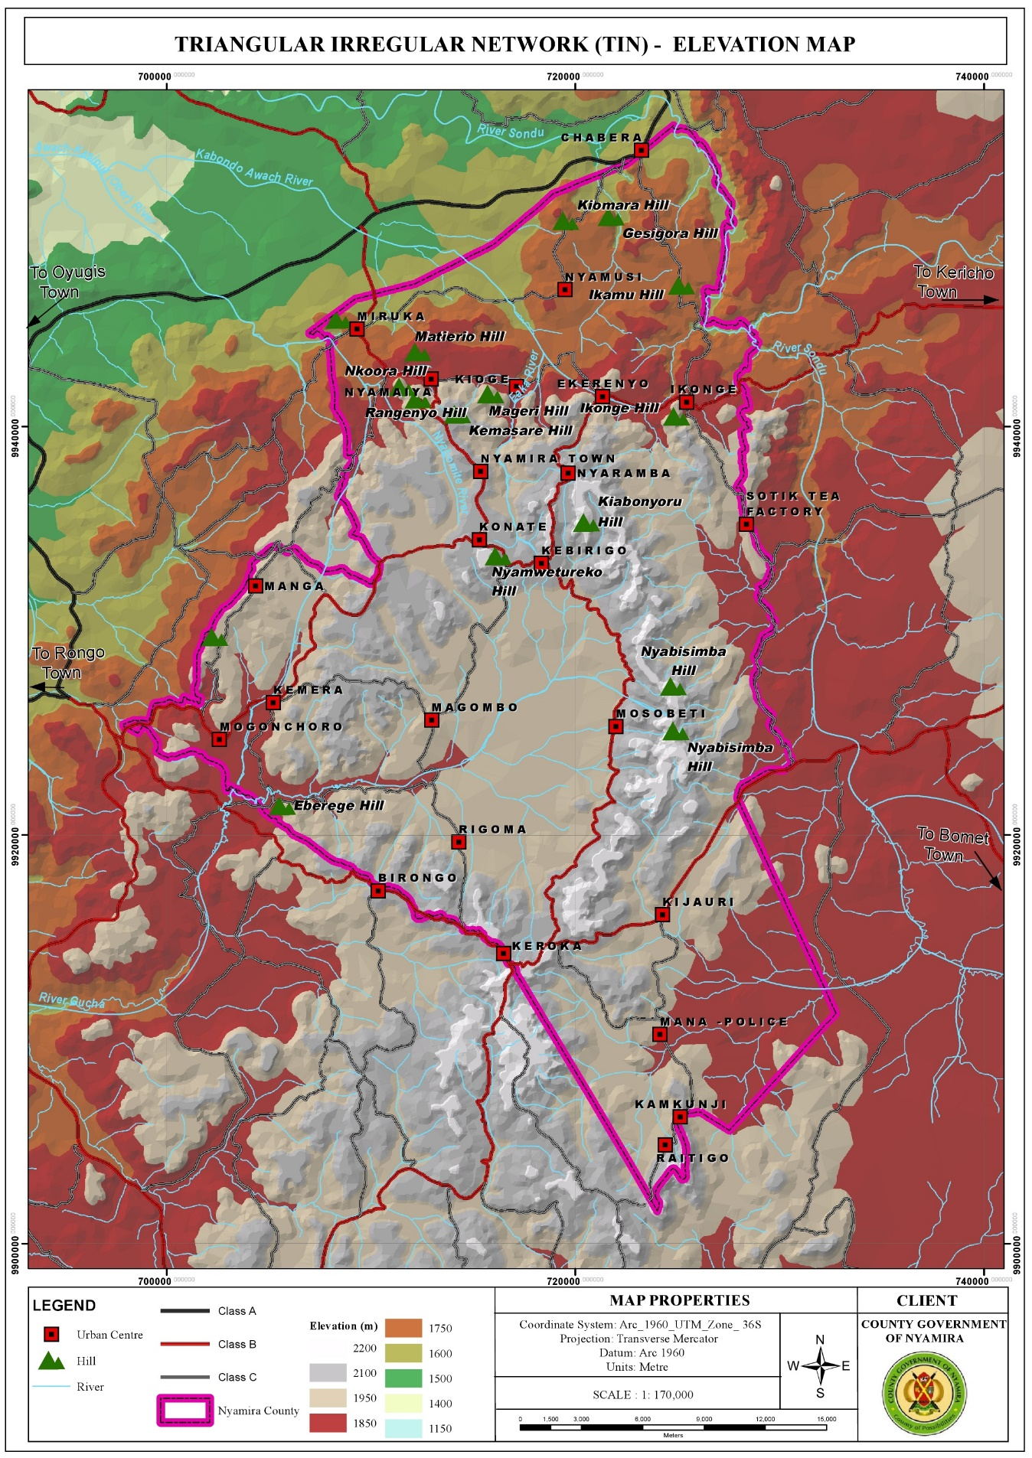

1. Poorly Drained Soils in Some Areas Resulting to Constrained Developments: A few areas in the county have poorly drained soils. These areas include sections of Magwagwa, Township, Bogichora, Bosamaro and Gesima Wards. They are characterized by red volcanic soils which are good for farming but make construction and road maintenance expensive. Thus, these areas are constrained in achieving high density developments.
2. Soil Erosion: Most of the rivers are characterized by brown waters, an evidence of soil erosion upstream. Soil erosion which displaces the fertile upper layer of the soil has negative implications on farm productivity as it results to reduced soil fertility. o High rainfall amounts The high rainfall amounts in the county coupled by increase in impervious layer make the county susceptible to flooding. The built areas especially those in the low lands face floods while the steep areas are susceptible to landslides especially in areas with loose soils.
3. Changing Weather Patterns: Changing weather patterns have affected all development sectors in the county with agriculture being the worst hit. The notable effects of this change are; delayed onset and untimely cessations of rain, skewed rainfall distribution and intensity and emergence of new pests and diseases.

**3.3.2 Population and Demography**

Population and demographic characteristics have far reaching implications on the county’s development. Various age cohorts present different needs with young population requiring the establishment of educational and health facilities. Youthful population requires focusing on youth empowerment programmes for skills and talent enhancement. To absorb the increasing labor force, investments in modern agricultural production and agro-based industries is necessary. The aged population on the other hand calls for allocation of resources for the provision of basic needs like water, food, clothing, shelter and medical services. The opportunities and challenges facing the county population are outlined below:

Figure **. Population Density Map**

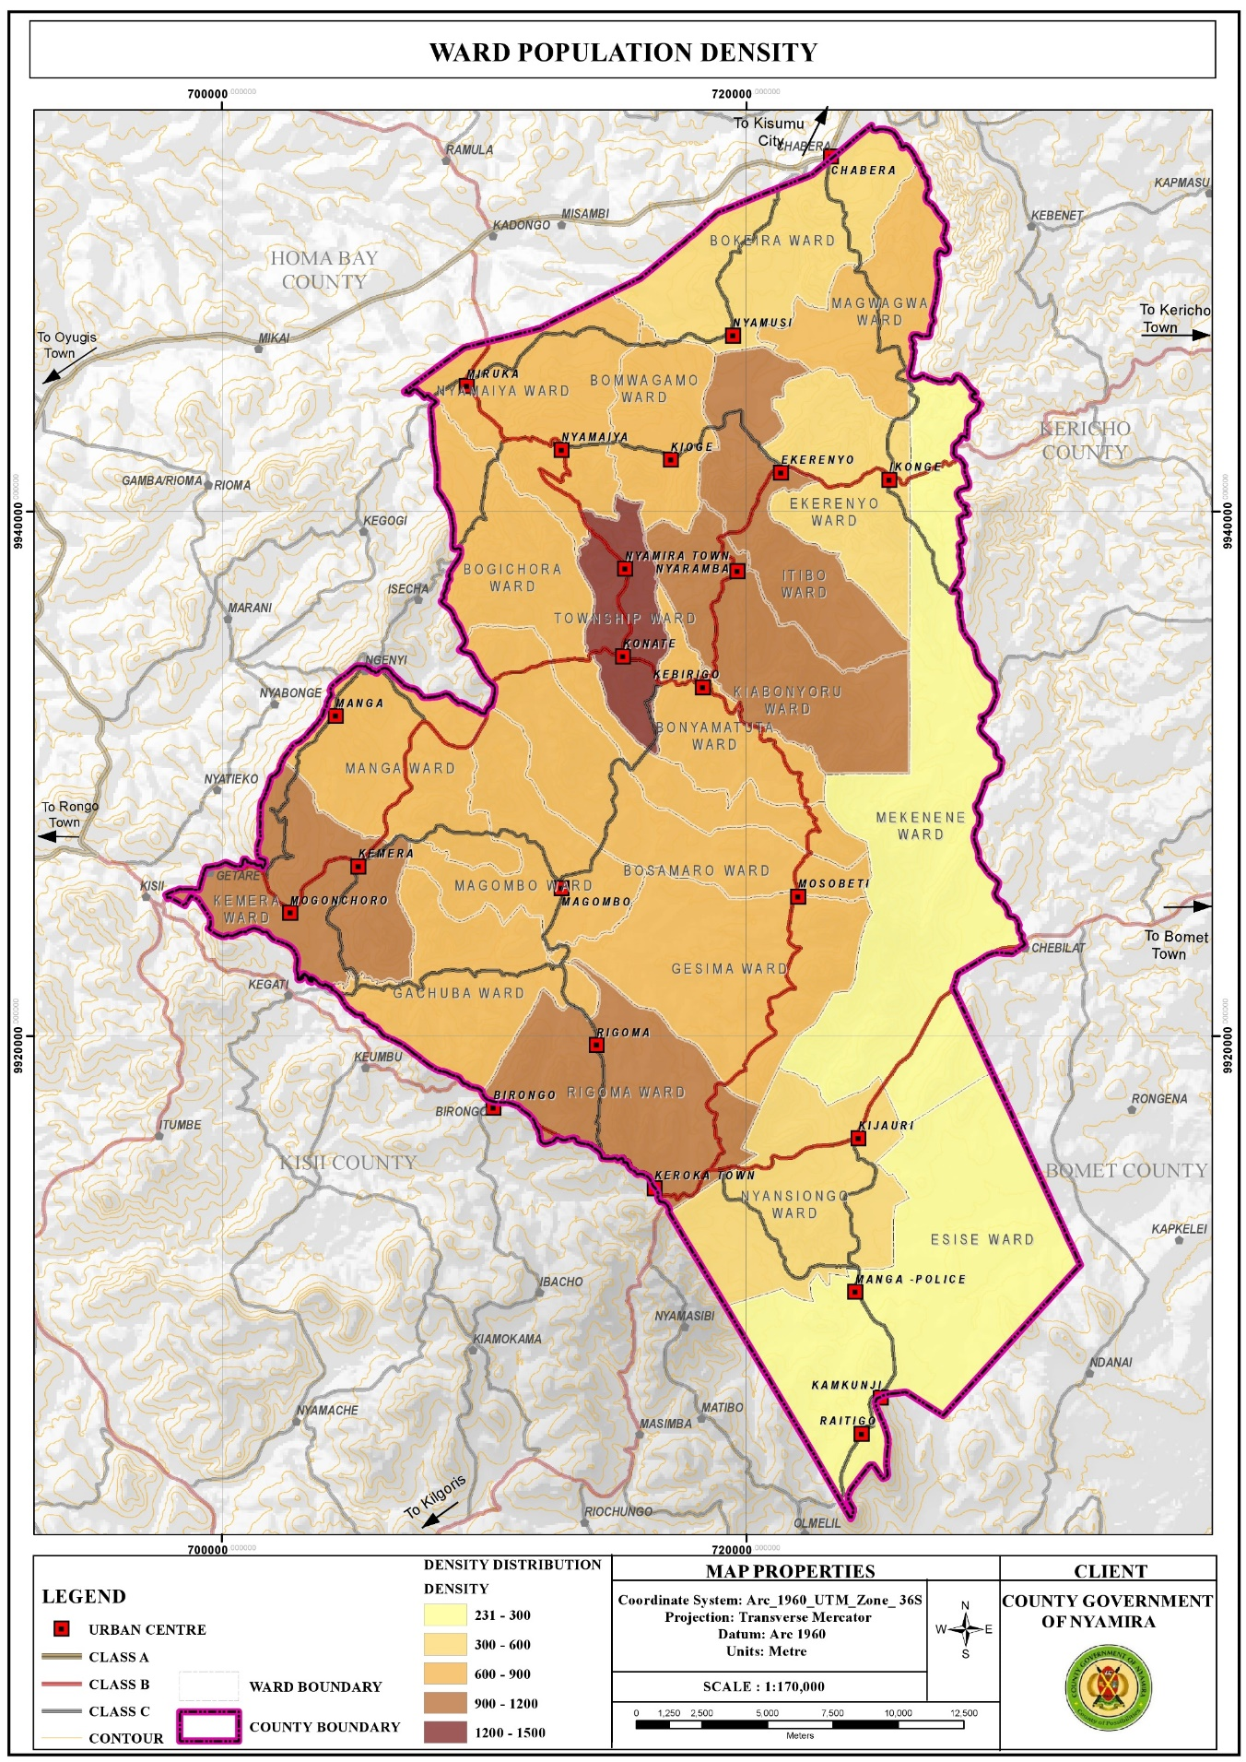

#### 3.3.2.1. Opportunities

1. High proportion of Youthful Population: The youthful population constitutes the largest segment of the county population as 72.44% is under the age of 35 years. The youths (15-35 years) in the county account for about 33.3% of the county population. This population requires massive investment in skill development. This presents opportunities for youth empowerment programmes for skills and talent enhancement.
2. High proportion of labor force: The labor force (15-64 years) constitutes about 55.8% of the total population. This calls for investment in diverse sectors like modern agricultural techniques and agro-based industries as well as creation of self-employment opportunities so as to absorb the increasing labor force
3. Development of Special Programmes : To address the needs of the elderly The aged population (65+ years) constitutes about 5% of the county population. This population presents opportunities in the provision of basic needs like food, water, clothing, shelter and health services so as to cater for the needs of this age group. In addition, this group presents opportunities for the development of special programmes and strategies.
4. High Literacy Levels for Basic Education: The county has relatively high literacy levels for basic education at 91.1% compared to the national literacy rate at 81.53%. However, only a small segment of the population has attained tertiary level of education as represented by 2.5% of the population.
5. Over reliance on agriculture as a source of income presents opportunities for investment in agricultural production programs. Agriculture is the economic backbone of Nyamira County providing employment and income for a large number of the people. In addition, the county is a food basket for the region and the country supplying food commodities to the Kenya’s capital, Nairobi.
6. High population is a market for good and services The county’s population is projected to be 629,287 people as at 2021 and 691,028 people by 2030. This population constitutes the immediate consumers of the goods and services produced in the county. It gives the primary motive of production as without consumption there wouldn’t be need for production.

#### 3.3.2.2 Challenges

1. Low number of population with tertiary level of education: The county has a very low proportion of the population who have attained tertiary level of education as represented by 2.5% of the population. This could be attributed to low transition levels from basic to tertiary education. Individuals with low literacy levels are more likely to experience fewer employment opportunities and outcomes thus lower incomes. As a result, they often face welfare dependency, low self-esteem and higher levels of crime. In Nyamira County, the low literacy levels in the male youths have pushed them to the boda boda sector leaving the agricultural sector with hardly no labor force. This reduces agricultural productivity. In addition, the high number of boda boda operators reduces the sector’s profit margin.
2. Overdependence in Agriculture as a Source of Livelihood: Agriculture is the main economic activity in the county employing a significant number of the population. This could be attributed to the low number of population with tertiary level of education; hence majority of the population lack the prerequisite skills to compete for the few white color jobs. The overreliance on agriculture is however not sustainable due to the diminishing and sizes resulting to uneconomical farm sizes. The reduced land sizes are as a result of population pressure especially in the denser areas as more agricultural land is being set aside for the construction of homesteads to house the growing population. In addition, intergenerational transmission of land rights that requires fathers to subdivide their property, land included to their heirs has resulted to unregulated land subdivisions. As a result, the emerging subplots are too small is some areas for any economical agricultural production. This has negative implication on individual households’ food and livelihood security.
3. High Proportion of Dependent Population: The county has a relatively high dependent population of 273,507 people as at 2021. This accounts for about 44.1% of the population and a dependency ratio of 79%. The county’s dependency ratio is relatively high compared to the national ratio of 69.8%. A high dependency ratio indicates more financial stress on working people as there is an increased burden to undertake child upbringing and pay pensions for the elderly.

## 3.3 Land and Land Use

Land and land-based resources facilitate social and economic developments as land is a requisite for all human undertakings. The opportunities and challenges regarding land are outlined below:

### 3.3.1 Opportunities

1. Large land parcels in Esise and Mekenene Wards in Borabu Sub-County Nyamira County is characterized by small scale farms with average farm sizes of 0.7Ha with the exemption of Esise and Mekenene Wards with large scale farm holdings of average farm sizes of 4 Ha. The farms in Mekenene Ward are owned by multinational companies while local individuals own the farms in Esise Ward. These large farms sizes present opportunities for large scale production hence the farmers can reap form the benefits of economies of scale.
2. High proportion of arable land The county has a high percentage of farmland as about 88.2% of the land is planted. This comprises of 64.5% under farmland and 23.7% under tree cover. This implies that, a great proportion of the county land is suitable for farming activities.

Figure **. Land Use Classification Map**

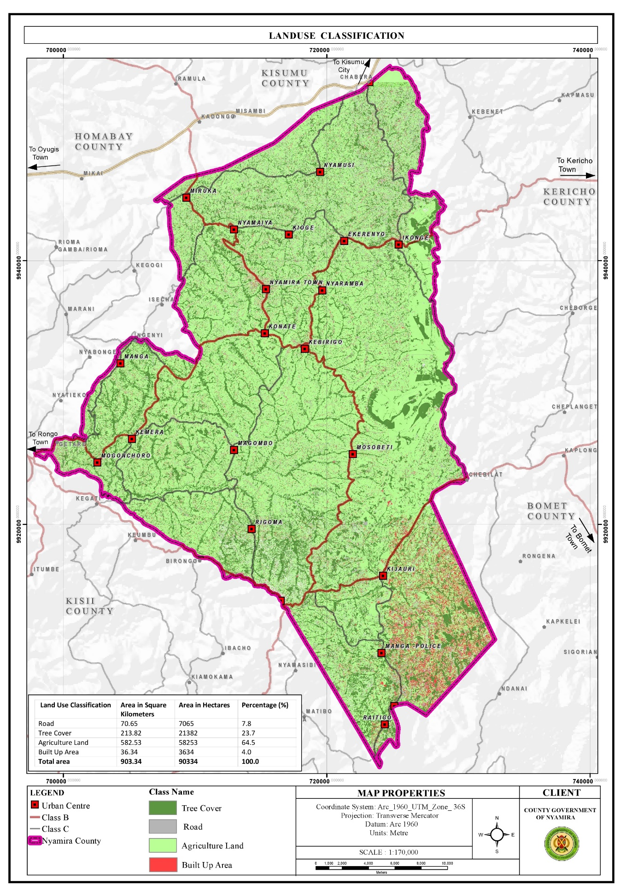

### 3.3.2: Challenges

1. Private land ownership: More than 90% of the county’s land is under freehold and comprises of the rural hinterland. The prevalence of private land ownership makes implementation of county development projects costly due to land acquisition and compensation costs.
2. Unregulated land subdivision: There has been significant land subdivision activities over the years mainly for inheritance purposes as the African culture and traditions dictate that fathers have to subdivide the property, land included to their heirs. Gradually, this practice coupled with population pressure has resulted to uneconomical land holdings
3. Freehold land ownership rights in most parts of the county, freehold land ownership rights are held at extended family where a family title is held in the name of the great grandparents. This poses challenges in succession, land managemet and administration.
4. Land use changes where urban developments are eating up agricultural land Changes in land use patterns are linked to a rapidly increasing population in the rural areas. This growth rate translates to an increased pressure and demand for land resources. The agricultural farms surrounding the towns and market centres are under massive pressure as the land parcels adjacent to the urban centres are gradually being converted to urban land uses. This threatens the sustainability of the agricultural sector in these areas as agricultural land use can’t be high for land as compared to commercial and residential land uses. O
5. Land fragmentation Land fragmentation in the county has been as a result of inheritance practices where all the heirs want to own land parcels both along the road and the riparian reserves. In addition, the small land sizes have forced the well up farmers to purchase or rent additional farm lots away from their original farms to add to their production levels. These fragmented land holdings have negative implications on agricultural production and food security due to the time lost accessing the fragmented parcels. There are also instances of increased disputes with neighbors.

## 3.4 Environment and Natural Resources:

Nyamira County has several ESAs which include green and open spaces, wetlands, hills/forests and water falls. These ESAs undertake key functions in the sustainability of the environment among them provision, regulatory, economic and cultural functions. They are however threatened by several human activities among them; farming, mining and construction. Opportunities and challenges affecting the environment and natural resources in the county are outlined below:

### 3.4.1 Opportunities:

1. High tree cover: The county has a relatively high tree cover of 35% compared to the recommended national minimum cover of 10%. Trees aid in; air purification through carbon sequestration, soil stabilization and protection from soil erosion, provision of timber and wood fuel and flood mitigation as the roots help in water infiltration to the ground.
2. Availability of several natural resources: The county is endowed with several natural resources like rivers, forest/hills, wetlands and water falls which provide opportunities for conservation, eco-system service provision and promotion of tourism.
3. Conducive climatic conditions for the thriving of these natural resources: The thriving of these natural resources is facilitated by the prevailing conducive climatic conditions in the county.
   * 1. **Challenges**
4. Planting of inappropriate tree species: Majority of the riparian reserves are planted with eucalyptus trees. Eucalyptus trees are widely grown and utilized throughout the world as they are a valuable source of timber and wood fuel. These tree species however deplete groundwater, dominate other tree species and cause loss of soil fertility. They are indeed a key contributing factor to the drying up of some streams and reduction of water levels in some rivers.
5. Deforestation: Despite the high forest cover of 35%, the county suffers from significant deforestation activities. This is mainly as a result of overreliance of wood fuel and the need for other wood products like timber. The county relies mainly on wood fuel for cooking with about 84.3% using firewood and 3.5% using charcoal for cooking. Apart from household wood fuel consumption, the tea factories in the county use firewood to process the tea leaves. In addition, several institutions like schools use firewood for cooking. Furthermore, due to the population pressure in the county, individuals are clearing trees to pave way for settlements and crop farming so as to house and feed the increasing population respectively.
6. Boundary tree planting conflicts: Planting of trees along the farm boundaries is a common practice in the county. Trees are used to demarcate the farm boundaries and in some instances, due to the small land sizes, there are no land parcels left for tree planting and farmers are forced to utilize the farm edges. In addition, competition for land with other farm land use allocations pushes tree planting to the edges as the little available land is allocated to production of staple food. This practice has resulted to significant conflicts as farmers on both sides want to utilize the edges for tree planting.
7. Encroachment of riparian reserves and forests: Rapid human population growth and overexploitation of resources are the main causes of land use and land cover change along river basins. In addition, agricultural land and urban settlements have increased at the expense of forests and grasslands. The conversion of land use and land cover into agricultural land and urban settlements has resulted to various environmental consequences like loss of ecosystem integrity, ecosystem imbalance and below optimum provision of ecosystem services.
8. Poor waste management causing pollution on the rivers: Most of the market centres do not have designated solid waste collection and disposal sites. This has led to sprouting of illegal disposal sites in the market centres as well as indiscriminate waste disposal. The disposal sites are also poorly managed. The poor waste management practices in the county cause significant pollution of the rivers as the waste is swept by surface runoff into the rivers. In addition, about 95% of the households use pit latrines for human waste disposal. The use of pit latrines impacts negatively on the quality of the underground water. The threats are even higher in flood prone areas where these latrines can contaminate surface run off. The health threat of this mode of waste disposal is alarming as about 80% of the population in Nyamira County depend on springs, streams, rivers and wells as the main water sources for their domestic use.
9. Environmental degradation: Environmental degradation in the county is as a result of unsuitable farming methods, effects of climate change, poor solid waste management, soil erosion, deforestation, quarrying activities and invasive species. o Floods and landslides The county is susceptible to flooding and landslides due to the high rainfall amounts experienced in the county coupled with increase in impervious cover.
   1. **Human Settlements and Urbanization**

Human settlements play a critical role in development as they are centres of social interactions, services and utility provision. These settlements are influenced by several parameters among them climatic conditions, infrastructure networks like roads, water and electricity as well as availability and access to gainful employment. Migration of rural population to major towns in search of employment and other services like education and health has resulted to strained infrastructural facilities in these urban centres. The human settlements and urbanization trends in the county present several opportunities and challenges as outlined below:

### 3.4.1 Opportunities

1. Strategic location: The county is located within the LREB among other 13 counties with similar ecological zones, natural resources and analogous cultural histories. The county benefits from the synergist links among the other counties in the bloc. In addition, majority of the towns and market centres are situated along transportation corridors, enhancing their accessibility.
2. Dense settlements provide ready market for products and are cheaper to service Consumption is the main motivation for production, as there won’t be need for production without adequate consumption. The dense populations both in the rural and urban centres translate to demand for goods and services. These dense settlements are also cheaper to service compared to linear and leap frog developments.
3. High percentage of home ownership at 85.5% The county has relatively high percentage of home ownership at 85.5% compared to the national percentage of 61.3%. This could be attributed to the fact that majority of the population resides in the rural areas where they have constructed their homesteads within the agricultural farms.
4. Manga Sub-County is earmarked for the development of housing under the big 4 agenda. Affordable housing is one of the Government’s big 4 agenda with the others being food security, manufacturing and affordable health care. The implementation of the housing project in Manga Sub-County is expected to propel investment in other sectors and spur the area’s economic growth.

Figure **. Urban Extents**

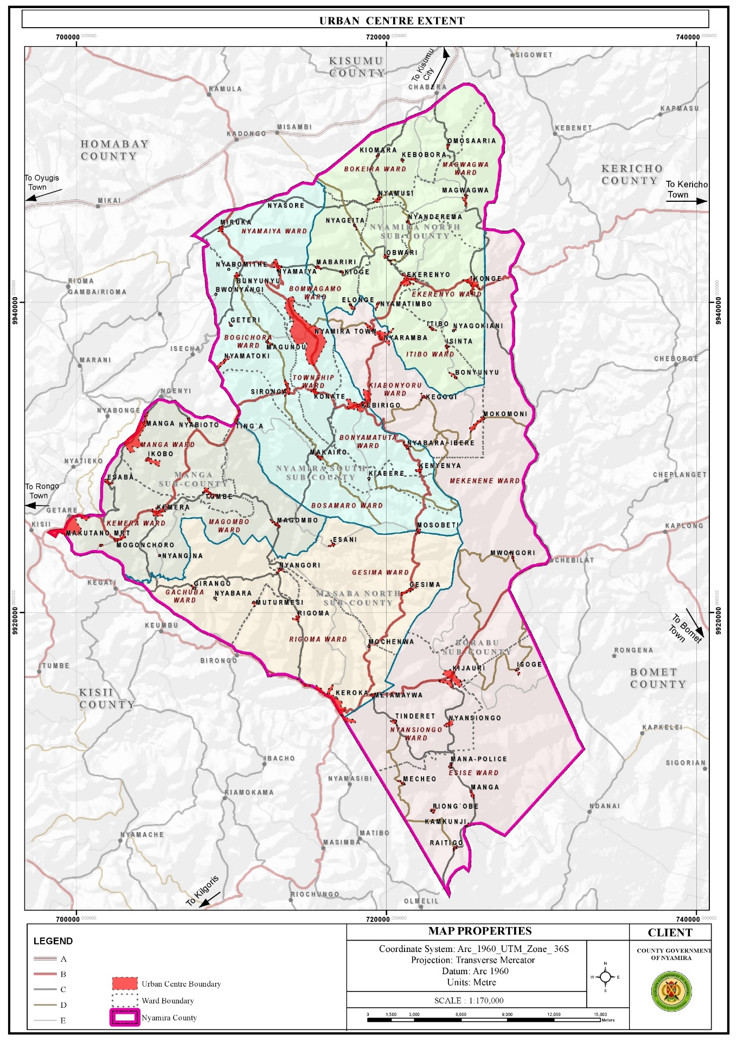

### 3.4.2 Challenges

1. Linear and leapfrog developments: Most market centres have developed along the major roads resulting to linear and leap frog developments. These developments are expensive to service.
2. Haphazard developments, urban decay and poor aesthetics of the market centres The towns and market centres in the county developed without any spatial framework to guide their development. As a result, majority of the centres are characterized by haphazard developments. In addition, the centres are not planned with the exemption of Nyamira Town, Miruka, Nyamaiya, Kioge, Ting’a, Sironga, Nyaramba, Kebirigo and Konate Market Centres though the plans are yet to be implemented. Some of the structures in the towns and market centres are in a dilapidated state as they are characterized by ugly walls and corroded roofs.
3. Poor solid waste management results to poor aesthetics in majority of the urban centres.
4. Limited accessibility and connectivity of the market centres Majority of the roads connecting the market centres are gravel and earth roads. The earth roads are in deplorable condition especially during the rainy season.
5. Inadequate land for future expansion of the urban centres as they are surrounded by freehold farm holdings. Majority of the market centres in the county were established by the former councils who identified public lands for potential growth of these centres and defined their boundaries.
6. Terrain The rugged topography in most of the urban centres has been a major limitation to their growth and development. For instance, construction of roads to certain places especially the hilly and low lands is costly and unfeasible in some areas. This renders some areas inaccessible. In addition, piping of the water from the various water sources in the low lands to the majority of the homesteads in the hilly areas is very costly, rending it unfeasible.

**3. 5 Transport, Infrastructure and Services**

Efficient transport, infrastructure services and utilities are prerequisite to socio-economic growth and development. The roads open up resource potential areas, link activity spaces and enable the circulation of goods and services. Water, ICT, energy, sanitation services and social infrastructure function towards uplifting the quality and standards of life for the county residents. This sector is presented with numerous opportunities and challenges as outlined below;

**3.5.1 Opportunities**

1. High connectivity of the county to the regional hinterland via the existing road network in the region: The county is well connected to the hinterland with Kisii-Chemosit road (B4) and Konate-Senta Road (B5) being the main roads connecting the county with other regions. Other roads linking Nyamira County to the rest of the region are; Narok – Kisii (B3), Kisii – Nyamira road (C21), Kisumu – Kisii Road (A1), Oyugis – Kendu Bay Road (C26), Kisii- Rongo Road, Kaplong – Chemasit – Kericho Road, Kericho – Kapsoit – Awasi – Ahero Road, Kebirigo – Ekerenyo – Ikonge – Chemosit Road, Ikonge – Magwagwa – Chabera Road among others

Figure **: Road Network and Classification**

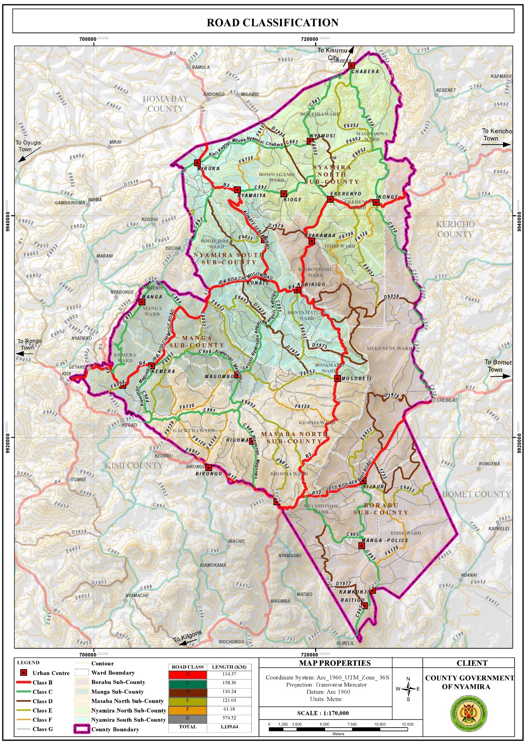

* + 1. **Challenges**

1. Poor road conditions: The county is characterized by poor road conditions with only about 20.1% of the classified roads being of bitumen surface type. About 27.6% of the roads are unclassified and are mainly earth roads. In Bosamaro Ward, for instance all the roads are earth roads. Majority of the gravel roads on the other hand are in poor condition due to poor maintenance and constant erosion of the top surface. The poor road condition especially for the earth roads renders them impassable during the rainy seasons. This poses a challenge in the transportation of farm inputs and produce.
2. Encroachment of road reserves: Majority of the road reserves have been encroached by informal businesses in the urban centres bringing about issues of space contestation between the road users, traders and customers. o Lack of bus terminus and parking spaces Most of the market centres in the county lack bus terminus with the exemption of Nyamira Town, Keroka Town and Ekerenyo Market Centre. This forces the Public Service Vehicles (PSVs) to load and offload along the roads. There are also no parking spaces in the urban centres and motorists are forced to park along the road reserves or building pavements.
3. Poor connectivity between the market centres : Despite the existence of roads connecting all the market centres, some of the roads are in a sorry state. The situation is further aggravated by missing bridges and poor conditions of the available bridges in some of the roads. This makes accessibility to some of the market centres a challenge.

## 3.6 ICT

### 3.6.1 Opportunities

1. Relatively high ICT proficient population: About 45% of the county population own mobile phones, 16% utilize the internet while 7% use laptops, tablets, computers and desktops. This presents opportunities for engagement in ICT related businesses.
2. Easier accessibility of ICT equipments : Accessibility to ICT equipment has become easier over the years since their introduction in the country. There are several electronic shops in the county headquarters (Township) where the county residents can access various devices at their convenience.

### 3.6.2 Challenges

1. Low budgetary allocation and inadequate staffing to operate the ICT infrastructure. o Inadequate skills in the ICT sector among staff in the county departments coupled by lack of training programmes to equip the staff with the required skills.
2. Low network reception in some areas, especially the low land areas as reception is hindered by the hilly areas. The residents have to move to higher grounds in search of network reception o Lack of resource centres, GIS lab and equipment for data storage and retrieving

## 3.7 Energy

### 3.7.1 Opportunities

1. Renewable energy sources: The Northern parts of the county comprising of the areas around Miruka, Nyamusi and Chabera have high solar potential that can be harnessed for solar power generation even at the household level. The area around Manga ridges, an area near Birongo Market Centre in Masaba North SubCounty and an area near Ekerenyo Market in Nyamira South Sub-County with relatively high wind power density of between 301 - 400 Watts per Square Metre are potential areas for wind power generation. There is also potential for production of biomass for cooking, though at household level. Tapping into these renewable energy sources could help minimize the negative effects of climate change.
2. Last mile connectivity : This presents an opportunity to connect other areas with electricity. 11.7.3.2 Challenges o Over-reliance on wood fuel for cooking Wood fuel is the main source of cooking energy with 84.3% and 3.5% of the population using firewood and charcoal respectively. In addition, the tea factories in the county use firewood for the processing of tea leaves. The use of wood fuel has implications on the environment as it leads to air pollution and reduction in tree cover.
3. Low electricity reticulation as some of the areas are not connected to the national grid : The current electricity coverage in the county stands at 49.5% which translates to about 85,548 connections. There are areas without electricity connectivity in the county like; Obwari, Gesura, Ensoko and Kiabora. These areas need to be connected to the national grid as electricity is a major component of socio-economic development.

Figure **: Electricity Reticulation Map**

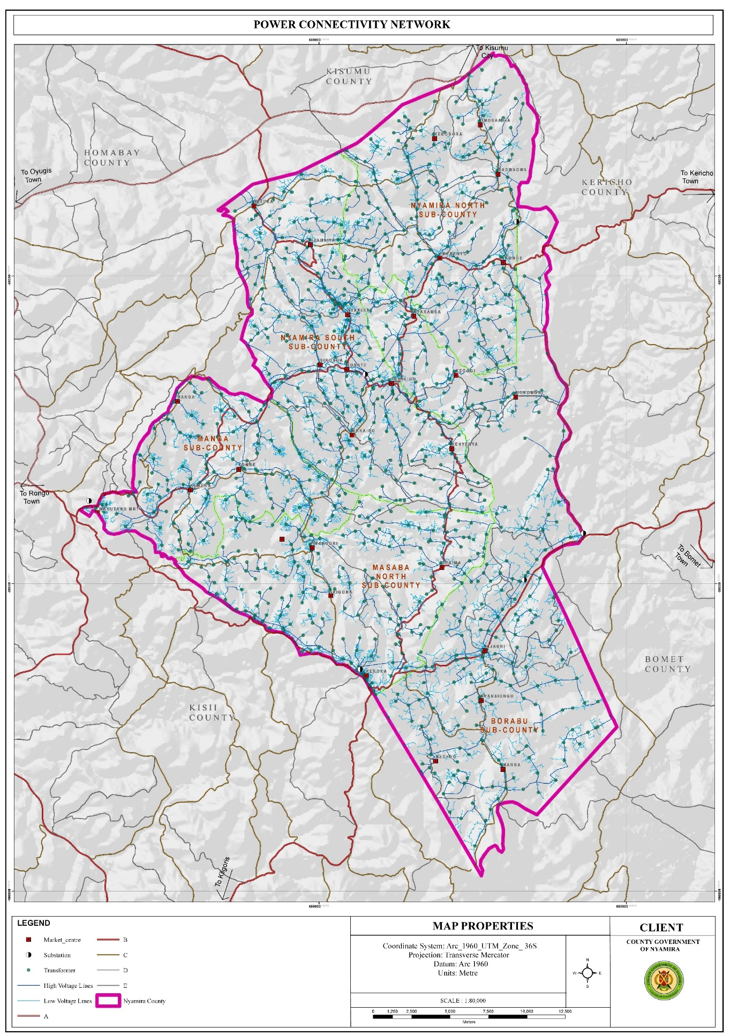

## 3.8 Water and Sanitation

### 3.8.1 Opportunities

1. Availability of water sources both surface and underground water sources : The county has about 2,021 shallow wells, 735 protected springs, 69 dams as well as over 2,790 unprotected springs and 7 permanent rivers. The availability of these water sources presents opportunities for easier access to water for both domestic and agricultural use.
2. High rainfall amounts present an opportunity for rain water harvesting The high rainfall patterns of between 1200 mm – 2100 mm per annum present an opportunity for rain water harvesting through creation of large-scale runoff collection reservoirs and household rainwater harvesting.
3. High water tables: The high-water tables in the county present opportunities for drilling of shallow wells. This explains the high number of shallow wells at the county which stands at 2,021. o Availability of waste The current solid waste generation in the county as at 2021 amounts to 104,146 tonnes and is projected to be 116,024 tonnes in 2030.

Figure **: Water Sources**

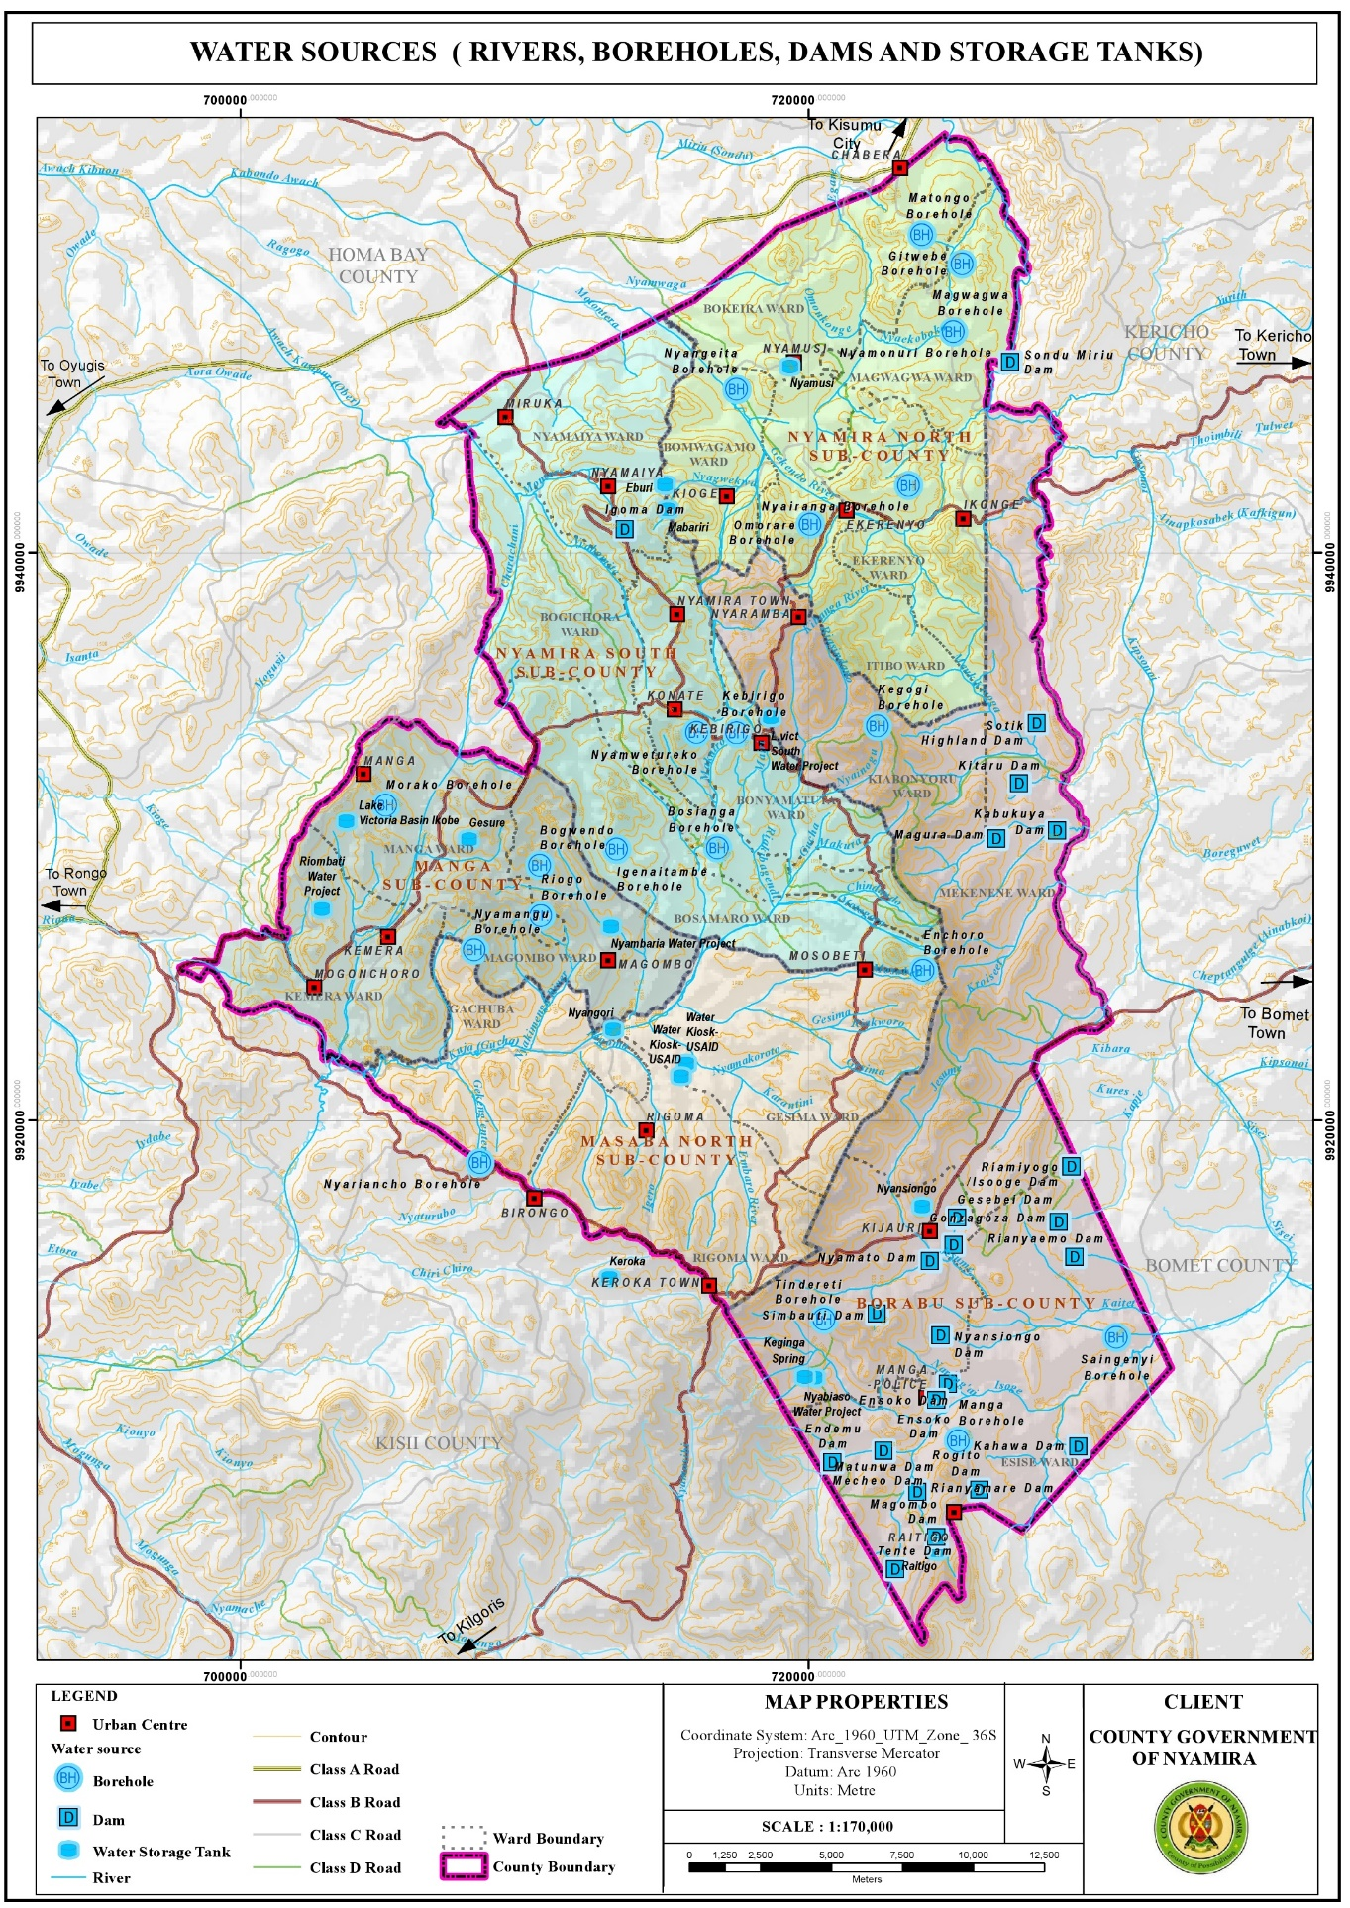

### 3.8.2 Challenges

1. Water: Over reliance on river and spring water Springs and rivers are the main water sources in the county, with about 36.6% using water from the streams/rivers while 36.4% and 9.4% utilize water from protected and unprotected springs respectively. o Inadequate water for the market facilities Water reticulation is only available in Nyamira and Keroka Towns. The rest of the towns rely on obtaining water from their natural sources.
2. Inaccessibility of water sources Despite the numerous water sources available in the county, water is not accessible to majority of the residents residing on the hilly areas as majority of the water sources are located at the low lands. The situation is further aggravated by the area’s topography which makes development of water reticulation from the low areas to the hilly areas unfeasible.
3. Poor water quality: The water quality in the county is compromised by constant pollution from the poor waste management practices carried out. Lack of designated solid waste management sites in most of the market centres has resulted to indiscriminate disposal of waste
4. Unprotected dams The unprotected dams are safety hazards to the county population as they are potential drowning areas. Siltation of some of the dams has made them dysfunctional over the years while privatization of others has made them inaccessible to the general public.
5. Rivers/springs : The rivers and springs are threatened by the planting of inappropriate tree species mainly eucalyptus trees. These tree species are a key contributing factor to the drying up of some streams and reduction of water levels in some rivers, wetlands and springs. o Lack of sewer reticulation network in the major urban centres Sewer reticulation is only available in Keroka Town. The rest of the urban centres don’t have a sewer reticulation network.

## 3.9 Education

* + 1. **Opportunities**

1. Have adequate schools : Based on the standards for the provision of educational facilities as outlined in the Physical Planning Handbook (2007), the existing educational facilities in the county are in surplus. This offers adequate learning institutions for the school going population. Presence of tertiary institutions The county has a total of 54 public TVETs spread across the county. The presence of tertiary facilities presents opportunities to further education as it offers alternatives to transition from secondary education to skill development. The student and staff population in these institutions provides a ready market for farm produce grown in the county and present opportunity for the construction of accommodation facilities.
   * 1. **Challenges**
2. Location of schools in the wetlands especially in Sironga making it difficult for infrastructure development
3. High number of pupils/students in boarding schools resulting to overstretched infrastructural facilities and services
4. Derelict infrastructural facilities in most of the public primary schools. o Poor waste management; solid waste is burnt in the open while inadequate land sizes constrain construction of additional pit latrines.
5. Poor accessibility of some of the schools within the rural areas due to impassable roads during the rainy season
6. Inadequate support infrastructure like appropriate sanitation facilities and learning materials o Delay in disbursement of funds to public schools affecting the smooth operation of school programs
7. High pupil/student teacher ratios in the public schools leading to overstretched teaching staff and poor performance of the pupils in national exams.
8. Inadequate land for the tertiary institutions as most of them are housed within primary or secondary schools land.
9. Inadequate schools for the physically challenged pupils forcing them to attend the normal schools without the prerequisite facilities for their learning.
10. Lack of water in some institutions making pupils carry water with jerricans to school. This practice is quite tiring to some of the pupils, thus affecting their concentration in class and their performance in general.

Figure **: Distribution of Primary Schools**

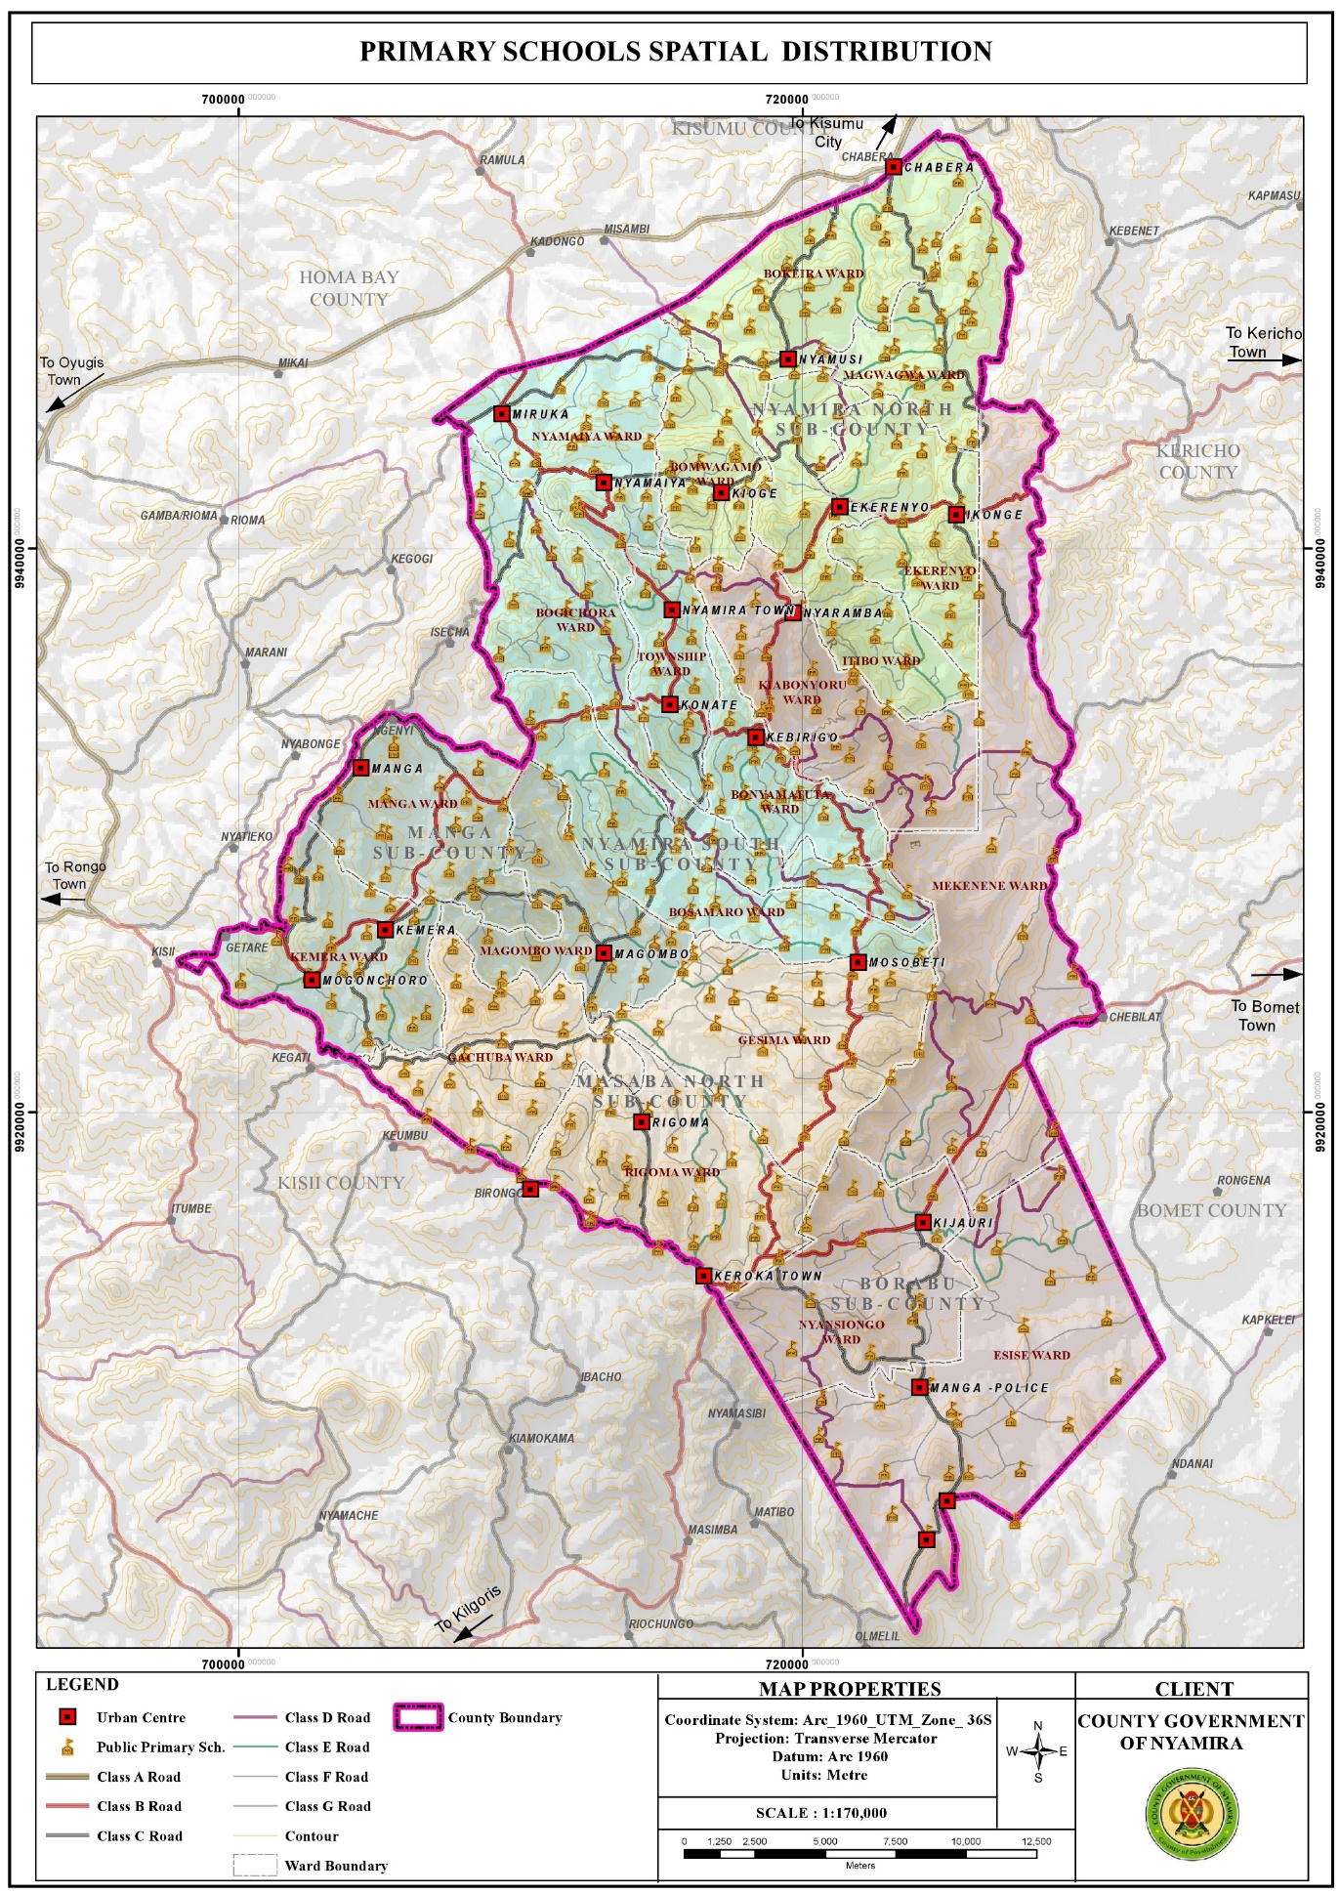

Figure **: Distribution of Secondary Schools**

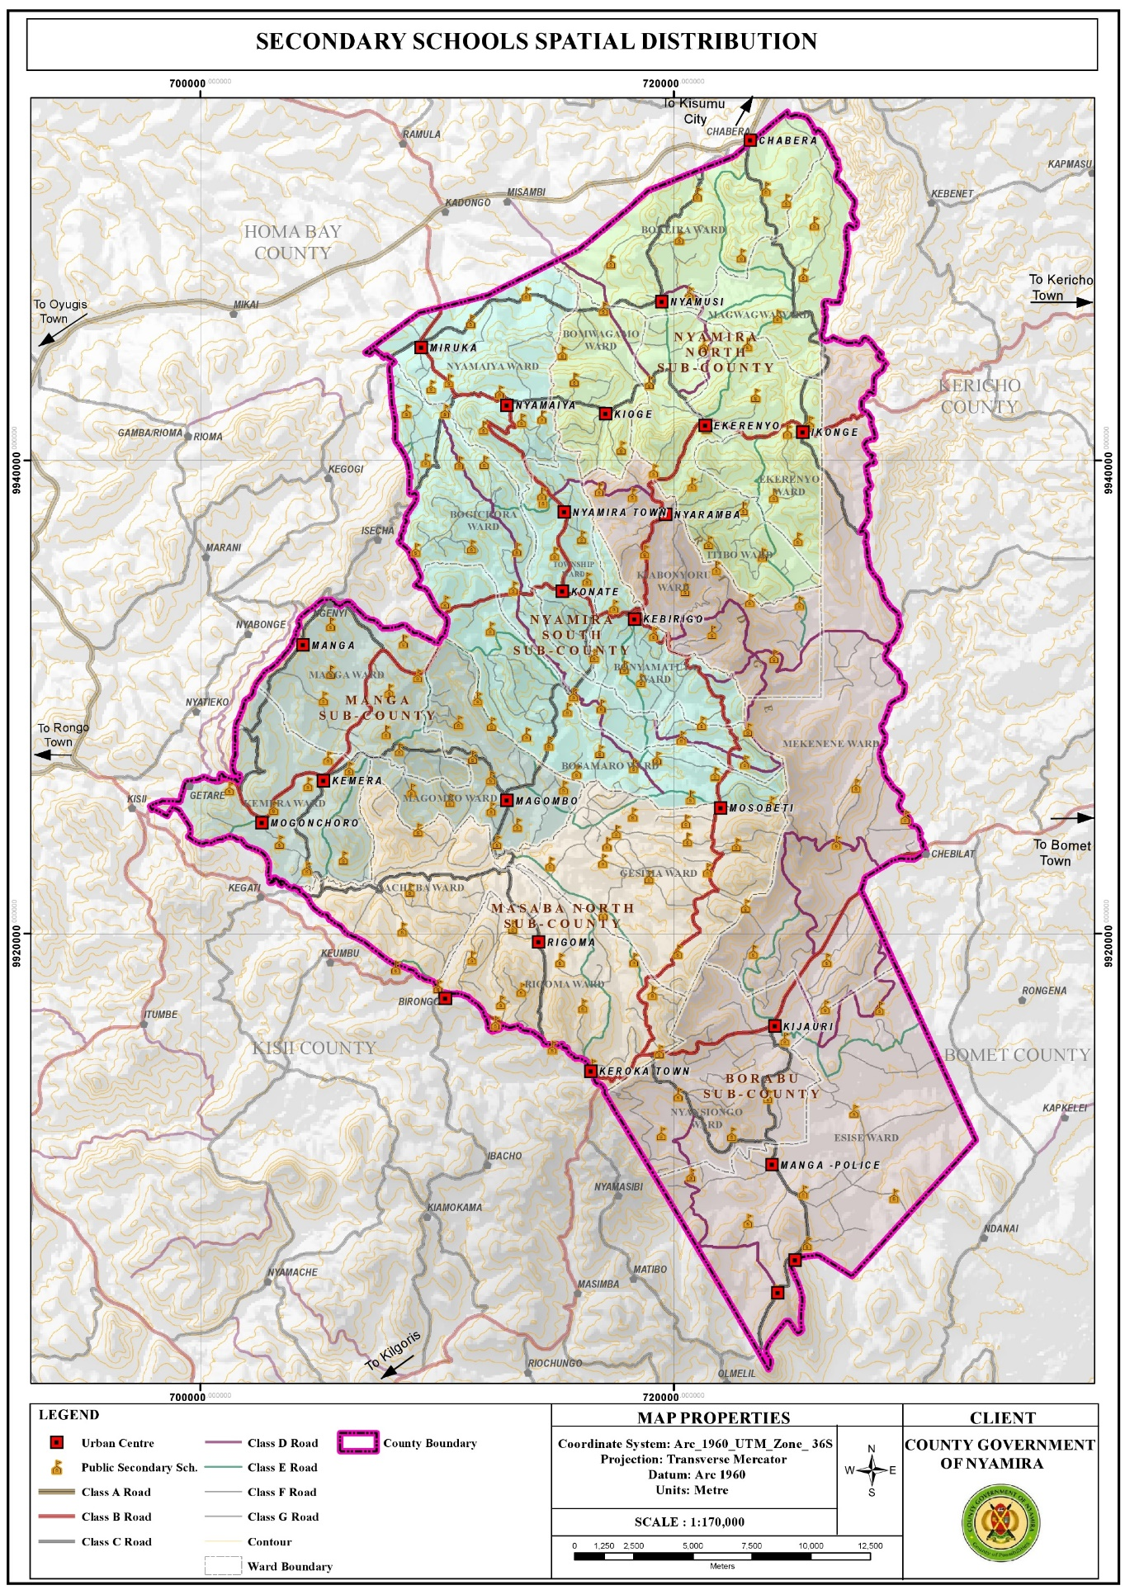

Figure **: Distribution of Tertiary Institutions**



## 3.10 Health

### 3.10.1 Opportunities

1. Availability of county referral hospital Nyamira County Referral Hospital is a government health facility which provides comprehensive medical and surgical services. The presence of the facility within the county presents a good opportunity to the county residents to access high level medical services in close proximity.
2. Adequate health facilities Based on the standards given by the ministry of health with regard to provision of health facilities versus the catchment population, the county has adequate public health facilities. However, despite the over-provision of health facilities, private health facilities have been mushrooming. This could be attributed to the deplorable state of some of the public facilities and lack of the requisite equipments and drugs.

## 3.10.2 Challenges

1. Inadequate staffing leading to overstretched medical staff. The doctor: population ratio is 1:11,906 against the Kenyan ratio of 1 doctor per 10,000 people. This indicates overstretched medical personnel. The inadequacy in staffing leads to low motivation hence low productivity. o Poor accessibility of some health facilities located in the rural areas due to impassable roads during the rainy season.
2. Inadequate medical equipment, drugs and lack of specialized treatment in most public facilities leading to sprouting of private facilities.
3. Poor conditions of some of the health facilities, for instance some of the facilities are in derelict state rendering then dysfunctional.
4. Stalled projects; the construction of most of the proposed health facilities has stalled.
5. Mushrooming of private health facilities to fill in the niche as a result of poor services in the public health facilities.
6. Increased lifestyle diseases among the elderly for example high blood pressure, diabetes and arthritis hence the need for special facilities to help fight such illness.
7. Locational disadvantage of some of the health facilities like Ikonge dispensary which is located downhill making it inaccessible to majority of the residents due to the county’s rugged terrain.

Figure **: Distribution of Health Facilities**

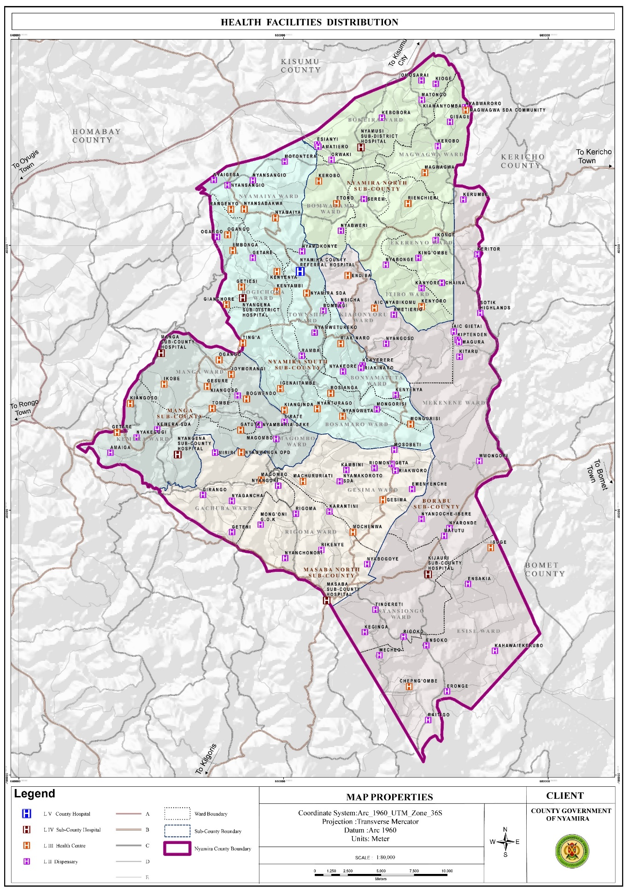

# CHAPTER 4

# DEVELOPMENT PRIORITIES, STRATEGIES AND PROGRAMMES

## 4.0 Introduction

This Chapter should provide sector development priorities, strategies, programmes, flagship projects, and cross-sectoral linkages.

## Development Priorities and Strategies

## 4.1.1 SECTOR NAME: SOCIAL PROTECTION, CULTURE AND RECREATION

**Sector composition and their roles**

**Sub sector of Culture**

The roles of the sub sector include, approvals of persons for awards & honors as heroes & heroines, coordination of cultural activities (Heritage, exhibition, museums/cultural centers, concerts, art and related food competitions /festivals, development of creative cultural industries). Liquor licensing and control, establishment of treatment and rehabilitation facilities and programs, carrying out public education on alcoholic drinks and drug abuse in the county in collaboration with other stakeholders. Provision of library and archiving services, consultancy, advisory and information dissemination and development of film industry.

**Sub sector of Sports**

The sports sub sector has the role of promotion and development of sports facilities and activities. In particular the sub sector develops sports stadia and play grounds. It also does talent search, research in sports and supports sports activities by providing sports equipment. The sub sector coordinates inter sectorial collaboration of programmes among stakeholder such as sports, art development and market sports as an industry in the County.

**Sub Sector of Youth Empowerment**

The sub sector involves coordinating the youth empowerment issues across the county. In specific capacity building of youth countywide in collaboration with other stakeholders and establish youth desk in each sector.

**Sub sector of Gender Empowerment**

The sub sector involves Gender mainstreaming and empowerment Women, Girls and Boys, establishment of gender desk in every sector to handle gender-based violence and related issues.

**Sub sector of Social Services**

The social services subsector involves empowerment of persons living with disability, social protection to children, widows/widowers, and older persons, interventions on various reliefs on vulnerable groups in the county

**Vision**

To be a leading County in social development, having high levels of gender parity in all spheres of life.

**Mission**

To empower the youth and vulnerable groups, promote culture and sports, and protect children while Main streaming gender parity for sustainable socio-economic development.

**Sub-Sector Goal**

Achieved social development by enhancing social inclusion

**Priorities and Strategies:** The sector priorities should be derived from the sector development issues documented in Chapters One and Two of the Plan. Strategies to achieve sector priorities should be proposed in relation to root causes of the development issues. Information in this section should be presented in Table 16.

Table : Sector Priorities and Strategies

|  |  |
| --- | --- |
| **Sector Priorities** | **Strategies** |
| Disability mainstreaming and sensitization programs | -Sensitization campaigns on the rights of persons with disabilities  -Mainstreaming training and audit to government ministries and MDAs  -Enforcement of relevant laws, policies and regulations on pwds  -Recruit staff ie sign language interpretors  -develop county specific plan of action for pwds  -Sensitization campaigns against harmful practices |
| Registration of persons with disabilities with NCPWD | Devolve Assessment facility to sub county hospital  -free assessment and any other health services to PWDs  -sensitization campaign on disability  Employ assessment team  Conduct mass registration at the locational level |
| Awareness creation on PWAs  Enhance PWA programs | Sensitization campaign |
| Provision of safety net programs for persons with disabilities | -Scale up of PWSD CT , scholarship  and bursaries  -Enforcement of relevant laws, policies and regulations  -operationalize county PWDs act and policies |
| Adequate provision of assistive devices | -procure various assistive devices and issuance to beneficiaries  -Enforcement of relevant laws, policies and regulations  -operationalize PWDs act and policies |
| Improve performance /standards in sports | Establish and equip talent centres /academies.  Establish and equip sports facilities (Build stadia and playing grounds) at grass root levels.  Develop laws, policies and regulations at county level.  Train sports personnel.  Mentor and nurture talents.  Benchmarking by sports personnel.  Capacity building of sports personnel.  Develop a reward and motivation system.  Create awareness on the existence and importance of other or emerging sports disciplines ( tennis, basketball, rugby etc)  Organize annual sports and cultural festivals/ events week.  Organize sports activities/tournaments at all levels.  Support and nurture young talents through funding of sporting activities  Start clubs.  Establishment of a high altitude training centres |
| High levels of Gender mainstreaming | Sensitization campaigns on Gender mainstreaming  Launch Area Gender Technical Working Groups (GTWG) at county level and ward level  Construct offices at sub county levels  Train Area Gender Technical Working Groups (GTWG) at all levels  Initiate Gender Protection Information Management System (GDIMS)  Enforcement of relevant laws, policies and regulations  Establishment of gender recovery centre/protection/ rescue centre Nyamira County  Increase Women empowerment- through provision of soft loans/grants to women groups. County wide  Recruit staff |
| Positive cultural practices | Sensitization campaigns on Gender mainstreaming  Launch Area Gender Technical Working Groups (GTWG) at county level and ward level  Initiate Gender Protection Information Management System (GDIMS)  Establishment of gender recovery centre/protection Nyamira County HQs  Anti FGM Board be devolved to county level |
| To reduce the rate of defaulters on affirmative loans/funds | Increasing funding from government and other multi- national partners.  The county government to establish gender affirmative funds. |
| Formulate/customize county gender policies | Customize national policies to county  Identification of partners to support development of various gender policies. |
| Establish GBV recovery centres | Identification of partners, state and non-state partners( NGAAF, county government and NGAO |
| Establish GBV spaces/ homes | Identification of partners, state and non-state partners( NGAAF, county government and NGAO |
| To end the causes of triple threats | Increase collaboration and multi-sectoral approach, GTWG and policies such as children/;’[-n’s act |
| Increase accessibility of gender statistics of the county | Advocacy and collaboration with stake holders  Awareness creation |
| High appreciation of cultural heritage | Construction of a social hall in every sub county.  Establishment of cultural centres Keroka, Nyamaiya & Nyamira  Establishment of botanical garden at county headquarters  Restoration of traditional caves at manga sub county  Celebration of annual cultural and sports festivals  Collection and preservation of artefacts  Equip the museum structure at manga  Refurbish the museum structure at manga  Documentation of oral traditions  Initiate a county choir and band and elders  Development of Nyamira film industries/studios {to document and showcase culture as an industry for employment for the youth} |
| Enhanced reading culture | Construction of one library per sub county  Create awareness on the importance of continuous reading county wide  Lobby for institutions to donate books to libraries in Nyamira county  Make the existing library to be user friendly. |
| Controlled Betting , lotteries and gaming | Develop county specific laws, policies and regulations  Conduct campaigns to sensitize the public on the negatives of addition to betting and gaming |
| Controlled alcohol consumption, drugs and substance abuse | Enforcement of relevant laws, policies and regulations at national level  Review of Nyamira County Alcohol consumption and control, and substance abuse act 2014  Proper enforcement of relevant laws, policies and regulations  Recruit staff  Establish at least one rehabilitation centre.  Conduct campaigns to sensitize the public on the dangers of addition and abuse of alcohol, and substance abuse |
| Enhanced community participation in socio-economic activities | Mobilize and sensitize community members on the importance of group formation  Registration of community groups in accordance with Community Group Registration Act 2022  Establish and capacity build County and Sub-County Social Development Committees (SDCs) as guided by the Act  Capacity building of community groups on resource mobilization  Link community groups to MFIs, State and other Non-State actors |
| Local communities protected from unintended negative adverse effects of social risks on development projects | Engage National Government and other non-state actors on the formation and training of County Social Risk and Management Committee  Address complaints and grievances from community members affected by development projects in the County |
| Rights of older persons protected  Strengthened partnership on the implementation of older persons and ageing programmes | Develop County Policy Brief on issues affecting older persons and Ageing  Hold consultative engagement forums on intergenerational solidarity  Engage State and Non-State actors on addressing issuing affecting older persons and ageing  Organize and participate in observance of the UN day on Older Persons (UN IDOP) |
| Strengthened family care and support systems | Identify and train County Trainer of Trainers (ToTs) on National Parenting Programme (NPP)  Train Lay Volunteer Counsellors (LVCs) as facilitators on the National Parenting Training Manual (NPTP)  Train parents/caregivers (including parents and caregivers of persons with disabilities) on NPP |
| Improved economic livelihood standards amongst the vulnerable members in the community | Capacity building of all cash transfer beneficiaries and caregivers on financial literacy  Mobilization of beneficiaries and caregivers in cash transfer program to ensure 100% utilization of the stipend |
| strengthen child protection system in the county | Sensitization campaigns on child rights  Train CACs at all levels  Improve Child Protection Information Management System (CPIMS) usage and data sharing  Enforcement of relevant laws, policies and regulations  Recruit staff  Build county child rescue centre  Develop, launch and implement a County Child Policy  Sensitization campaigns against harmful cultural practices  Coordinate County stakeholder meetings |
|  | Promote family based care for all children  Scale up of CT OVC  Scale up and bursaries  Enforcement of relevant laws, policies and regulations  Provide parenting training to caregivers  Community awareness programs to promote care for children  Advocacy and lobbying of partnerships to support vulnerable households  Advocacy to improve county funding for children welfare programs  Conduct parenting training sessions |
| To promote youth talent, innovation and entrepreneurship development through Promotion of skills development and job creation for the youth. | Hold ensitization Fora/clinics on Affirmative Action Funds. (AGPO, UWEZO, YEDF, WEF, NGAAF).  Fund more youth groups.  Create a legal framework for follow-up of loan defaulters.  To create a youth development fund at the county level.  Constitute a Youth Sector Working Group on Youth Unemployment.  Operationalization of  Community Youth SACCOs.  Hold talent Auditions and innovation contests to harness youth talent and innovation.  Link the harnessed (identified) youth talent and innovations to relevant stakeholders for mentorship/ skills transfer/Incubation/Technical support /Financial support/ markets networks.  Develop a youth talent and innovation documentary.  Mobilize and engage youth in Brand Kenya Active campaign.  Enactment of a Youth Policy, Bill and Act.  Awareness creation on the Youth Policy.  Establish youth sector working groups.  Hold implementation forums on Youth development Policy.  Establish a Youth Development Index technical working group.  Hold a retreat to develop a county Youth Development Index framework.  Analysis of data, report writing and printing.  Benchmarking by Youth Development Officers.  Provide internship opportunities.  Sensitization on the importance of technical skills.  Mobilize youth to join TVETs.  Multi sectoral collaborations towards an Industrialized economy.  Sensitization programmes and activities on corruption.  Hold Career guidance fora..  Train youth in new technologies.  Construct and renovate offices.  Develop county specific plan of action for youth.  Identification of youth engaged in agriculture. |
|  | Hold ensitization Fora/clinics on Affirmative Action Funds. (AGPO, UWEZO, YEDF, WEF, NGAAF).  Fund more youth groups.  Create a legal framework for follow-up of loan defaulters.  To create a youth development fund at the county level.  Constitute a Youth Sector Working Group on Youth Unemployment.  Operationalization of  Community Youth SACCOs.  Hold talent Auditions and innovation contests to harness youth talent and innovation.  Link the harnessed (identified) youth talent and innovations to relevant stakeholders for mentorship/ skills transfer/Incubation/Technical support /Financial support/ markets networks.  Develop a youth talent and innovation documentary.  Mobilize and engage youth in Brand Kenya Active campaign.  Enactment of a Youth Policy, Bill and Act.  Awareness creation on the Youth Policy.  Establish youth sector working groups.  Hold implementation forums on Youth development Policy.  Establish a Youth Development Index technical working group.  Hold a retreat to develop a county Youth Development Index framework.  Analysis of data, report writing and printing.  Benchmarking by Youth Development Officers.  Provide internship opportunities.  Sensitization on the importance of technical skills.  Mobilize youth to join TVETs.  Multi sectoral collaborations towards an Industrialized economy.  Sensitization programmes and activities on corruption.  Hold Career guidance fora..  Train youth in new technologies.  Construct and renovate offices.  Develop county specific plan of action for youth.  Identification of youth engaged in agriculture. |
|  | Hold ensitization Fora/clinics on Affirmative Action Funds. (AGPO, UWEZO, YEDF, WEF, NGAAF).  Fund more youth groups.  Create a legal framework for follow-up of loan defaulters.  To create a youth development fund at the county level.  Constitute a Youth Sector Working Group on Youth Unemployment.  Operationalization of  Community Youth SACCOs.  Hold talent Auditions and innovation contests to harness youth talent and innovation.  Link the harnessed (identified) youth talent and innovations to relevant stakeholders for mentorship/ skills transfer/Incubation/Technical support /Financial support/ markets networks.  Develop a youth talent and innovation documentary.  Mobilize and engage youth in Brand Kenya Active campaign.  Enactment of a Youth Policy, Bill and Act.  Awareness creation on the Youth Policy.  Establish youth sector working groups.  Hold implementation forums on Youth development Policy.  Establish a Youth Development Index technical working group.  Hold a retreat to develop a county Youth Development Index framework.  Analysis of data, report writing and printing.  Benchmarking by Youth Development Officers.  Provide internship opportunities.  Sensitization on the importance of technical skills.  Mobilize youth to join TVETs.  Multi sectoral collaborations towards an Industrialized economy.  Sensitization programmes and activities on corruption.  Hold Career guidance fora..  Train youth in new technologies.  Construct and renovate offices.  Develop county specific plan of action for youth.  Identification of youth engaged in agriculture. |
|  | Hold ensitization Fora/clinics on Affirmative Action Funds. (AGPO, UWEZO, YEDF, WEF, NGAAF).  Fund more youth groups.  Create a legal framework for follow-up of loan defaulters.  To create a youth development fund at the county level.  Constitute a Youth Sector Working Group on Youth Unemployment.  Operationalization of  Community Youth SACCOs.  Hold talent Auditions and innovation contests to harness youth talent and innovation.  Link the harnessed (identified) youth talent and innovations to relevant stakeholders for mentorship/ skills transfer/Incubation/Technical support /Financial support/ markets networks.  Develop a youth talent and innovation documentary.  Mobilize and engage youth in Brand Kenya Active campaign.  Enactment of a Youth Policy, Bill and Act.  Awareness creation on the Youth Policy.  Establish youth sector working groups.  Hold implementation forums on Youth development Policy.  Establish a Youth Development Index technical working group.  Hold a retreat to develop a county Youth Development Index framework.  Analysis of data, report writing and printing.  Benchmarking by Youth Development Officers.  Provide internship opportunities.  Sensitization on the importance of technical skills.  Mobilize youth to join TVETs.  Multi sectoral collaborations towards an Industrialized economy.  Sensitization programmes and activities on corruption.  Hold Career guidance fora..  Train youth in new technologies.  Construct and renovate offices.  Develop county specific plan of action for youth.  Identification of youth engaged in agriculture. |
| To promote a sober youthful population for community development | Sensitization on drugs and substance abuse and negative cultural practices (FGM) and Radicalization. |
| To promote, support & mobilize youth in Youth social development | Training Youth in Leadership and life skills.  Map and Engage youth partners in Decision making.  Train Youth on mentorship and Sensitize on National values.  Engage Youth in peace building through youth exchange programmes and activities.  Carry out a baseline survey to collect data on youth mentorship programs from the youth on the ground.  Design and Develop a training manual on youth mentorship & Coaching.  Sensitization on environmental conservation.  Tree planting exercises. |
| To enhance youth access to youth friendly services | Refurbishment and Equipping of Youth Empowerment Centres.  Provision of adequate facilities and equipment.  Operationalization of YECs.  Construction of new YECs.  Train Youth empowerment centres management committees. |
| To enhance youth access to youth friendly services. | Sensitization of youth on Sexual and Reproductive Health issues. |

## 4.2 Sector Programmes and Flagship Projects

### 4.2.1 Sector Programmes

The section should provide sector programmes to be implemented within the planned period. This information should be presented in a tabular form.

Table : Sector Programmes

|  |  |  |  |  |  |  |  |  |
| --- | --- | --- | --- | --- | --- | --- | --- | --- |
| **PROGRAMME 1: GENERAL ADMNISTRATION AND POLICY PLANNING** | | | | | | | | |
| **Objective 1: Enhancing institutional efficiency and effectiveness in implementation and service delivery. Adherence to set up legal framework** | | | | | | | | |
| **Outcome: Increased access to services across the county** | | | | | | | |  |
| **Sub Programme** | **Key Output** | **Key Performance Indicators** | **Linkages to SDG** | **Planned Targets and Indicative Budget (KSh. M)** | | | | **Total Budget (KSh. [m]** |
| **2023-2027** | | **2028-2033** | |
| **target** | **cost** | **target** | **cost** |
| **Sub-P 1: Policy and planning services.** | trainings and capacity building sessions for staffs and other Stakeholders held | No of trainings and capacity building sessions for staffs and other Stakeholders held |  | 250 | 0.5m | 250 | 0.5m | 1 |
| Bills, Policies and Plans prepared | No of Bills, Policies and Plans prepared |  | 5 | 2.5m | 5 | 2.5m | 5 |
| Strategic Plans prepared | No of Strategic Plans prepared |  | 1 | 1.5m | 1 | 1.5m | 3 |
| annual budgets prepared | No annual budgets, ADP, Procurement plans, work plans prepared |  | 15 | 5m | 15 | 5m | 10 |
| Meetings and Workshops held for staff members | No of Meetings and Workshops held for staff members |  | 70 | 2.5m | 70 | 2.5m | 5 |
| **Sub-P 2: General administration and support services** | staff remunerated | No of staff remunerated |  | 260 | 205m | 260 | 205m | 410 |
| staff recruited | No of staff recruited |  | 5 | 2.4m | 5 | 2.4m | 4.8 |
| operational offices. | No. of operational offices. |  | 10 | 12.5m | 10 | 12.5m | 25 |
| motor vehicle bus purchased | No. of motor vehicle bus purchased |  | 1 | 9m | 1 | 9m | 18 |
| motor vehicle van and two double –cabin purchased | No. of motor vehicle van and two double –cabin purchased |  | 1 | 5.5m | 1 | 5.5m | 11 |
| **PROGRAMME 2: CULTURAL DEVELOPMENT & PROMOTION** | | | | | | | | |
| **Objective 1:**  **Appreciation and promotion of cultural expression and heritage.** | | | | | | | | |
| **Outcome:**  **Improved appreciation of cultural expression and heritage** | | | | | | | | |
| **Sub Programme** | **Key Output** | **Key Performance Indicators** | **Linkages to SDG** | **Planned Targets and Indicative Budget (KSh. M)** | | | | **Total** |
| **2023-2027** | | **2028-2033** | | **Budget (KSh.**  [m] |
| target | cost | target | cost |  |
| **Sub-P 1: Cultural Promotion and Heritage.** | Cultural festivals held. | No. of Cultural festivals held. | *1* | 15 | 40m | 15 | 40m | 80 |
| cultural centres /social halls established in each sub county | Number cultural centres / social halls established in each sub county | *1* | 3 | 30m | 3 | 30m | 60 |
| botanical gardens established | No of botanical gardens established | *11,13* | 1 | 2m | 1 | 2m | 4 |
| traditional caves identified and restored | Number of traditional caves identified and restored | *1,15,16* | 5 | 2.5m | 5 | 2.5m | 5 |
| artifacts collected and preserved | Number of artifacts collected and preserved | *11,15.* | 500 | 3.5m | 500 | 3.5m | 7 |
| Museums structures refurbished | Number of Museums structures refurbished | *1,15,16* | 1 | 15m | 1 | 15m | 30 |
| One Museum structure equipped | No of Museum structure equipped | *1,15,16* | 1 | 10m | 1 | 10m | 20 |
| oral traditions documented | Number oral traditions documented | *11,15* | 50 | 2.5m | 50 | 2.5m | 5 |
| County choir/artists and troupes established | No of County choir/artists troupes established | *1,16* | 30 | 7.5m | 30 | 7.5m | 15 |
| cultural equipment purchased | No of cultural equipment purchased | *1,15* | 40 | 16m | 40 | 16m | 34 |
| Benchmarking | No. of benchmarking (museum/cultural centre) | *15,16* | 2 | 3m | 2 | 3m | 6 |
| Awards to festival/ film winners | No. of awards to festival / film winners. | *1,16* |  | 5m |  | 5m | 10 |
| **Objective 2: To increase safety in alcohol consumption** | | | | | | | |
| **Outcome: Responsible and safe alcohol consumption across the county** | | | | | | | |
| **Sub-P 2: Reduction of alcohol and substance abuse** | licensed outlets selling alcohol | Number of licensed outlets selling alcohol | 1 | 2690 | 10m | 2690 | 10m | 20 |
| Act reviewed | One Act reviewed | *17,* | 1 | 5m | 1 | 5m | 10 |
| staff redesignation | 5staff redesignationed | *10,1* | 5 | 1m | 5 | 1m | 2 |
| One rehabilitation center established in the county. | No of rehabilitation center established in the county. | *3,* | 1 | 10m | 1 | 10m | 20 |
| One rehabilitation centre equipped | No of rehabilitation centres equipped | *3* | 1 | 15m | 1 | 15m | 30 |
| **Objective: To Promote and develop a reading culture** | | | | | | | | |
| **Outcome: Reading Culture promoted and developed** | | | | | | | | |
| **Sub-P 4: Promotion of reading culture.** | persons accessing functional library services | Number of persons accessing functional library services | *4,10* | 5000 | 0.5m | 5000 | 0.5m | 1 |
| awareness campaigns done on the importance of continuous reading culture county wide | No of awareness campaigns done on the importance of continuous reading culture county wide | *16,12* | 25 | 1m | 25 | 1m | 2 |
| Libraries constructed | No. of libraries constructed | *4,17* | 1 | 20m | 1 | 20m | 40 |
| **Sub-P 5: Control Betting, lotteries and gaming in the county.** | persons participating in betting, lottery and gaming | No of persons participating in betting, lottery and gaming | *1,3* | 18400 | 1m | 18400 | 1m | 2 |
| licensed Betting, lotteries and gaming premises | Number of licensed Betting, lotteries and gaming premises | *3,4* | 135 | 0.75m | 135 | 0.75m | 1.5 |
| **Objective: To promote and develop the film industry.** | | | | | | | | |
| **Outcome: Established and vibrant film industry in the county** | | | | | | | | |
| **Sub-P 6: Establish and operationalize film industry** | Film production and studios produced and established | No. of film productions and studios produced and established. | *1,5* | 4 | 13m | 4 | 13m | 26 |
| revenue generated | Amount of revenue generated | *1,3* | 0 | 0.3m | 0 | 0.3m | 0.6 |
| **Programme Name:**  **PROMOTION AND MANAGEMENT OF SPORTS** | | | | | | | | |
| **Objective:**  **To promote and develop sports talent** | | | | | | | | |
| **Outcome:** **Improved and increased participation in sports** | | | | | | | | |
| **Sub Programme** | **Key Output** | **Key Performance Indicators** | **Linkages to SDG** | **Planned Targets and Indicative Budget (KSh. M)** | | | | **Budget (KSh.** |
| **Targets\*** |  |  |  |  |  |
|  | **2023-2027** | | **2028-2033** | |  |
|  | Coaches, Referees and Sport Administrators trained | No of Coaches, Referees and Sport Administrators trained | *3,4* | 250 | 2.5m | 250 | 2.5m | 5 |
| sports equipment purchased | No of sports equipment purchased | *3,9* | 125 | 25m | 125 | 25m | 50 |
| benchmarking visits | No of benchmarking visits | *9,4* | 10 | 2.5m | 10 | 2.5m | 5 |
| sports disciplines/men and women rewarded | No of sports disciplines/men and women rewarded | *1,5* | 2500 | 25m | 2500 | 25m | 50 |
| annual sports weeks/festivals held | No of annual sports weeks/festivals held | *1,3,16* | 5 | 15m | 5 | 15m | 30 |
| sports activities/tournaments held. | No of sports activities/tournaments held. | *3,5* | 25 | 50m | 25 | 50m | 100 |
| **Objective 2: To Provide adequate and standard sports facilities** | | | | | | | | |
| **Outcome: Improved participation and performance in sports** | | | | | | | | |
| **Sub-P 2:** Sports facilities development | youth talent centers established and equipped | No of youth talent centers established and equipped | *9,1* | 100 | 2.5m | 100 | 2.5m | 5 |
| talent academies constructed/rehabilitated | No of talent academies constructed/rehabilitated | *3,17* | 5 | 10m | 5 | 10m | 20 |
| Stadium developed | No of Stadium developed | *3,1* | 10 | 175m | 10 | 175m | 350 |
| Play fields developed | Number of Play fields developed | *3,11* | 10 | 25m | 10 | 25m | 50 |
| High altitude training centres constructed | Number of high altitude training centres constructed | *9,3,1* | 1 | 20m | 1 | 20m | 40 |
| ***Programme Name****:* ***GENDER AND SOCIAL SUPPORT SERVICES*** | | | | | | | | |
| **Objective: Appreciate and promote gender equality** | | | | | | | | |
|  | Girls and women empowerment and sensitization on gender equality | No of girls and women empowered | *4,5,10* | 4000 | 10m | 4000 | 10m | 20 |
| Girls sensitized on equal access to education opportunities | No of girls sensitized | *4* | 2500 | 10m | 2500 | 10m | 20 |
| Girls’ empowerment/ sensitization on issues of SGBV and early marriages | No of girls empowered | *5* | 5000 | 20m | 5000 | 20m | 40 |
| Develop gender policy | No of policies | *5* | 5 | 10m | 5 | 10m | 20 |
| Celebration of international days e.g., women, girl child etc. | No of celebrations held | *4,5,10,16* | 10 | 10m | 10 | 10m | 20 |
|  |  |  | 0 |  | 0 |  |  |
| **Programme Name:**  YOUTH AFFAIRS DEVELOPMENT AND PROMOTION SUPPORT SERVICES | | | | | | | | |
| **Objective 1:** To Promote Youth talent, Innovation and Entrepreneurship Development for Employment Creation. | | | | | | | | |
| **Outcome:** Increased Alternative Employment Opportunities | | | | | | | | |
| **Sub Programme** | **Key Output** | **Key Performance Indicators** | **Linkage s to SDG** | **Planned Targets and Indicative Budget (KSh. M)** | | | | **Total** |
| **Targets\*** | **2023-2027** | | **2028-2033** | | **Budget (KSh.** |
|  |  |  |  |  |  |
|  | target | cost | target | cost |  |
| **Sub P 1**: Youth Entrepreneurship for Employment Creation. | Youth sensitized on AGPO promotion , AAFs and entrepreneurship | No. of youth sensitized on AGPO promotion, AAFs and entrepreneurship. | *SDGs 8,1,17* | 5000 | 20 | 5000 | 20 | 40 |
| Youth groups Funded through AAFs. | *Number of* youth groups Fund through AAFs | SDGs 8, | 100 | 20 | 100 | 20 | 40 |
| Operationalized community Youth SACCOs | No. of community Youth SACCOs Operationalized | SDGs 8,17 | 15 | 7.5 | 15 | 7.5 | 15 |
| Create a Youth Development Fund at the county level. | A Youth Development Fund created at the county level. | SDGs 8,17 | 1 | **500** | 1 | 500 | 1000 |
| Create a legal framework for follow-up of loan defaulters. | A legal framework for follow-up of loan defaulters Created. | SDGs 8,17 | 1 | *20* | 1 | 20 | 40 |
| #VALUE! |  |  | 0 | *0* | 0 | 0 | 40 |
| Constitute a Youth Sector Working Group on Youth Unemployment. | A Youth Sector Working Group on Youth Unemployment Constituted. | SDGs 8,17 | 1 | **5** | 1 | 5 | 10 |
| Youth engaged in internship | No. of Youth engaged in internship | SDGs 8,17 | 50 | **18** | 50 | 18 | 36 |
| Youth Sensitized on the importance of technical skills. | No. of Youth Sensitized on the importance of technical skills. | SDGs 8,17 | 5000 | 20 | 5000 | 20 | 40 |
| Establish Multi sectoral collaborations to support creation of an Industrialized economy. | No of Multi sectoral collaborations established to support creation of an Industrialized economy. | SDGs 8,17 | 5 | **11.5** | 5 | 11.5 | 23 |
| Sensitization programmes and activities on corruption | No of Sensitization programmes and activities on corruption | SDGs 8,17 | 5000 | 20 | 5000 | 20 | 40 |
| Hold Career guidance fora for the youth. | No of Career guidance fora for the youth held | SDGs 8,4,1,17 | 5 | **10** | 5 | 10 | 20 |
| Train youth in new technologies and online jobs. | No of youth Trained in new technologies and online jobs | SDGs 8,4,1,5,17 | 5000 | 20 | 5000 | 20 | 40 |
| Youth Development Officers engaged in Benchmarking | No. of Youth Development Officers engaged in Benchmarking | SDGs 8,4,1,17 | 50 | **2.5** | 50 | 2.5 | 5 |
|  |  |  | 0 |  | 0 |  | 0 |
| Youth engaged in food and nutrition security identified | No. of Youth engaged in food and nutrition security identified | SDGs 8,12,2,17 | 5000 | 20 | 5000 | 20 | 40 |
| **Outcome:** Improved Youth Talent Development and Innovation Harnessing | | | | | | | | |
| **Sub Programme** | **Key Output** | **Key Performance Indicators** | **Linkage s to SDG** | **Planned Targets and Indicative Budget (KSh. M)** | | | | **Total** |
| **Targets\*** | **2023-2027** | | **2028-2033** | | **Budget (KSh.** |
|  |  |  |  |  |  |
|  | target | cost | target | cost |  |
| **Sub P 2**: Youth Innovation and Talent Development | Hold talent Auditions and innovation contests to harness youth talent and innovation. | No of talent Auditions and innovation contests Held to harness youth talent and innovation | SDGs 8,1,9,17 | 50 | 25 | 50 | 25 | 50 |
| Link the harnessed (identified) youth talent and innovations to relevant stakeholders for mentorship/ skills transfer/Incubation/Technical support /Financial support/ markets networks. | No of harnessed (identified) talented youth and innovators linked to relevant stakeholders for mentorship/ skills transfer/Incubation/Technical support /Financial support/ markets networks. | SDGs 8,1,9,17 | 100 | 5 | 100 | 5 | 10 |
| **Outcome:** Established Youth Development Policy | | | | | | | | |
| **Sub Programme** | **Key Output** | **Key Performance Indicators** | **Linkage s to SDG** | **Planned Targets and Indicative Budget (KSh. M)** | | | | **Total** |
| **Targets\*** | **2023-2027** | | **2028-2033** | | **Budget (KSh.**  [m] |
|  | taregt | cost | target | cost |  |
| **Sub P 3:** Youth Development Policy | Enactment of a Youth Policy, Bill and Act. | A Youth Policy, Bill and Act Enacted. | SDGs 8,17 | 15 | 10 | 15 | 10 | 20 |
| Sensitization on the Youth Policy. | No of Youth Sensitized on the Youth Policy. | SDGs 8,17 | 5000 | 20 | 5000 | 20 | 40 |
| Establish youth sector working groups as per the youth policy. | A youth sector working group as per the youth policy Established. | SDGs 8,17 | 5 | 5 | 5 | 5 | 10 |
| Hold implementation forums on Youth development Policy. | No of implementation forums on Youth development Policy Held. | SDGs 8,17 | 10 | 5 | 10 | 5 | 10 |
| Establish a Youth Development Index technical working group. | A Youth Development Index technical working group Established. | SDGs 8,17 | 5 | 5 | 5 | 5 | 10 |
| Hold a retreat to develop county Youth Development Index framework. | No of retreats Held to develop county Youth Development Index framework | SDGs 8,17 | 5 | 5 | 5 | 5 | 10 |
| Develop county specific plan | A County specific plan | SDGs 8,17 | 5 | 5 | 5 | 5 | 10 |
| of action for youth. | of action for youth developed. |  | 0 |  | 0 |  |  |
| **Objective 2:** To Promote a Sober Youthful Population for Community Development | | | | | | | | |
| **Outcome:** Reduced Levels of Drugs and Substance abuse and Radicalization | | | | | | | | |
| **Sub Programme** | **Key Output** | **Key Performance Indicators** | **Linkage s to SDG** | **Planned Targets and Indicative Budget (KSh. M)** | | | | **Total** |
| **Targets\*** |  |  |  |  | **Budget (KSh.** |
|  | **2023-2027** | | **2028-2033** | | **M)\*** |
|  | target | cost | target | cost |  |
| **Sub P 1:**Youth Drugs and Substance abuse and Radicalization. | Youth Sensitized on drugs and substance abuse and negative cultural practices (FGM) and Radicalization. | No of Youth Sensitized on drugs and substance abuse and negative cultural practices (FGM) and Radicalization. | SDGs 3,16,5,17 | 5000 | 20 | 5000 | 20 | 40 |
| **Objective 3:** To Promote, Support & Mobilize Youth in Youth Social Development | | | | | | | | |
| **Outcome:** Increased Awareness on Youth involvement in Social and Sustainable Community Development | | | | | | | | |
| **Sub Programme** | **Key Output** | **Key Performance Indicators** | **Linkage s to SDG** | **Planned Targets and Indicative Budget (KSh. M)** | | | | **Total** |
| **Targets\*** |  |  |  |  | **Budget (KSh.** |
|  | **2023-2027** | | **2028-2033** | | **M)\*** |
|  | target | cost | target | cost |  |
| **Sub P 1:** Youth Social and Sustainable Community Development | Train Youth in Leadership and life skills. | No of Youth Trained in Leadership and life skills. | SDGs 10,16,17 | 5000 | 20 | 5000 | 20 | 40 |
| Map and Engage youth partners in Decision making. | No of youth partners Mapped and Engaged in Decision making | SDGs 10,16,17 | 26 | 7.8 | 26 | 7.8 | 15.6 |
| Train Youth on mentorship and Sensitize on National values. | No of Youth Trained on mentorship and Sensitized on National values. | SDGs 10,16,17 | 5000 | 20 | 5000 | 20 | 40 |
| Engage Youth in peace building through youth exchange programmes and activities. | No of Youth Engaged in peace building. | SDGs 10,16,17 | 150 | 20 | 150 | 20 | 40 |
|  | No of youth exchange programmes and activities held. | SDGs 10,16,17 | 5 | 5 | 5 | 5 | 10 |
| Carry out a baseline survey to collect data on youth mentorship programs from the youth on the ground. | A Baseline survey to collect data on youth mentorship programs from the youth on the ground Carried out. | SDGs 10,8,17 | 5 | 7.5 | 5 | 7.5 | 15 |
| Design and Develop a training manual on youth mentorship & Coaching. | A training manual on youth mentorship & Coaching Designed and Developed. | SDGs 10,8, 17 | 5 | 7.5 | 5 | 7.5 | 15 |
| Sensitize youth on environmental conservation. | No of youth Sensitized on environmental conservation | SDGs 13,15,17 | 5000 | 20 | 5000 | 20 | 40 |
| Plant Trees for environmental conservation | No of Trees Planted for environmental conservation | SDGs 13,15, 17 | 1250 | 5 | 1250 | 5 | 10 |
| **Objective 4:** To Enhance Youth Access to Youth Friendly Services. | | | | | | | | |
| **Outcome:** Reduced Occurrences of the Triple Threads. | | | | | | | | |
| **Sub Programme** | **Key Output** | **Key Performance Indicators** | **Linkage s to SDG** | **Planned Targets and Indicative Budget (KSh. M)** |  |  |  | **Total** |
| **Targets\*** |  |  |  |  | **Budget (KSh.** |
|  | **2023-2027** | | **2028-2033** | | **M)\*** |
|  | target | cost | target | cost |  |
| **Sub P 1:** Teenage pregnancies, SGBV and high levels of HIV/AIDs infections among the youth | Sensitize youth on Sexual and Reproductive Health issues. | No of Youth Sensitized on Sexual and Reproductive Health issues. | SDGs 3, 17 | 5000 | 20 | 5000 | 20 | 40 |
| Sensitize Youth on SGBV | No of Youth Sensitized on SGBV | SDGs 3, 17 | 5000 | 20 | 5000 | 20 | 40 |
| Sensitize Youth on HIV/AIDs infections among the youth. | No of Youth Sensitized on HIV/AIDs infections among the youth. | SDGs 3, 17 | 5000 | 20 | 5000 | 20 | 40 |
| **Outcome:** Increased existence of operational Youth Empowerment Centres and Offices | | | | | | | | |
| **Sub Programme** | **Key Output** | **Key Performance Indicators** | **Linkage s to SDG** | **Planned Targets and Indicative Budget (KSh. M)** | | | | **Total** |
| **Targets\*** |  |  |  |  | **Budget (KSh.** |
|  | **2023-2027** | | **2028-2033** | | **M)\*** |
|  | target | cost | target | cost |  |
| **Sub P 2:** | Construct, Refurbish and Equip Youth Empowerment Centres. | , No of Youth Empowerment Centres Constructed. | SDGs 8, 17 | 5 | 50 | 5 | 50 | 100 |
| Youth Empowerment Centres and Offices |  | No of Youth Empowerment Centres Completed, Refurbished and Equipped. | SDGs 8, 17 | 5 | 28.5 | 5 | 28.5 | 57 |
| Proved adequate facilities and equipment. | No of facilities and equipment Provided. | SDGs 8, 17 | 5 | 37.5 | 5 | 37.5 | 75 |
|  |  |  | 0 |  | 0 |  | 0 |
| Construct and renovate offices. | No of offices Constructed and renovated. | SDGs 8, 17 | 5 | 18 | 5 | 18 | 36 |
| Operationalize YECs. | No of YECs Operationalized | SDGs 8, 17 | 5 | 27 | 5 | 27 | 54 |
| Train Youth empowerment Centres’ Management Committees. | No of Youth Empowerment Centres’ Management Committees trained. | SDGs 8, 17 | 10 | 10 | 10 | 10 | 20 |

### 4.2.2 Flagship Projects

Table : Flagship Projects

|  |  |  |  |  |  |  |  |  |
| --- | --- | --- | --- | --- | --- | --- | --- | --- |
| **Project**  **Name** | **Location** | **Objective** | **Description of Key Activities** | **Key**  **Output(s)** | **Time Frame\*** | **Estimated cost (Ksh.)** | **Source of Funds** | **Lead Agency** |
| Manga stadium | manga | Tap, nurture and develop talents | Construction of sports facilities terraces, volley pitch, basketball etc | Facilities constructed | 5 years | 180 m | County government | GYSC&SS |
| Nyamaiya stadium | Nyamaiya | Tap, nurture and develop talents | Construction of sports facilities terraces, volley pitch, basketball etc | Facilities constructed | 5 years | 180 m | County government | GYSC&SS |
| Esanige stadium | magwagwa | Tap, nurture and develop talents | Construction of sports facilities terraces, volley pitch, basketball etc | Facilities constructed | 5 years | 180 m | County government | GYSC&SS |
| Museum | Manga | Preservation and appreciation of heritage | Renovation and equipping of Manga Baraza Hall | Museum renovated and equipped | 5 years | 50m | County Govt./National Govt. | GYSC&SS |
| Rescue centre | Esise | Provide a safe environment for GBV victims | Construction | Rescue centre constructed | 5 years | 20m | County Govt/National Govt.. | GYSC&SS |
| Rehabilitation centre for alcohol and substance abusers | Bosamaro | Provide healing and craft trade to the victims | Construction | Rehabilitation centre constructed | 5 years | 50m | County Govt. | GYSC&SS |
| Youth empowerment Centres | Nyamaiya | Provide youth friendly services | Refurbishment and equipping | Youth empowerment centre refurbished | 5 years | 10m | National and County Govt. | Directorate of youth Affairs/DGYSC&S |
|  |  |  |  |  |  |  |  |  |

Note: The programmes and projects should mainstream cross-cutting issues such as green growth and green economy, climate change, HIV and AIDS, Gender, Youth, Persons with Disability (PWD), and Disaster Risks among others.

## 4.3 CIDP Linkages with National Development Agenda, Regional and International

**Development Frameworks**

This section should indicate how the CIDP is linked with and is contributing towards the achievement of the following (among others):

1. Kenya Vision 2030 and its Medium-Term Plans;
2. The UN 2030 Agenda and the Sustainable Development Goals;
3. Africa’s Agenda 2063;
4. Paris Agreement on Climate Change, 2015;
5. EAC Vision 2050;
6. ICPD25 Kenya Commitments; and
7. Sendai Framework for Disaster Risk Reduction 2015 – 2030.

This information should be presented in Table 19.

Table **: Linkage with Kenya Vision 2030, other plans and international obligations**

|  |  |  |
| --- | --- | --- |
| **National Development**  **Agenda/Regional/International Obligations** | **Aspirations/Goals** | **County Government contributions/Interventions\*** |
| **National council for persons with disabilities(ncpwd)** | | |
| ICPD25 Kenya Commitment | ICPD25 Comm. No. 15: End gender and other forms of discrimination | -Sensitization campaigns on the rights of persons with disabilities  -Mainstreaming training and audit to government ministries and MDAs  -Enforcement of relevant laws, policies and regulations on pwds  -Recruit staff i.e., sign language interpreters  -develop county specific plan of action for pwds  -Sensitization campaigns against harmful practices |
| SDGs |  | Devolve Assessment facility to sub county hospital  -free assessment and any other health services to PWDs  -sensitization campaign on disability  Employ assessment team  Conduct mass registration at the locational level |
|  | * Sensitization campaign |
| Goal 10: Reduced inequalities | -Scale up of PWSD CT , scholarship  and bursaries  -Enforcement of relevant laws, policies and regulations  -operationalize county PWDs act and policies |
| **Sports Development** | | |
|  |  |  |
| ICPD25 Commitments | *Comm. No. 8: Eliminate legal, Policy and programmatic barriers that impede youth participation* | Establish and equip talent centres /academies.  Establish and equip sports facilities (Build stadia and playing grounds) at grass root levels.  Develop laws, policies and regulations at county level.  Train sports personnel.  Mentor and nurture talents.  Benchmarking by sports personnel.  Capacity building of sports personnel.  Develop a reward and motivation system.  Create awareness on the existence and importance of other or emerging sports disciplines (tennis, basketball, rugby etc)  Organize annual sports and cultural festivals/ events week.  Organize sports activities/tournaments at all levels.  Support and nurture young talents through funding of sporting activities  Start clubs.  Establishment of a high-altitude training centres |
| **Gender Development** | | |
| ICPD25 | * *Commitment. No. 13: End FGM* * *Comm. No. 14: Eliminate all forms of gender based violence* | Sensitization campaigns on Gender mainstreaming  Launch Area Gender Technical Working Groups (GTWG) at county level and ward level  Construct offices at sub county levels  Train Area Gender Technical Working Groups (GTWG) at all levels  Initiate Gender Protection Information Management System (GDIMS)  Enforcement of relevant laws, policies and regulations  Establishment of gender recovery centre/protection/ rescue centre Nyamira County  Increase Women empowerment- through provision of soft loans/grants to women groups. County wide  Recruit staff |
| ICPD25 | *Comm. No. 13: End FGM* | Sensitization campaigns on Gender mainstreaming  Launch Area Gender Technical Working Groups (GTWG) at county level and ward level  Initiate Gender Protection Information Management System (GPIMS)  Establishment of gender recovery centre/protection Nyamira County HQs |
|  |  | Increasing funding from government and other multi- national partners.  The county government to establish gender affirmative funds. |
|  |  | Customize national policies to county  Identification of partners to support development of various gender policies. |
|  |  | Identification of partners, state and non-state partners( NGAAF, county government and NGAO |
|  |  | Increase collaboration and multi-sectoral approach, GTWG and policies such as children/;’[-n’s act |
|  |  | Advocacy and collaboration with stake holders  Awareness creation |
| **Cultural Development** | | |
| Agenda 2063 | *Aspiration No. 5; Africa with a strong Cultural identity, common heritage, values and ethics* | Construction of a social hall in every sub county.  Establishment of cultural centres Keroka, Nyamaiya & Nyamira  Establishment of botanical garden at county headquarters  Restoration of traditional caves at manga sub county  Celebration of annual cultural and sports festivals  Collection and preservation of artefacts  Equip the museum structure at manga  Refurbish the museum structure at manga  Documentation of oral traditions  Initiate a county choir and band and elders  Development of Nyamira film industries/studios {to document and showcase culture as an industry for employment for the youth} |
|  |  | Construction of one library per sub county  Create awareness on the importance of continuous reading county wide  Lobby for institutions to donate books to libraries in Nyamira county  Make the existing library to be user friendly. |
|  |  | Develop county specific laws, policies and regulations  Conduct campaigns to sensitize the public on the negatives of addition to betting and gaming |
|  |  | Enforcement of relevant laws, policies and regulations at national level  Review of Nyamira County Alcohol consumption and control, and substance abuse act 2014  Proper enforcement of relevant laws, policies and regulations  Recruit staff  Establish at least one rehabilitation centre.  Conduct campaigns to sensitize the public on the dangers of addition and abuse of alcohol, and substance abuse. |
| **Social Development and Services** | | |
|  |  | Mobilize and sensitize community members on the importance of group formation  Registration of community groups in accordance with Community Group Registration Act 2022  Establish and capacity build County and Sub-County Social Development Committees (SDCs) as guided by the Act  Capacity building of community groups on resource mobilization  Link community groups to MFIs, State and other Non-State actors |
|  |  | Engage National Government and other non-state actors on the formation and training of County Social Risk and Management Committee  Address complaints and grievances from community members affected by development projects in the County |
|  |  | Develop County Policy Brief on issues affecting older persons and Ageing  Hold consultative engagement forums on intergenerational solidarity  Engage State and Non-State actors on addressing issuing affecting older persons and ageing  Organize and participate in observance of the UN day on Older Persons (UN IDOP) |
|  |  | Identify and train County Trainer of Trainers (ToTs) on National Parenting Programme (NPP)  Train Lay Volunteer Counsellors (LVCs) as facilitators on the National Parenting Training Manual (NPTP)  Train parents/caregivers (including parents and caregivers of persons with disabilities) on NPP |
| **Children Development** | | |
| Demographic Dividend Roadmap | *Pillar 1: Health & Wellbeing*  *Action Area 5:* Promote policies and programmes to improve child survival | Sensitization campaigns on child rights  Train CACs at all levels  Improve Child Protection Information Management System (CPIMS) usage and data sharing  Enforcement of relevant laws, policies and regulations  Recruit staff  Build county child rescue centre  Develop, launch and implement a County Child Policy  Sensitization campaigns against harmful cultural practices  Coordinate County stakeholder meetings |
| ICPD25 commitments | *Comm.no 4:*  *Improve support to older persons, persons with disabilities, orphans and vulnerable children* | Promote family based care for all children  Scale up of CT OVC  Scale up and bursaries  Enforcement of relevant laws, policies and regulations  Provide parenting training to caregivers  Community awareness programs to promote care for children  Advocacy and lobbying of partnerships to support vulnerable households  Advocacy to improve county funding for children welfare programs  Conduct parenting training sessions |
| **Youth Development** | | |
| Kenya demographic dividend roadmap | *Pillar 111: employment and entrepreneurship costing* | Hold ensitization Fora/clinics on Affirmative Action Funds. (AGPO, UWEZO, YEDF, WEF, NGAAF).  Fund more youth groups.  Create a legal framework for follow-up of loan defaulters.  To create a youth development fund at the county level.  Constitute a Youth Sector Working Group on Youth Unemployment.  Operationalization of  Community Youth SACCOs.  Hold talent Auditions and innovation contests to harness youth talent and innovation.  Link the harnessed (identified) youth talent and innovations to relevant stakeholders for mentorship/ skills transfer/Incubation/Technical support /Financial support/ markets networks.  Develop a youth talent and innovation documentary.  Mobilize and engage youth in Brand Kenya Active campaign.  Enactment of a Youth Policy, Bill and Act.  Awareness creation on the Youth Policy.  Establish youth sector working groups.  Hold implementation forums on Youth development Policy.  Establish a Youth Development Index technical working group.  Hold a retreat to develop a county Youth Development Index framework.  Analysis of data, report writing and printing.  Benchmarking by Youth Development Officers.  Provide internship opportunities.  Sensitization on the importance of technical skills.  Mobilize youth to join TVETs.  Multi sectoral collaborations towards an Industrialized economy.  Sensitization programmes and activities on corruption.  Hold Career guidance fora..  Train youth in new technologies.  Construct and renovate offices.  Develop county specific plan of action for youth.  Identification of youth engaged in agriculture. |
| Kenya demographic divedend roadmap | *Pillar IV: rights, governance and youth empowerment roadmap* | Training Youth in Leadership and life skills.  Map and Engage youth partners in Decision making.  Train Youth on mentorship and Sensitize on National values.  Engage Youth in peace building through youth exchange programmes and activities.  Carry out a baseline survey to collect data on youth mentorship programs from the youth on the ground.  Design and Develop a training manual on youth mentorship & Coaching.  Sensitization on environmental conservation.  Tree planting exercises. |
|  |  | Refurbishment and Equipping of Youth Empowerment Centres.  Provision of adequate facilities and equipment.  Operationalization of YECs.  Construction of new YECs.  Train Youth empowerment centres management committees. |
|  |  | Sensitization of youth on Sexual and Reproductive Health issues. |
|  |  | Hold ensitization Fora/clinics on Affirmative Action Funds. (AGPO, UWEZO, YEDF, WEF, NGAAF).  Fund more youth groups.  Create a legal framework for follow-up of loan defaulters.  To create a youth development fund at the county level.  Constitute a Youth Sector Working Group on Youth Unemployment.  Operationalization of  Community Youth SACCOs.  Hold talent Auditions and innovation contests to harness youth talent and innovation.  Link the harnessed (identified) youth talent and innovations to relevant stakeholders for mentorship/ skills transfer/Incubation/Technical support /Financial support/ markets networks.  Develop a youth talent and innovation documentary.  Mobilize and engage youth in Brand Kenya Active campaign.  Enactment of a Youth Policy, Bill and Act.  Awareness creation on the Youth Policy.  Establish youth sector working groups.  Hold implementation forums on Youth development Policy.  Establish a Youth Development Index technical working group.  Hold a retreat to develop a county Youth Development Index framework.  Analysis of data, report writing and printing.  Benchmarking by Youth Development Officers.  Provide internship opportunities.  Sensitization on the importance of technical skills.  Mobilize youth to join TVETs.  Multi sectoral collaborations towards an Industrialized economy.  Sensitization programmes and activities on corruption.  Hold Career guidance fora..  Train youth in new technologies.  Construct and renovate offices.  Develop county specific plan of action for youth.  Identification of youth engaged in agriculture |
| ICPD25 kenya commitments | *Comm no.13: end female genital mutilation by strengthening coordination in the area of legislation and policy framework, communication and advocacy, evidence generation and support cross border collaboration on elimination of FGM by 2022* | Sensitization on drugs and substance abuse and negative cultural practices (FGM) and Radicalization. |
|  |  | Training Youth in Leadership and life skills.  Map and Engage youth partners in Decision making.  Train Youth on mentorship and Sensitize on National values.  Engage Youth in peace building through youth exchange programmes and activities.  Carry out a baseline survey to collect data on youth mentorship programs from the youth on the ground.  Design and Develop a training manual on youth mentorship & Coaching.  Sensitization on environmental conservation.  Tree planting exercises. |
|  |  | Refurbishment and Equipping of Youth Empowerment Centres.  Provision of adequate facilities and equipment.  Operationalization of YECs.  Construction of new YECs.  Train Youth empowerment centres management committees. |
|  |  | Sensitization of youth on Sexual and Reproductive Health issues. |
|  |  | Training Youth in Leadership and life skills.  Map and Engage youth partners in Decision making.  Train Youth on mentorship and Sensitize on National values.  Engage Youth in peace building through youth exchange programmes and activities.  Carry out a baseline survey to collect data on youth mentorship programs from the youth on the ground.  Design and Develop a training manual on youth mentorship & Coaching.  Sensitization on environmental conservation.  Tree planting exercises. |

## 4.4 Cross-Sectoral Linkages

This section should provide the cross-sectoral impacts of each sectoral programme and appropriate actions to harness cross-sector synergies or mitigate adverse cross-sector impacts.

* **Harnessing cross-sector synergies:** Indicate what considerations will be made in respect to harnessing cross-sector synergies arising from possible programme impacts.
* **Mitigating adverse cross-sector impacts:** State the mitigation measures that may be adopted to avoid or manage potential adverse cross-sector impacts.

The cross-sectoral impacts and the mitigation measures should be presented in the format indicated in Table 20.

Table : Cross-sectoral impacts

|  |  |  |  |  |
| --- | --- | --- | --- | --- |
| **Programme Name** | **Linked**  **Sector(s)** | **Cross-sector Impact** | | **Measures to Harness or Mitigate the Impact** |
| **Synergies\*** | **Adverse impact** |
| *social protection, culture and recreation* | Agriculture, Livestock and fisheries | providing food and livelihoods to the vulnerable groups |  |  |
|  | Roads and public works | provides the link in both social and economic activities  facilitate social, cultural and sporting activities. |  | opening of many rural roads |
|  | Health | Sporting and recreation activities ensure that people remain healthy |  | fight of negative cultural practices like female genital mutilation, unhygienic traditional male circumcision, and early marriages |
|  | Education | Enhancing skills development through established institutions within it; access to quality education by vulnerable children, orphans and persons with disabilities |  | provision of bursary to orphans and vulnerable children and persons with disabilities. |
|  | Environment Protection, Water and Natural Resources | ensures that workplaces do not pollute the environment through emissions and effluent waste. | *Environment pollution* | *Comply and enforce NEMA guidelines* |

# CHAPTER FIVE

# SECTOR IMPLEMENTATION FRAMEWORK

## 5.0. Introduction

This chapter provides the county’s institutional arrangement and their specific roles towards implementation of the CIDP. In addition, the chapter should present the resource mobilization and management framework, asset management, and risk and mitigation measures.

## 5.1. Institutional Framework

This section provides the institutional framework of the County including an organizational chart that displays the implementation the CIDP and how the County’s internal transformation needs are addressed. The framework should indicate the County Government’s institutional arrangements and demonstrate linkages with the National Government Departments at the county as well as other key stakeholders.

CECM CULTURE AND SPORTS

Directorate of Culture

COUNTY CHIEF OFFICER

CULTURE AND SPORTS

Directorate of Sports

Division of talent development and sports promotion

Division In charge of liquor licensing & control

Division of Facilities, development and maintenance

Division of Library, Research, Archives & Information development and sports promotion

Division of Heritage filming, betting, & recreational facilities

Talent Development

Sports promotion

Facility maintenance

Library & information

Facility development

Museums section,artl promotion

Betting, filming, Parks/ social halls

Control/ compliance/enforcement

Liquor licensing

Sub-County Sports officers

Sub-County cultural officers

Administration

Accounts clerk (4)

Procurement assistant (2) Drivers (4) Subordinate staff (3) Secretary

*Figure 3: Organizational Chart*

**Departmental Organogram**

### Roles of the Structures

* **ECMs Office** – Head of the Department. Coordinating policy formulation and implementation while overseeing the plan implementation. Representing the Department in the Executive Committee and Cabinet meetings, develop policy and assist in implementation. The ECM will also be responsible for Resource mobilization at county and outside the county levels.
* **COs Office** – The Chief Officer will be in charge of administration and accounting for financial undertakings of the Department, overseeing the implementation of the strategic plan and coordinating all departmental activities.

**Directorate of Sports**  – Promotion and development of sports and sports facilities. Aims at construction of sports facilities, developing healthy and disciplined county residents through sports, promoting unity and harmony within the county and the country at large. The secretariat will initiate working agreements on sports between Nyamira County and other counties.

**Directorate of Culture** – Promotion, development and preservation of both tangible and intangible cultural heritage. The Department is tasked with social protection, establishment of a museum in Nyamira County and the identification , classification and preservation of historical Heritage and cultural sites. It seeks to encourage and nurture the culture of the Abagusii in support of nation building activities. It also encourages mutual respect and understanding for each other’s culture. It organizes cultural activities; cultural exchange programmes; cultural training programmes and exhibitions as well as promotion of arts and reading culture.

**Directorate of administration** – facilitating administrative functions and creating enabling environment. The role of the administration and management function is to coordinate all the Department’s activities and ensure efficient delivery of services. The delineation of functions between the national and county governments is still blurred in some aspects. The Department needs to design strategies to enhance clarity and improve productivity and effectiveness for better service delivery. There is need for recruitment of more staff with requisite skills as well as requisition of various office furniture, vehicles and office equipment.

Table : Institutional Arrangement

|  |  |
| --- | --- |
| **Stakeholders** | **Importance of the stakeholders** |
| Financial institutions-Equity bank & KWFT, | Provision of credits, entrepreneurial skills to the youths before funding and monitor and evaluate individual or funded group projects. |
| National & County Government departments-MoH, Ministry of Interior & National Coordination, Information, MoA, NEMA, Gender & social Development, Cooperative Department, Children Department,AGPO,YEF | Provision of personnel, technical support and financial resources. MoH provision of VCT services, registration of groups & conflict resolution, registration of youth Sacco’s |
| NGOs-ADRA(K), World vision &Aphia Plus | Provision of material and financial support, Creation of awareness, Capacity building on various youth related issues |
| Sponsors/Business community/Private sector e.g. Kenya Chamber of Commerce & Industry | Provide necessary financial, Offer internship & apprenticeship, employment & business opportunities & enterprises |
| Sports associations e.g. FKF, AK | To identify, recruit raw sports talent and nurture them into high performance athletes |
| National & County Government Departments | To allocate land and offer financial support for the development of sporting facilities |
| Sponsors/Business community/Private sector e.g. Kenya Chamber of Commerce & Industry, Safaricom | Provide necessary funding for sports development |
| County sports council | To mobilize funding for sports development programmes |
| Donor agencies – e.g. IFAD | Provision of financial resources, Capacity building & monitoring & evaluation |
| MYWO | Community mobilization and capacity building |
| Community | Participation in project activities, ownership and sustainability |
| NGOs & CBOs-ADRA(K), World vision, Aphia Plus | Provision of resources and capacity building |
| National & County Government departments- Ministry of Interior & National Coordination, Information, MoA, NEMA, Cooperative Department | Provision of personnel, technical support and financial resources |
| National & County Government departments- Ministry of Interior & National Coordination, Information, MoA, NEMA, Cooperative Department | Provision of personnel, technical support and financial resources |
| Community | Participation in project activities, ownership and sustainability |
| NGOs & CBOs-ADRA(K), World vision, Christian association and other Non-State actors | Provision of resources and capacity building |
| Children | Participate in various activities. |
| National & County Government departments- Ministry of Interior & National Coordination, Information, National Museum Of Kenya,UNESCO. | Provision of personnel, technical support and financial resources |
| NGOs & CBOs-ADRA(K), other Non-State actors, Gusii council of elders, association herbalist, | Provision of resources and capacity building, Provision of artifacts’/ material culture. |
| Community | Participate in various activities. |
| Media | Promotion of positive culture |
| NACADA, Liquor licensing committees, provincial administration, community, Business community, | Policy formulation at national level and capacity building |

## 5.2 Resource Mobilization and Management Framework

This section provides the projected resource requirements by sector, revenue projections, estimated resource gap and measures of addressing the gaps.

### 5.2.1 Resource Requirements by Sector

This section should indicate the projected financial resources required for each sector during the plan period. The section should also include the percentage of the total budget for each sector. This information should be presented as in Table 22.

Table : Summary of Sector Financial Resource Requirements

|  |  |  |  |  |
| --- | --- | --- | --- | --- |
| **Sector/Department Name** | **Resource Requirement (Ksh. Million)** | |  |  |
|  |
| **SOCIAL PROTECTION, CULTURE AND RECREATION** | **FY** | **FY** | **Total** | **% of total budget requirements** |  |
|  |
|  |
| **2023-2027** | **2028-2033** |  |
| General Administration And Policy Planning | 246.4 | 246.4 | **492.8** | **0.12624568** |  |
| Cultural Development & Promotion | 214.55 | 214.55 | **429.1** | **0.10992699** |  |
| Promotion And Management of Sports | 352.5 | 352.5 | **705** | **0.18060715** |  |
| Directorate Of Youth Affairs | 1138.3 | 1138.3 | **2276.6** | **0.58322019** |  |
| **Total** | **1951.75** | **1951.75** | **3903.5** | **1** |  |

### Source: Sectors

### **5.2.2: Revenue Projections** This section should indicate the various sources of revenue in the County as in Table 23.

Table : Revenue Projections

|  |  |  |  |  |
| --- | --- | --- | --- | --- |
| **Type of Revenue** | **Base year 2022/23** | **FY** | **FY** | **Total** |
| **2023-2027** | **2028-2033** |
| a) Equitable share | 87,579,182 | 588,147,630 | 588,147,630 | **1,176,295,261** |
| g) Own Source Revenue | 10,036,711 | 67,402,637 | 67,402,637 | **134,805,274** |
| **Total** | **97,615,893** | **655,550,267** | **655,550,267** | **1,311,100,534** |

### 5.2.3 Estimated Resource Gap

This section should highlight the County resource gap in terms of the estimated resource needs against the projected revenues as in Table 24.

Table : Resource Gaps

|  |  |  |  |
| --- | --- | --- | --- |
| **FY** | **Requirement (Ksh. Mn)** | **Estimated (Ksh. Mn)** | **Variance (Ksh. Mn)** |
| **Revenue** |
| **2023/24** | 356,250,000 | 107,377,482.30 | *-248,872,517.70* |
| **2024/25** | 356,250,000 | 107,377,482.30 | *-248,872,517.70* |
| **2025/26** | 356,250,000 | 107,377,482.30 | *-248,872,517.70* |
| **2026/27** | 356,250,000 | 107,377,482.30 | *-248,872,517.70* |
| **2027/28** | 356,250,000 | 107,377,482.30 | *-248,872,517.70* |
| **2028/29** | 356,250,000 | 107,377,482.30 | *-248,872,517.70* |
| **2029/30** | 356,250,000 | 107,377,482.30 | *-248,872,517.70* |
| **2030/31** | 356,250,000 | 107,377,482.30 | *-248,872,517.70* |
| **2031/32** | 356,250,000 | 107,377,482.30 | *-248,872,517.70* |
| **2032/33** | 356,250,000 | 107,377,482.30 | *-248,872,517.70* |
| **Total** | ***3,562,500,000*** | ***1,073,774,823*** | ***-2,488,725,177*** |

### 5.2.4 Resource Mobilization and Management Strategies

This section should identify the feasible resource mobilization and management strategies to address the resource gap. The section should include capital financing strategies, operational financing strategies and other strategies that will enhance cost effectiveness.

## 5.3 Asset Management

The section should discuss the measures the County Government has put in place to manage its assets.

## 5.4 Risk Management

This section should provide the key anticipated risks that may hinder the implementation of the CIDP, potential risk implications and proposed mitigation measures to enhance sustainable development. The information should be provided in the format presented in Table 25.

Table : Risk, Implication, Level and Mitigation Measures

|  |  |  |  |
| --- | --- | --- | --- |
| **NO** | **Risk** | **Rate** | **Mitigation** |
| **1** | Inadequate financial allocation/mobilisation | High | * Get alternative funding sources/partners * Lobby for more funding |
| **2** | Unprecedented changes in technology that DGYSCSS may not cope with | Low | * Continuous training and capacity building * Acquiring latest technology |
| **3** | Adverse change in Government policy and/ or structures | Medium | * Restructure the department to conform to the prevailing circumstances * Customize county government policies to conform to the current changes. |
| **4** | Undue resistance towards desirable behaviour change because of outmoded cultural practices (e.g. FGM) | High | * Carry out awareness and sensitization campaigns |
| **5** | Corruption and other poor governance facets that prevent effective use of resources; | High | * Training and capacity building * Computerize systems to a void wet areas(Cashless system of financial management) |
| **6** | External factors-such as political instability of countries of the region-that pose unknown risks | Medium |  |
| **7** | Other risks arising from the political, economic, social, technological, and environmental factors. | Medium | * Develop systems that will withstand various political systems |

# CHAPTER SIX

# MONITORING, EVALUATION AND LEARNING

## 6.1 Overview

This chapter outlines how the plan will be monitored and evaluated during and after its implementation. The M&E processes, methods and tools should be guided by Section 232 of the Constitution and all the legal provisions that provide for M&E, County M&E Policy in line with the National M&E Policy, CIMES Guidelines, Kenya Norms and Standards for M&E and Kenya Evaluation Guidelines. The chapter should highlight: The proposed M&E structure; data collection, analysis, reporting and learning; M&E outcome indicators tracking; and dissemination and feedback mechanism.

## 6.2 County Monitoring and Evaluation Structure

This section summarizes systems and structures put in place in the County to organize the M&E process for implementing the plan. This includes the institutional arrangement of the M&E function (Directorate/Unit), various committees and coordination of M&E activities i.e. departmental focal persons, champions and stakeholder engagement as stipulated in the CIMES guidelines.

## 6.3 M&E Capacity

This section discusses M&E skills available, the resources allocated for M&E function and technological requirements for implementing the M&E function.

## 6.4 M&E Outcome Indicators

This section presents programme outcome indicators by sector as captured in Table 17 on sector programmes in Chapter Four. The information should be presented as in Table 26.

Table : Outcome Indicator Reporting

|  |  |  |  |  |  |  |  |
| --- | --- | --- | --- | --- | --- | --- | --- |
| **Programme** | **Outcome** | **Outcome**  **Indicator (s)** | **Baseline\*** | | **Mid**  **Term**  **Target** | **End**  **Term**  **Target** | **Reporting**  **Responsibility** |
| **Value** | **Year** |
| CULTURAL DEVELOPMENT & PROMOTION | Improved appreciation of cultural expression and heritage |  |  |  |  |  | Directorate of culture |
| PROMOTION AND MANAGEMENT OF SPORTS | Improved and increased participation in sports |  |  |  |  |  | Directorate of sports |

## 6.5 Data Collection, Analysis and Reporting

This section provides the main methods and tools that will be used for data collection, archiving, analysis and reporting arrangements in line with the National M&E Norms and Standards. This includes development of CIDP Indicator Handbook, standard reporting templates based on the County Annual Progress Report Guidelines. The County Government should also state how they integrate technology in M&E through the use of e-CIMES. The section should also provide the types of M&E Reports to be prepared and the frequency of reporting.

## 6.6 Dissemination, Feedback Mechanism, Citizen Engagement and Learning

This section highlights how the County Government will disseminate, get feedback, engage citizens in M&E process as well as learning. Specific means of communicating M&E information based on unique needs of various stakeholders should be identified. The section should also present how M&E reports produced should be used for evidence-based decision making (*State of the County Address, peer to peer learning, presentation of the reports to Budget committees among others*).

## 6.7 Evaluation Plan

This section identifys key policy/programmes/projects for evaluations during or after the plan period. This may include rapid evaluations, impact evaluations, CIDP midterm/endterm Reviews or any other type of evaluation. The evaluations proposed can be at program or sector level. Due to the cost implication of evaluations, the proposals should be limited to key priority programs/Areas *(The criteria for selecting programs to include in this plan as well as template for presenting the plan are available in the Kenya Evaluation Guidelines, 2020*). The Plan should be presented as in Table 27.

Table : Evaluation Plan

|  |  |  |  |  |  |  |  |  |  |
| --- | --- | --- | --- | --- | --- | --- | --- | --- | --- |
| **No** | **Policy/**  **Progrme/**  **Project** | **Evaluation Title**  **(**  **)**  **specify the type** | **Outcome(s)** | **Use of the**  **Evaluation**  **Findings** | **Commissioning**  **Agency/ Partners** | **Anticipated**  **Evaluation**    **start date** | **Anticipated**  **Evaluation**    **end date** | **Evaluation**    **Budget (Kshs.)** | **Source of Funding** |
| 1 | CIDP | Midterm Review of the Third Generation  CIDP | Improved implementation of the CIDP | Improve implementation of CIDP. | CEC  Planning and Finance | June 2025 | Sept 2025 | Kshs.  XX  million | GoK/ Donor |
| 2 | Social services, culture and recreation  Sector  Programs | Rapid  Evaluation of the  Social services, culture and reaction Sector program | Increased access to culture and sports  Services | Improve the delivery of  Culture and sports services | CEC  Gender, youths, sports , culture and social services | June 2027 | Sept 2027 | Kshs.  XX  million | GoK/ Donor |
| 3 | … |  |  |  |  |  |  |  |  |